Blindata Release Note 7.9.2 

29 April 2016

Bug Fixes and Enhancements

The following bugs were recorded in www.support.blindata.co.uk and have been resolved.

552. Cannot filter Daily Status Report for held orders only
563. Component

New Work and Customer Requests
4740. Purchase Order Bought In – Bespoke 42

There is a new bought in PO report called ‘Purchase Order Bought In – Bespoke 42’. This is based on ‘Purchase Order Bought In (Blind Size).

Customer Special Instructions are now being printed.
Delivery Instructions (which are relevant for all blinds, eg total order) now appear under Delivery Details.
4741. Delivery Docket – Customer Special

There is a new parameter in Parameters > Report Parameters called ‘Exclude Bought In Blinds from Delivery Docket’. If this is set to true, then bought in blinds will not appear on this report.

4742. Works Order – Bespoke 42
The numbering has been altered to only include Manufactured Blinds.
eg. Mixed Order for 2 Manufactured Blinds and 1 Bought In Blind states Item 1 of 3 / 2 of 3, 3 of 3 is not available to despatch as it is Bought In, therefore the numbering should be ‘1 of 2’ and ‘2 of 2’.

4768. Works Order – Bespoke 65

There is a new report called ‘Works Order – Bespoke 65.

4774. Sales Analysis Periodic Summary

There is a new report in Reports > Sales Analysis called ‘Sales Analysis Periodic Summary’.

4775. Sales Analysis Weekly Detailed Summary

There is a new report in Reports > Sales Analysis called ‘Sales Analysis Weekly Detailed Summary’.

4782. Order Processing > Orders > Quotation Text

There is now a parameter to allow ‘Quotation Text’ to be entered in sales orders and to be converted through from quotations.

The parameter is called ‘Allow Quotation Text In Orders’ and defaults to false. If true, then when a quotation is converted to an order, it is possible to select the text lines to convert.

Also, if the new parameter is true, the ‘Quotation Text Entry’ button is enabled in the blind detail line entry.

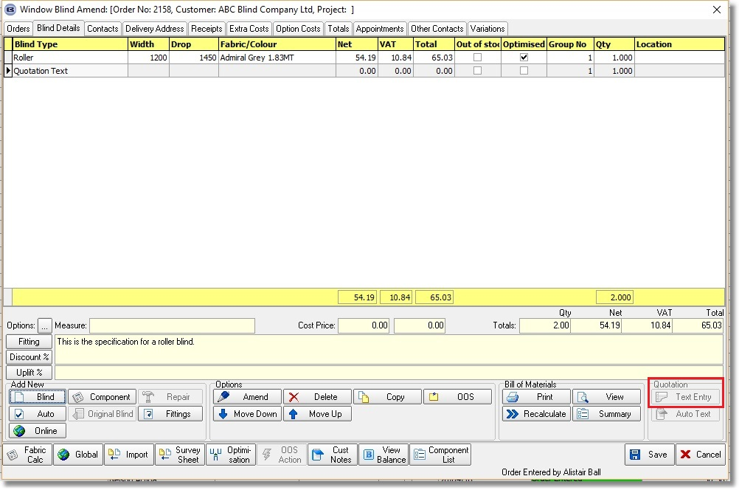

4783. Contact Management > Add Contact Record

There is a new field here called ‘Person Responsible:’ in this form. This looks up the employee table.

4784. Customers > Contact Management

At the moment a contact management record can be added against a customer record. It may then be necessary to tie this contact record to an order. So when editing the contact record, it is now possible to lookup order numbers that relate to that customer and save that order number against the contact record.

All current Blind Types now appear in the ‘Blind Type’ list.

When editing a contact form created against a customer in the “All Contacts” listing (Order Enq.) the entire form is now visible.

4786. Purchase Order Enquiry > Update

Permissions/button visibility
There are now button visibility flags for the following buttons (in Administration > Users > Button Visibility(2) ).

Unpost Invoice
Delete Invoice
Delete PO (there is an existing permission for this, ideally could have button visibility)
Undeliver PO

4787. Order Processing > Orders > Order Amend Enquiry (See Comments Below)

There is now a new button on this form called ‘Picked’. It has a button visibility permission. If it is clicked, then a new field in the order (called ‘Picked’) is set from false to true or from true to false.

There is a column choice for the ‘Picked’ field in this form as well.

We also implemented an additional feature in Blindata. There are now many Column Choices and they do not fit the screen normally. Sometimes it takes quite a long to find needed column.

So we added new parameter called ‘Number of Lines per Column’ for the ‘Columns’ menu item” and added it to the Forms tab.
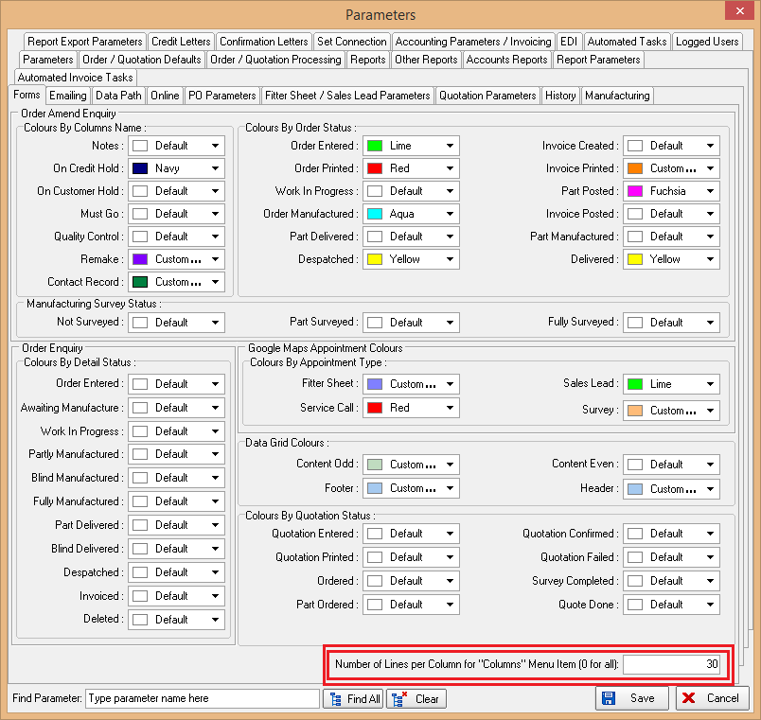
It is 0 by default which means all column choices are displayed as before. If another value is entered there (30) for example, then all column choices will be split onto several columns by 30 choices in each.
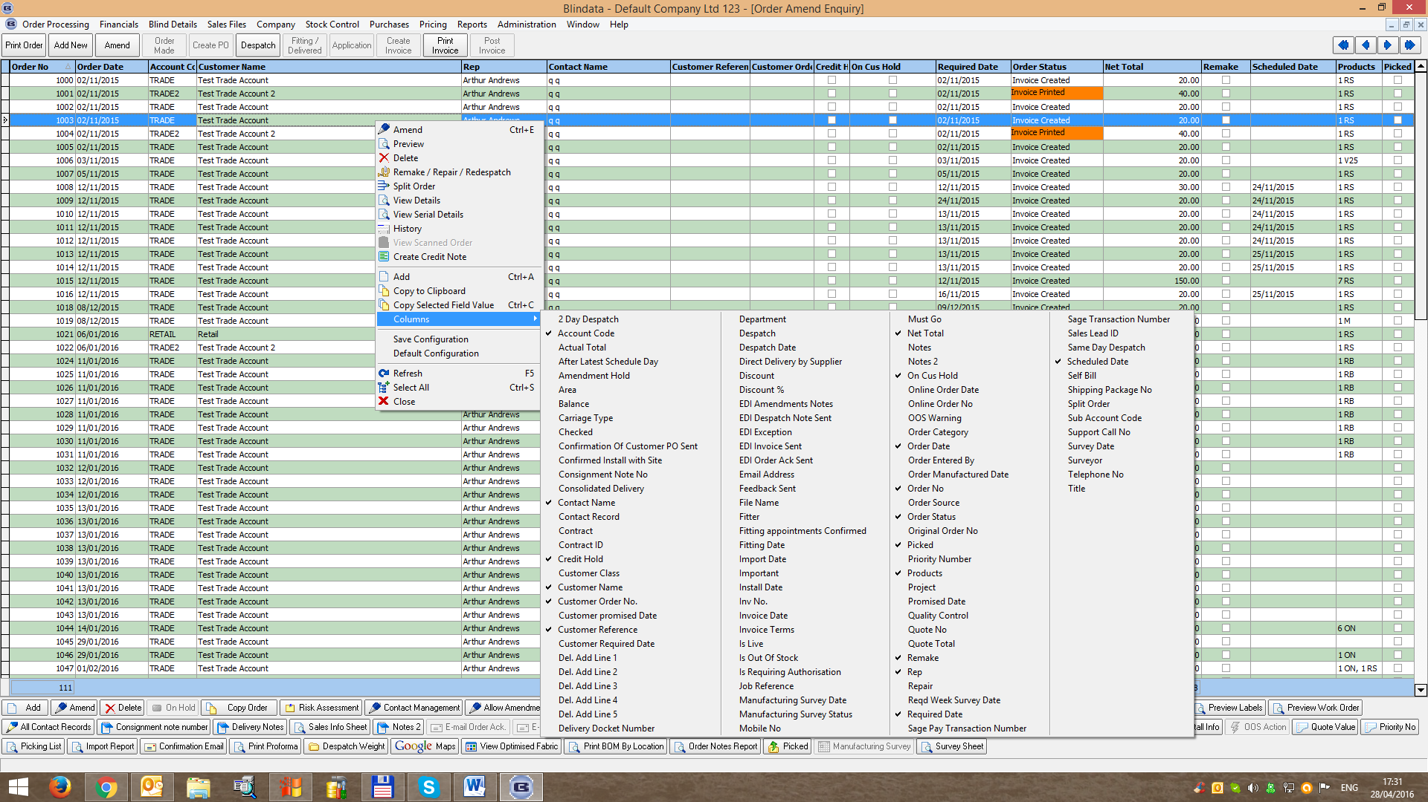

This is a centralised function so this will work on all forms where ‘Column Choice’ exists.

