Blindata Release Note 7.9.0 

18 April 2016

Bug Fixes and Enhancements

The following bugs were recorded in www.support.blindata.co.uk and have been resolved.

367. Window Blind Amend
393. Child Safety Acknowledgment Form
410. Order Processing > Quotations > Blind Details - Totals incorrect
419. Saving Orders via the website
426. Stock Transaction
432. Stock Items
438. purchases>purchase order enq
440. Vertical Combination
448. Works Order - Bespoke 54
458. Order Processing > Orders > Receipts > Post To Sage
460. Day Book Standard

New Work and Customer Requests
4749. Deflection Calculation

It is now possible to check the deflection of a roller tube when an order detail line is entered. There is a new parameter for this in Blind Details > Blind Types called ‘Check Tube Deflection’, which defaults to false.

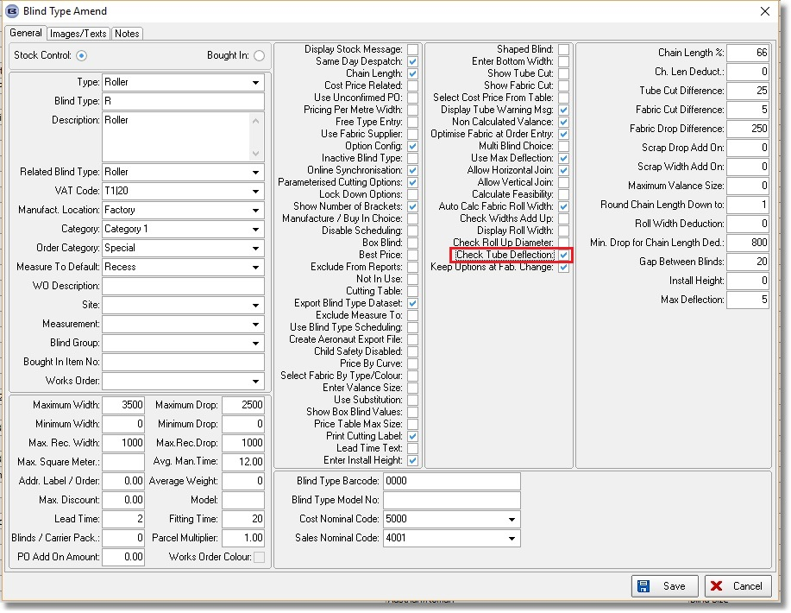

If this parameter is set to true, and if the calculated deflection is > admissible deflection, a message will appear.

The formula for this is as follows.

MI for Solid Round Beams = (pi * (OD⁴ - ID⁴)) / 64
Deflection = (length³ * force) / (3 * E * MI)
Bending Stress = (force * length) / (MI / (0.5 * height))
Where,
MI = Moment of Inertia
E = Modulas of Elasticity in psi
If bending stress exceeds the materials yield strength it will be permanently deformed and not return to its original shape.
Example:
Calculate the deflection of a simple round tube.
Length (Inches) = 15
Diameter (Inches) = 5
Wall Thickness (Inches) = 0.2
Force (Pounds) = 5
Material = Steel

Solution:
Apply Formula:
MI for Solid Round Beams = (pi * (OD⁴ - ID⁴)) / 64
Deflection = (length³ * force) / (3 * E * MI)
Bending Stress = (force * length) / (MI / (0.5 * height))
Deflection = 0.000006111549814728781 (Inches)
Bending Stress = 6.111549814728781 (PSI)

The ‘Admissible Deflection’ and ‘Moment Of Inertia’ are held in the stock record. There is a new field called ‘Modulas Of Elasticity’ which is held in the Characteristics tab.

The force is calculated as the weight of the blind, so we now calculate this. The weight is calculated for each bill of material record and stored there, and then also held in the detail line and also in the order total (there is a display field for it in the Totals tab). It is displayed in the BOM form and is a column choice in ‘Window Blind Amend’.

The weight is calculated by taking the quantity calculated in the BOM record and multiplying it by the ‘Specific Weight’ field that is in the stock record.

Similar to dev 4748, the ‘admissable deflection’ and ‘moment of inertia’ are taken from the relevant chosen tube option. If the calculated deflection > admissible deflection, a warning message will appear saying ‘The calculated deflection has exceeded the admissible deflection for this tube. Please select a bigger tube’.

4758. Order Enquiry > Pick List Validation

The pick list validation is now scanning the serial id barcode.

The WO label now prints automatically after the product is scanned. So the validation process only has 3 steps:
Operator sign on/scan on
Scan the pick report
Scan the product

When the ‘Pick List Validation’ is done successfully, the works order (in this case ‘Works Order – Label Blind Size 2’ prints immediately only for this blind.

Then when the validation is done and the label printed, the detail line now changes to WIP. When all the detail lines are in WIP, the order status changes to ‘Work In Progress’.

Error messages

We do not need the validation success warning pop up – this was only extra work.

4759. Batch Picking List

This report now prints all serial detail lines, not order detail lines. The barcode that prints is the serial id, not the blind id.

There is a line printed between orders.

Orders that are on credit hold/customer hold/backorder/non-checked do not print on this report.

The box blind stock code for the detail line now prints.

4760. Works Order – Label Blind Size 2

The Serial ID now prints on this report instead of the blind ID.

4761. Parameters > Automated Tasks

The ‘Export to ERP’ parameter in Automated Tasks is used to send orders to separate folders. This has been expanded to include 4 folders.

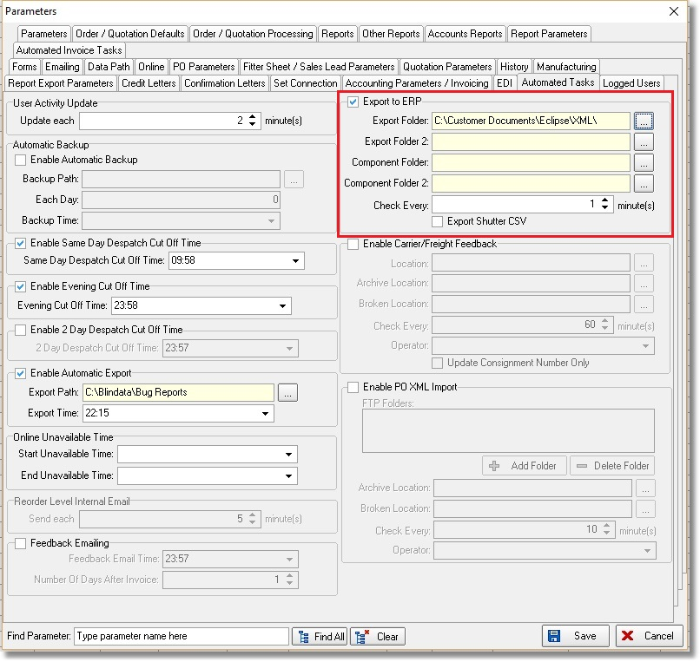

4762. Order Processing / Online Ordering

There could be a situation where only certain fabrics/components are available to certain customers. This means the program looks at System Tables > Option Restrictions. It works for both blind and component orders if Available is false, but did not work properly if Available is true. The blind detail line entry was correct but the component detail line entry was incorrect ie it was still making the fabric available to other customers. This functionality has now been applied to component detail lines as well.

This logic should also be applied to the online sites.

4765. Parameters > Automated Tasks > Enable PO XML Import

Despatch docket XML can now be imported into system, update PO and then update sales order.

We did a dev item recently 4702 where XML order acknowledgements could be taken from a ftp folder and a PO record updated.

A file will be created in the sender Blindata system if ‘Send Delivery Docket Batch XML’ is switched on in the customer record.

These files are now included in the automated task called ‘Enable PO XML Import’. The function can now distinguish between an order acknowledgement XML file and a delivery docket XML.

When the delivery docket XML is examined, it updates the PO status (and detail lines) and if all the detail lines in the sales order that relate to that PO are delivered, then it change the status of the sales order to ‘Order Manufactured’.

The workflow is as follows. Company A sends a XML PO to Company B. When it is received by Company B, a PO XML file can be sent back (see dev 4702). The order is then manufactured by Company B and despatched to Company A. At the ‘Despatch’ stage, the delivery docket XML file will be created and uploaded to the ftp folder. The automated task at Company A looks in this folder for despatch docket XML files and then updates the status of the bought in PO and, where applicable, then updates the status of the sales order.

4766. Order Processing > Orders > Child Safety

We have had a request that there be more information displayed on this form about the child safety calculation. There is now a message on the form describing how the calculation has been made and what the maximum length the chain could be.

As an example, a message will appear saying ‘This blind has been selected with a fixed tension system, so the bottom of the chain must be at least 1500mm from the floor. Therefore the chain length has been calculated as 4000 – 1500 = 2500mm’.

Also, it is no longer possible to enter an install height that is less than the drop of the blind. If this happens, a message appears saying ‘The install height should be greater than the drop of the blind’. This does not appear if the install height is 0.

4767. Export to ERP

If, in the customer record, ‘Export XML Account Code’ is not null, a separate XML file is exported to ERP. This file now contains the customer invoice address.

