Blindata Release Note 7.8.6 

21 March 2016

Bug Fixes and Enhancements

The following bugs were recorded in www.support.blindata.co.uk and have been resolved.

65. Stock Transaction Entry
159. Order Entry Import routine Chain Length not Printing on Work Order
220. Purchase Order Bought In - Bespoke 64
239. Nominal trans check
257. Printed Acknowledgement/Emailed PDF Acknowledgement Issues
265. Sales Analysis Report - Incorrect Total Figure
266. From Bug #83 Order history is not showing the status of the change – operator and date are recorded Previous enquiry 4624
272. Email invoice button
281. Unnecessary Line items appearing on PO's and Fitter Sheet - Bespoke 64
289. date error

New Work and Customer Requests
4408. Stock Items > Stock Transaction

There is a new button on the ‘Stock Transaction’ tab called ‘View PO’. The user is able to view the PO that this PO transaction came from via this button.

4555. Order Processing > Orders > Multi Blinds

Further changes have been made to the way multi blinds can be entered. At the moment we can choose ‘2 on 1’, ‘3 on 1’ and ‘4 on 1’ which means that additional widths and a gap can be entered. The form now looks like this:

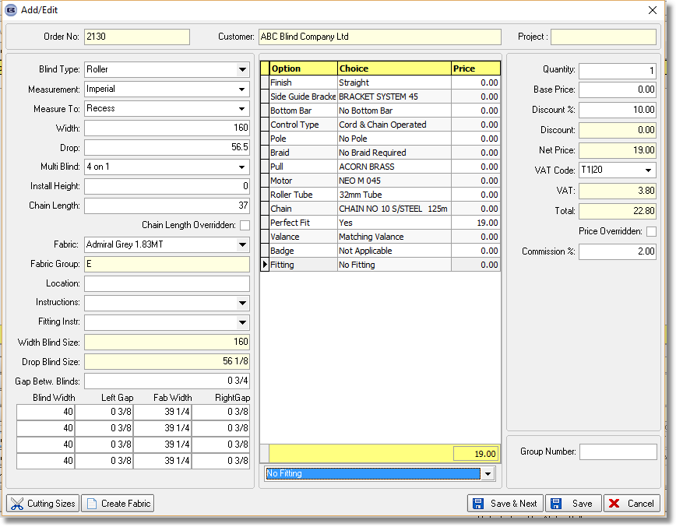

The blind widths are entered first – they must add up to the exact width ie ‘Measure To’ is taken into account. When a blind width is entered, the ‘Gap Between Blinds’ should be divided by 2 to give the left gap and right gap. For example, if the ‘Gap Between Blinds’ was 1 ½, and the blind width entered was 45, then it would calculate the fabric width as 43 ½. Therefore the 3 figures would be ¾, 43 ½, ¾.

4572. Reports > Sales Analysis > Sales Analysis by Customer by Net

There are three extra columns in this report for account code, one for previous year and the other for spend increase/decrease as a % between the previous and current year.

4574. New Customer Sales Report

There is a new report in Reports > System Reports called ‘New Customer Sales Report’.

The criteria is ‘Account Opened Start Date’ and ‘Account Opened End Date’. The report is grouped by customer and shows invoiced, not yet invoiced amounts and total.

4616. Purchase Order Enquiry

When selecting ‘Print PO’ or ‘Print Labels’, the following form now appears.

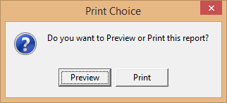

4702. PO XML Import

We have a number of cases where our customers buy from each other. For example, customer A buys wood blinds from customer B and they send EDI XML files to them. There is existing functionality to send an XML acknowledgement back to a ftp location.

There is new functionality to import that XML acknowledgement and update the original PO to say it has been received and to record the order number it has been assigned to.

There is a new automated task to do this. We also need to be able to store the location of where the XML acknowledgements are – there could be multiple locations.

When the XML acknowledgements are imported, they should go into an archive or broken folder. If the import is successful, this should update ‘Acknowledgement Received’ and ‘Acknowledgement Number’ fields in the PO header (these will both be new fields and should also be column choices in the Purchase Order Enquiry form.

There are two flags that are currently used for sending order acknowledgements to specific customers. There is a new separate flag called ‘Send Confirmation of Customer PO’. This will only send a XML file back to a ftp location if the sales order has been received via EDI. It only contains the original PO from the customer and the sales order number of the sales order.
Also, there is a separate FTP Location for this routine. A new “Send Confirmation of Customer PO” flag and “Confirmation Ack FTP Location” field have been added to the customer table.

4705. Order Processing > Orders > Stock Notes

At the moment if there are notes in the Stock Items > Characteristics tab > Notes field, these notes will pop up in a window if that fabric is chosen. This also now applies to options as well. This does not apply to default options – the notes only appear if an option has been selected.

4709. Order Processing > Credit Notes

There is now functionality to put items back into stock if a sales credit note is raised for component detail lines.

If the credit note is for a component detail line, it is now possible to put this item back into stock IE to do a stock receipt transaction for the item. There is a new button on the window blind amend form called 'Stock Return' which is only visible if it is a credit note and is for a component. If ‘Stock Return’ is selected, a form appears that says ‘Do you want to return this item to stock?’ If the answer is yes, then a stock receipt transaction is created and the stock in hand figure is updated.

