Blindata Release Note 7.8.4 

7 March 2016

Bug Fixes and Enhancements

100. Invoice Terms and conditions

The ‘Invoice Due Date’ on an invoice was wrong for certain terms and conditions settings.

114. Stock Valuation Report

If ‘Fabric Location’ was selected, a timeout error could occur.

174. Projects > Contract Type

This was greyed out. Fixed.

181. Stock Valuation Report

A timeout error occurred on the stock valuation report at one customer site. Fixed.

192. Sales Intake Report

It was duplicating records – fixed.
‘Enq No’ now says ‘Quote No’.
‘Job No’ now says ‘Order No’ and the order_id prints in this column.

New Work and Customer Requests
4573. Order Processing > Orders > Child Safety

If the install height is known (ie if the install height <> 0), once the child safety is applied, the chain length is now calculated by deducting from the install height and not from the drop of the blind.

In this example, the chain has to be at least 600mm above the ground, so the maximum length it can be is the install height – 600 = 2400mm.

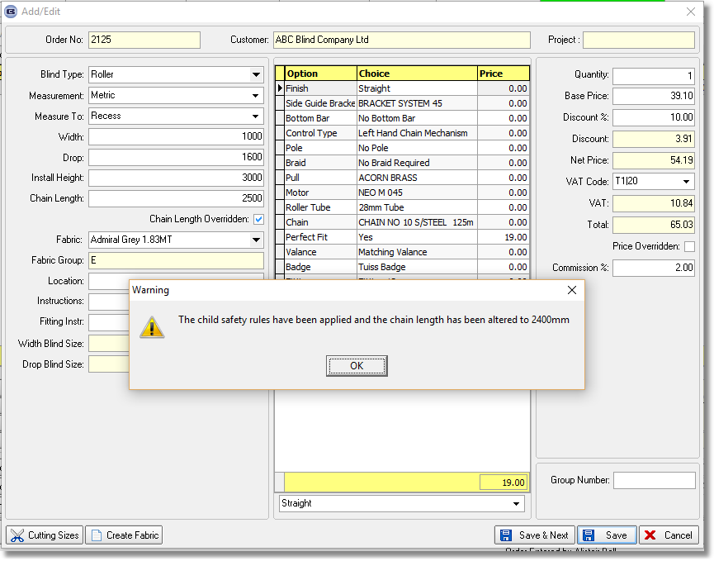

4585. Works Order - Bespoke 33

The information on the works order bespoke 33 has now been set to 30 option lines on each blind type.

The price of the order, the contact name, account number and delivery notes now show on this works order.

4625. Order Processing > Global Search

There is now a ‘Contact Management’ button on this form.

4689. Consignment Note Number Update

It is now possible to update the consignment note number from a carrier system into Blindata. A carrier system can store a file with the order number and consignment note number in it. This can then be automatically updated to Blindata. The following fields need to be set up in Parameters > Automated Tasks.

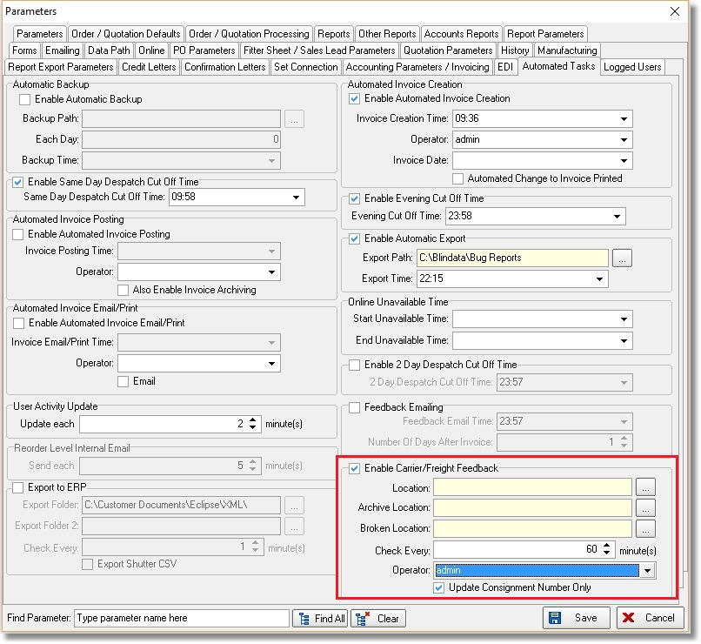
One user (and only one) should be st up with the following advanced permission switched on.

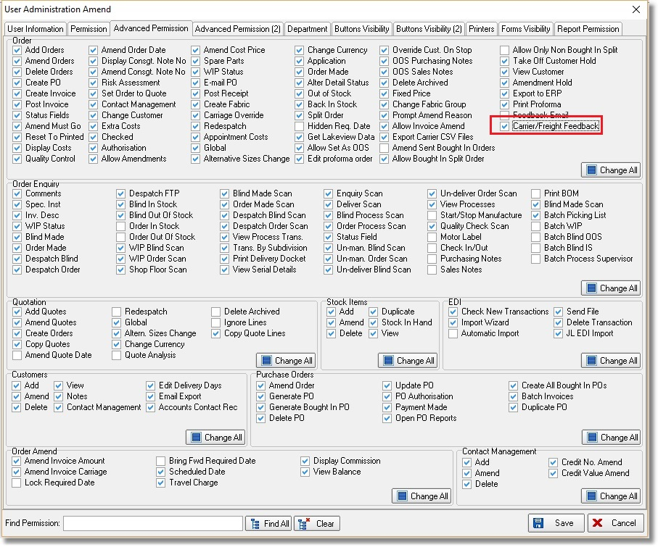
The file should be a csv file and will only have two columns in it – the Blindata order number and the consignment note number.

Once the consignment note number is saved in the order record, an order history record will be created.

4691. Quotations > Create New Revision

- Some changes have been made to the quotation form when a new revision is created.
- The 'Terms and conditions' records (if the 'Show terms and conditions tab' is switched on in Parameters > Quotation Parameters) is now copied.
- The sales forecast date is retained.
- When the revision is created, the quote date is saved as the current date in the revision.
- Column choices – the Net total column is now available, and it is possible to save the configuration of columns.
- The column configuration is loaded for the quote revision the same way as the header quote level.

4704. Stock Enquiry > Recalculate Stock On Hand

There is a new button on this form called ‘Recalculate Stock On Hand’. This will run the Maintenance > Recalculate Stock On Hand function but just for the record that is being pointed at.

This button has a permission flag in Users > Button Visibility(2).

4710. Stock Control > Reports > Stock Valuation Report

If ‘Enable Stock Location by Transaction’ is switched on, the amounts per location are now shown on the stock valuation report. There is currently room for two locations.

4711. Quotation – Bespoke 45

- The address boxes have been made deeper.
- The unit price and discount columns in the detail section have been removed.
- Freight is now included in the total in the footer.

4715. Works Order – Bespoke 54

- Appliceable is now spelt Applicable.
- Order No is now the Customer Order Number.
- ‘Our Ref’ is now order number.
- The headings are now called Customer Order Number and Job Number.
- The bottom of the form has also been adjusted as per request.

