Blindata Release Note 7.8.2 

22 February 2016

Bug Fixes and Enhancements

6171. Post Invoices
This problem has happened at a customer using foreign currency. If they have a sales invoice for a customer that is in US dollars (and their base currency is Canadian dollars), when the invoice is posted, the figures in the nominal ledger were not quite right.
It posted the amount to the debtor account correctly, but the amount that went to the sales account was incorrect - base amount is correct, but the foreigh currency credit amount was incorrect. Fixed.
6197. Drop Ship By Vendor
When the function >Parameters>PO Parameters>Check Stock at Create PO = TRUE is selected and an order is entered for a component, upon selecting Create PO the following happens:
1. a window message appears requiring a Yes or No response but the program does not allow the selection of either choice, the program locks up requiring the use of Task Manager to end Blindata running. Fixed.
6198. Production List By Blind Identifier Detailed
This is printing orders with a status of invoiced even if ‘Exclude Records After Status’ = Order Manufactured is selected. It was ignoring the criteria. Fixed.
Also there is now a page break after each blind identifier (just in the ‘Detailed’ report).
6205. Packing Slip - Bespoke 37
This now prints the term ‘Sales Tax’ instead of ‘VAT’.
6208. Stock Enquiry > Stock Items
If you tried to add a new stock item (using the ‘Add’ button), the record would not save because there was no way of entering a sales nominal or cost nominal. This is because these fields are now in the ‘Defaults’ tab. Fixed.
6209. Purchases > Suppliers
If a supplier record was open, it started to cause timeouts in Blindata. When the form is saved or exited, the timeouts stopped. Fixed.
6216. Works Order - Bespoke 33A
The fields in 1 now also print on the small label (2)for all Impala blind types.
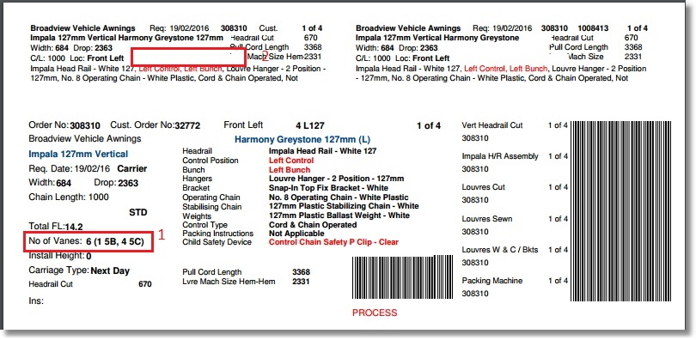
New Work and Customer Requests
4593. Customers > Export Transaction Data

Two new columns have been added to the spreadsheet, one for the ‘VAT Total’ for the order and one for the ‘Total’ for the order. These have been inserted to the right of the current ‘Net Total’ column. Both these columns are also be summed at the bottom.

4636. Projects

There is a new system table called ‘Build Type’. It has two fields, id and Description.
There is a new field in the Projects form called ‘Build Type’ which looks up the Build Type system table.
This field displays below ‘Contract Type’ on the Projects form.

4637. Quotations

There is now a routine to copy detail lines from one quote to another (leaving lines in original quote). There is a new button called ‘Copy Quote Lines’. The user is then able to select quote detail lines and then enter the quote number that they are to be copied to. When the ‘Copy Quote Lines’ button is chosen, it displays a form similar to this (below). Also, there is an ‘Advanced Permission’ flag for this button.

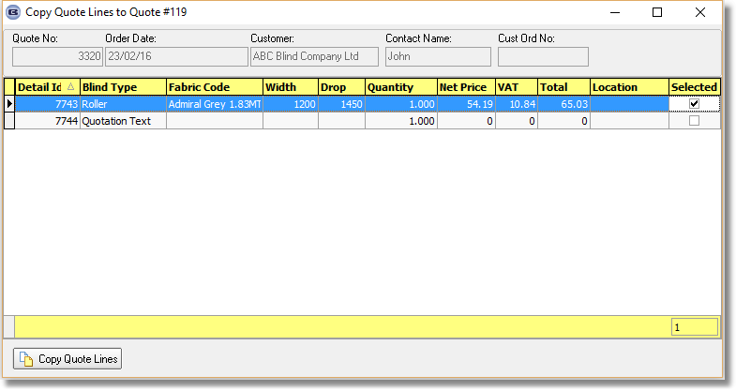

4640. Purchase Order Enquiry > Open PO Reports

If You go to Purchase Order Enquiry and select the ‘Open PO Reports’ button, the following is displayed.

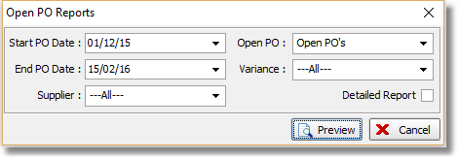
Check boxes for have been added for the statuses ‘In Progress’ and ‘Delivered’ if ‘Open POs’ is selected. If ‘Open POs’ is selected, then the right hand column ‘Full Payment Made Date’ is replaced by ‘Raised By’. ‘Raised By’ is the operator that entered the PO.

4672. Sales Order Report

There is a new report in Reports > System Reports called ‘Sales Order Report’. The user is able to select the status field (tick boxes for each status) and there is a start and end date for either order date or required date.

The report has columns for order no, order date, customer reference, net value, order status. It prints in order no order.
4673. Works Order – Bespoke 42
If the blind identifier = Vertical, the report prints in ‘WO Control’ order, and within that by order and order detail line.
4676. Order Processing > Paid Proformas

There is now a short cut for this form. Ctrl/R.

4677. Fitter Sheet – Bespoke 64

Some layout changes have been made to this report.

- ‘Measured By’ and name have been moved up and across.
- The larger rectangle to the right is now filled with ‘Delivery Notes’ from the order record.
- ‘Comments’ says ‘Fitting Instructions’.
- Location then fitting instructions now print in the right hand detail column. The field is now shrinkable and expands if there is more wrapped round text.
- The option ‘Motor’ now prints to the right of pole.
- Qty is slightly narrower.
- Fitted in ‘Measure To’, which will take up a small amount of space ie either OM or IM.
- The report is now 11” wide.
- ‘Proposal’ now has the company name in it, not the contact name.
- Contact Name is a second column in header.

4678. Survey Sheet – Bespoke 64

This is a new report that has a similar layout to ‘Fitter Sheet – Bespoke 64’. This report will print out if ‘Survey Sheet’ is selected in Order Processing > Quotations or Orders.

4679. Works Order Label 7

The ‘Scheduled Date’ now prints on the small labels’ instead of the ‘Required Date’.

4680. Administration > Maintenance

There is a new option called ‘Update Unit Cost Prices’. If this is selected each stock items (with ‘Non Stock’ = false) is looked at. If there is no unit cost record held against the stock record, then it is created. A record with ‘Unit’ is saved and the cost price is updated from the stock record.

4686. Company > Corrections

It is now possible to amend financial values for nominal transactions in the Correction form.

W258. Component Detail Line Entry

The layout of this form has been changed so it looks more like this.

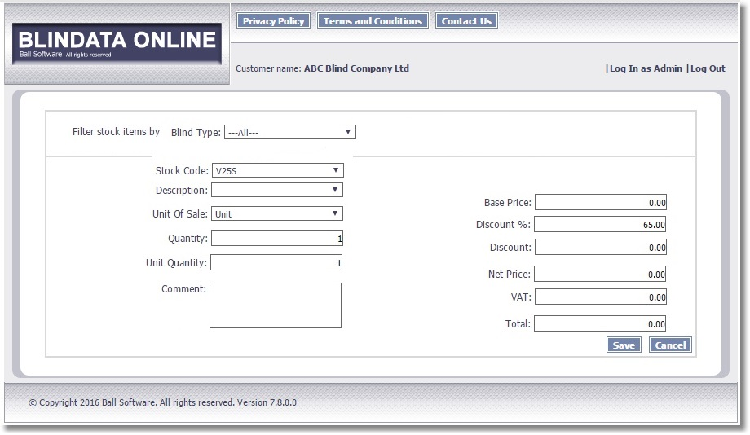

W259. Component Enquiry Line

These columns now show stock code, stock description, and unit of sale if the order is for components.

Also, we have stopped the mixing of ‘Blind’ and ‘Component’ detail lines. Therefore if the first line entered is a blind, then only the ‘Blind’ button is available for all subsequent lines. If the first line entered is a component, then only the ‘Component’ button is available for all subsequent lines.

W260. Print

Detail section columns are now replaced by stock code, stock description, and unit of sale if the order is for components.

