Blindata Release Note 7.7.4 

28 December 2015

Bug Fixes and Enhancements

5886. Picking List - Bespoke 37

The number of characters for instruction to be printed on picking list has been increaded.

5996. Order Processing > Orders

The remake/repair orders that are generated from original orders now have the detail lines in the same order.

6002. Works Order - Bespoke 45

The sidemark has been moved on this report.

6003. Quotation - Bespoke 65

- There is now an extra row for printing options. This is shrinkable.
- The ‘Bank Payment Details’ have been removed completely
- There is more space in the footer in the bottom left to fit in the text from company Details > Quotation Text.

This report has been renamed ‘Quotation - Bespoke 45’.

6004. Project Profitability Report

This report was printing in Landscape - it is now in Portrait. Also, if the company is US or Canada, the paper size is 8.5” x 11”.

6005. Purchase Order - Bespoke 37

There is more room for the product code column.

6008. Quotation - Bespoke 45

- The total is now only be the total for blinds, not quotation text as well.
- The square foot figure was not taking into account if the quantity in a line is > 1. Fixed.

New Work and Customer Requests
4575. Amazon S3 Connection

There is a new group box ‘Amazon S3 Connection’ in Parameters > Set Connection screen. It contains 2 field - Access Key ID and Secret Access Key
There is a new choice ‘Amazon S3’ in Parameters > EDI > Connect To tab.
After selecting this choice then it is possible to add buckets to Parameter > EDI > FTP Folders List and to select buckets in the Archive folder and Broken transaction folder.
After this, the EDI routine will work in the usual way except it will use Amazon S3 storage instead of FTP.

4577. Purchase Order Enquiry > Update

Foreign currency has been added to the purchase invoicing.

When posting invoices for inventory and expenses the following nominal transaction are posted.
Inventory / Expense (PI) Debit 100
Trade A/C payable (USD) Credit 90
Foreign Exchange Credit 10
The stock(inventory) item will always be in the base currency.

4588. Stock Control > Stock Items > Shortfall

It is now possible to parameterise the data that appears in the Shortfall form. This can be done in Administration > Parameters > PO Parameters.

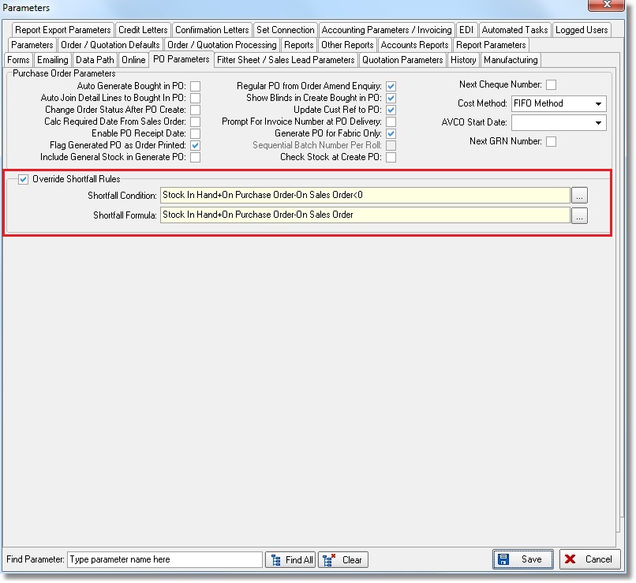
When you click on the 3 dots to the right of these fields, the formula form appears.

