Blindata Release Note 7.7.2 

14 December 2015

Bug Fixes and Enhancements

5929. Invoice - Bespoke 22A

The ‘Country’ has been replaced by the ‘Postcode’.
The email address on the header of the invoice was showing the customer email - it is now the email address from ‘Company Details’.
The registered address at the very bottom of the page is now in 8
The currency sign is a £, not a ?
The invoice text from the ‘Totals’ tab now prints.
The logo has been right aligned.
The box around the Customer address has been removed.
The text size has been reduced by a point for the header section of the invoice.

5946. Reports > Sales Analysis

The archive orders have been added to the reports.

5947. Sales Files > Customers > Sales History

There is now a ‘Copy To clipboard’ option for this form.

5949. Invoice – Bespoke 57

The VAT number from Administration > Company Details now prints in the header.

5950. Works Order - Label Blind Size 2.1

- ‘Valance size’ has been removed completely from this report.
- The serial id barcode has been removed from the lower right hand label.
- The cust ref barcode is smaller (only prints if ‘Print Cust Ref Barcode on Delivery Docket’).

5952. Works Order - Bespoke 52

The figure for the cutting size was wrapping round if the cutting size description was long.

5953. Works Order – Bespoke 54

A number of layout changes have been made to this report.

5954. Contact Management

It is no longer possible to select an owner for the ‘Ownership’ field if the user is flagged as ‘Disable This Account’ in Administration > Users.

New Work and Customer Requests
4232. Quotation – Bespoke 65

A new quotation report has been createdcalled ‘Quotation – Bespoke 65. .

4527. Quickbooks Department Nominal

We now hold two new Quickbooks ref field, (called ‘Quickbooks SI Ref’ and ‘Quickbooks PI Ref’) in ‘Department Nominal Codes’. It should be possible to save this record with either a nominal code in it or with either (or both) of the new Quickbooks fields filled.

If there is a department nominal code record, and Quickbooks is being used and there is a Quickbooks SI Ref in the new field, then for a sales detail line that has a bought in blind, this field should be used instead of the one that is held in the blind type record when an invoice is posted to Quickbooks. For a bought in purchase order, if there is Quickbooks PI Ref in the department nominal code, then this is used when the purchase invoice is posted to Quickbooks.

4539. Order Processing > Orders > Component Detail Entry

When a roll of fabric is sold and entered as a component detail line, there is no wastage, therefore the scrap % is 0. Previously it used the scrap allowance % that is held in the stock record. Therefore when a component detail line is saved, the ‘scrap allowance’ in the stock transaction is 0.

4540. Maintenance > Recalculate BOM

The ‘Recalculate BOM’ routine has been changed so that it will not work for order detail lines that have at least one completed process transaction related to them.

4548. Sales Lead – Bespoke 10

A new sales lead sheet has been created called ‘Sales Lead – Bespoke 10’.

4552. Cost Price Table Calculation

A significant change has been made to the ‘Cost Price Table Calculation’ functionality.

It now looks at the link options for each width and drop to determine the components that should be used, and there is also the ability to enter a fabric square yard / metre price, and a scrap %.

Previously when the cost price table calculation was done, the bill of materials is generated from the fabric group selected and the options selected here.

However this is not giving an accurate cost price table for two reasons.
- The fabric price is not accurate because it only does a calculation for the linear amount required.
- When a blind gets to a certain size an option may change eg a larger tube is required or a bigger clutch is needed.

We therefore need to make the calculation more accurate by doing the following.

The user is now able to enter a square metre or square yard cost for the fabric and also a scrap %. When the bill of material cost for the fabric is calculated, it will be based on the area of fabric required – this will be the width and drop calculated from the calculator, multiplied by the scrap % and the fabric cost.

On the form when the fabric is selected, as well as showing the fabric group, the unit cost price and the roll width is also displayed. This then fills the square metre or square yard price with a calculated amount that the user can change. The calculated amount will be (unit cost price / roll width) * 1000 for metric and (unit cost price / roll width) * 36 for square yardage.

Example:

Fabric cost per square metre = 10.00
Scrap % = 15%
Fabric calculator = Width or Drop (width * 1) + (drop + 300mm)
Width = 500
Drop = 500

Fabric cost = (500 * 800)/1000000 * 1.15 * 10 = 4.60.

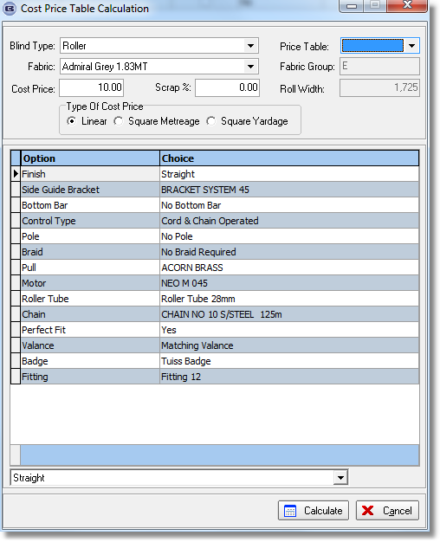

4553. Project Profitability Report

There is a new report that will analyse profit by project, so we could have multiple orders tied to a project. The report lists the orders and detail lines for the project, and also lists the extra costs for the orders in the project and gives a net profit figure. The report is called ‘Project Profitability Report’ and is in Reports > Financial Reports.

The criteria is just be project name (by lookup). The report then shows (with normal report headings ie company name etc):

Project Number / Name

Customer Name

Order Date Invoice Date Net Order Total Net Cost
Blind Type Quantity Net Total Cost
Blind Type Quantity Net Total Cost

Extra Costs

Date Description Hours Cost
Date Description Hours Cost

Profit:

Order Date Invoice Date Net Order Total Net Cost
Blind Type Quantity Net Total Cost
Blind Type Quantity Net Total Cost

Extra Costs

Date Description Hours Cost
Date Description Hours Cost

Profit:

Profit On Project:

4554. Archive Enquiry

It is now possible to assign extra costs to an order after it has been invoiced. This means that the ‘Extra Costs’ tab in the order is enabled in an order in Order Processing > Archive Enquiry.

4564. Sales Analysis Cost Of Goods Sold

This report size is now correct for USA customers.

4566. Order Processing > Orders

There is now a column choice for ‘Direct Delivery By Vendor’.

4567. Parameters > Authorisation Below

At the moment there is an ‘Authorisation Amount’, so if an order is over this it has to be authorised. There is a new field in Parameters called ‘Authorisation Below’ which default to 0. If a quotation or order is entered for an amount below the ‘Authorisation Below’ figure, authorisation will be required.

4568. Order Processing > Quotations

In the Totals tab, when the lookup for Project is done, the Project ID is also shown.

4570. Quotations > Contact Management

At the moment if the ownership of a quotation contact record is set, it is saved in the fitterid field.

When a user logs in to Blindata, if ‘Display Current Quote Contact Info on Login’ is switched on or if Ctrl/T is used, the contact records for the owner that has logged in are displayed.

