Blindata Release Note 7.6.1 

25 September 2015

Bug Fixes and Enhancements

5641. Purchase Order Enquiry

In Purchases > Purchase Order Enquiry > Generate PO there were issues where when entering stock, it was not defaulting to the correct unit of sales. Fixed.

5646. Purchase Order Bought In 8.5 x 11

The report now prints up to 500 characters, which is what can be typed into special instructions in the order detail entry.

5647. Default Printers

The way the default printers are stored has been altered as some customers were experiencing issues where the default printer choices were being lost.

5657. Acknowledgement – Bespoke 60

If a component detail line is entered, the Comments field now appear in full on this report - previously they were being cut off.

5658. Quotation – Bespoke 60

If a component detail line is entered, the Comments field now appear in full on this report - previously they were being cut off.

5659. Purchase Order Regular – Bespoke 59

If a component detail line is entered, the Comments field now appear in full on this report - previously they were being cut off.

5660. Settlement Discount

We made a change in 7.3.5, dev 4109, where the settlement discount showed a different amount from 01/4/15. But for invoices dated 31/03/15 and before, the previous method is now used and the VAT shown as the amount calculated after the settlement discount has been removed.

New Work and Customer Requests
4359. Grid Filters

At the moment you can filter columns in the tabular forms eg ‘Order Amend Enquiry’, ‘Order Enquiry’ etc. If you filter one column and then go to filter another one, it showed all the possible options in the original form display.
This has been changed in the stock enquiry form so that the second filter only shows the choices that are available after the first filter has been done.

To enable this, there is a new parameter choice called ‘Filter Multi Choice’ that has to be set to true. If customers like this, it will be also be applied to other forms.

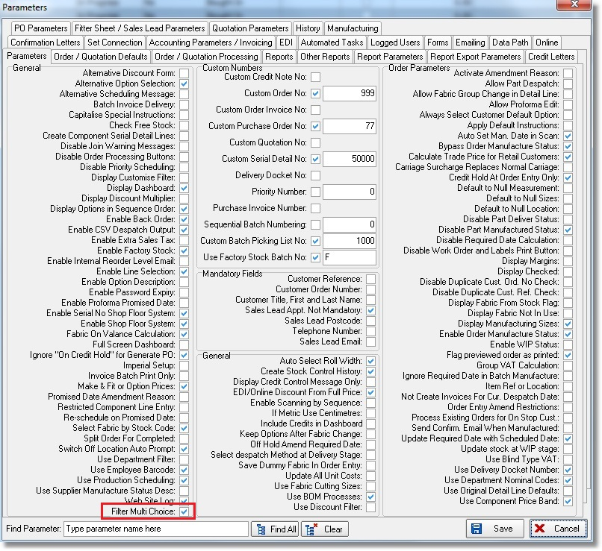

4406. EDI Enquiry > Import Wizard > EDI Orders / Online EDI Orders

There is now a way to remove these records if they have not imported. There is a ‘Delete’ option in the context menu in both ‘EDI Orders’ and ‘Online EDI Orders’ - it brings up a warning message before deleting eg ‘Are you sure you want to delete this EDI order?.

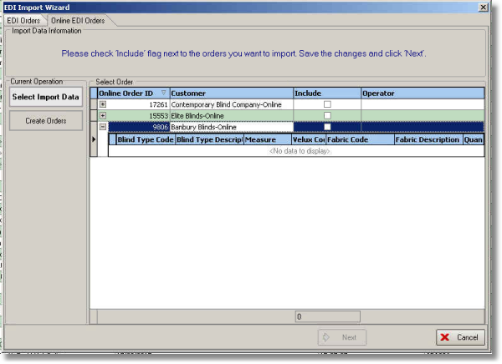
4413. Order Processing > Orders

There is a new parameter called ‘Carriage Override = True if Remake’ so in orders if switched on if an order is a remake, the ‘Carriage Override’ is set to true.

4414. Import From Excel

There is a new import routine for Customer/Blind Type Fabric Group (tab in Stock Items).

4425. Financials > Journal Entry

This relates to dev 5553. When a journal entry is made, we now identify all the JD and JC transactions as being in that journal entry. This is required because if an imbalance has occurred, we need to be able to see this journal in ‘Nominal Transaction Check’.

4434. Label Print – 3 ½ x 1 – Bespoke 59

There is a new label based on ‘Label Print – 3 ½ x 1 – Standard’. ‘Manufactured By’ has been replaced by options – these print depending on whether the label flag is switched on in Blind Types > Option Setup.

Also ‘1 of n’ only takes into account blinds ie miscellaneous or component lines are not be in the total n.

4435. Purchases > Suppliers > Invoices

When entering a purchase invoice, the nominal code now also displays the nominal description so you know what it is. This has also been applied to purchase credits, Sales Files > Customers > Invoice and Credit.

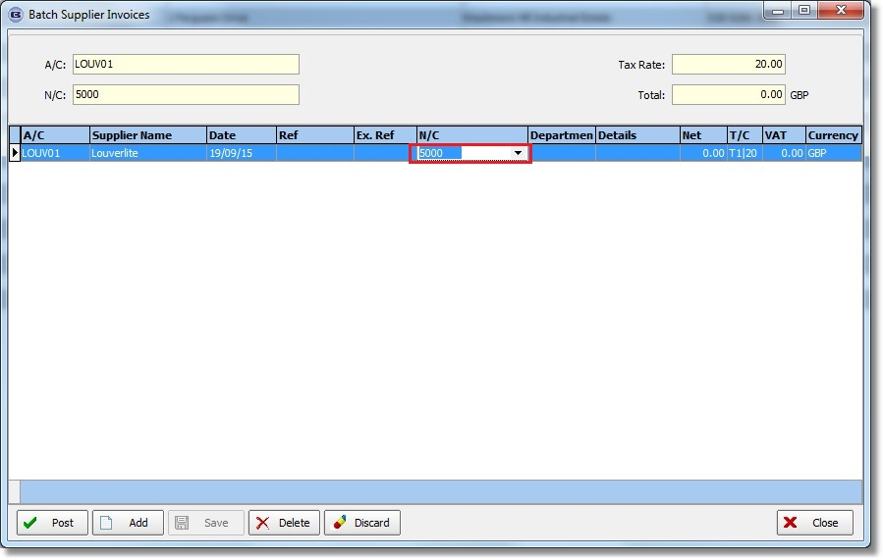

4436. Order Processing / Create PO / Purchase Order Enquiry

There are two new fields in the purchase order – ‘Sales Order No’ and ‘Customer’ and these should be saved in the purchase order record when the PO is created from ‘Create PO’.

4438. Order Processing > Orders > Create PO

When a purchase order is created for a component detail line, the following is now done:

- Create a history record against the sales order indicating what purchase order numbers have been created.
- Cross reference the sales order number in the header of the purchase order record (in the Reference field) and print it on the relevant purchase order.

