Blindata Release Note 7.6.2 

2 October 2015

Bug Fixes and Enhancements

5666. Settlement Discount

The settlement discount now reverts to the old calculation if the invoice date is < 01/04/15.

5669. Quotations / Invoices

Since we made the change in bug 5660, an error occurred for US customers when they printed quotations and invoices. This was happening because they have the US date format set up and we had code which said <= 31/03/15. This has been changed to < 01/04/15, which solves it (or get it to check which date format is being used).

5675. Post Invoices (Sage 200 Espi)

When the csv file is generated for posting invoices to Sage 200 Espi, what goes into the ‘Second Reference’ field is now truncated to 20 characters. It was causing problems when being imported to Sage if this field has more than 20 characters in it.

5680. Quotation - Laser Print By Option

If this is being printed for a proforma, the header ‘Quotation No’ and ‘Quotation Date’ now say ‘Proforma No’ and ‘Proforma Date’.

5681. Department Acknowledgement Email

If an acknowledgement report is held against a department, the Mail Subject line information is now taken from the department name and not from the Company name.

New Work and Customer Requests
4379. Blind Types > Link Options

In the middle section there are now a Min Chain Length and Max Chain Length fields so options can be determined by the chain length.

4389. Import From Excel

There is now a ‘Blind Type Update’ option on this form. This is similar the ‘Stock Update’ except it is for the blind type table. The first column is the ‘blind type’ field eg L89. It is then possible to update all fields on the General tab

4437. Works Order Portrait 8.5 x 11

A Venetian barcode is required for a specific customer. There are two new flags on the blind type record (if blind identifier = Venetian) called ‘Headrail Barcode’ and ‘Slat Punch Barcode’. These both default to false but if either is true then one or both of the following barcodes print on this report.

Automated Head Rail Barcode Breakdown:

The following are the short codes that are required for the automated head rail punching machine
LEFT LEFT 1
RIGHT RIGHT 2
LEFT RIGHT 3
RIGHT LEFT 4
CENTER TILT 5 -

ThIs code is held in the ‘Special’ field in the stock control record so when one of the above options is chosen, the correct number is selected.

Example Barcode number - 3 118.000 003.125 114.875 8.000 5

The barcode is made up of the following fields

Code 1 char This is taken from the Special field in the option – only one option will have a number
Width 999.999 This is the blind size width in inches
First hole 999.999 This is the first cord from ‘Cord Spacing’
Last hole 999.999 This is the last hole (distance is from the end of the width)
Max Spacing 9.999 This is the max spacing from ‘Cord spacing’
No of ladders Integer This is the number of ladders – it is worked out from the cord spacing eg if cord spacing is 3.125-15.125-27.125, then it will be 2. It is the (number of sizes – 1).

Example:

3 Code for LEFT RIGHT
118.000 Width of the Blind (in Inches to the nearest 1/8”)
003.125 Measurement to the center of the Tilter Hole (this is the smaller of the control holes)
114.875 Measurement to the center of the Cord Lock hole
8.000 Measurement to the center of the center of the first lift cord hole
5 Number of ladders

Slat Punching and Assembly Machine:

The barcode is made up from the following fields:

Width 999.999 Blind size width in inches
Number of slats 999 Taken from the ‘Number Of Slats’ table
Lift Cord Hole 9.99 New field in ‘Cord spacing’ called ‘Lift cord Hole’
No of Holes Integer Need a new field in ‘cord spacing’ called ‘Max Lift cord spacing’ and from that we can calculate the number of holes.

Example Barcode number - 066.750 091 6.00 3

066.75 Width of the Blind
091 Number of slats (not the drop size)
6.00 Distance from the start of the slat to the first lift cord hole punch
3 Number of holes that need to be punched

We can use the ‘Cord Spacing’ to generate the gaps between punch holes or cord lock holes eg 6-20-20-20-6 or 6-26-46-66 if it is accumulative.

There is a new field in ‘Cord Spacing’ called ‘Max Lift Cord Spacing’ and from that we can calculate the number of holes.

This figure is calculated as follows:

Let’s look at this (badly drawn) diagram. There are two different sets of holes, 1 and 2 (punch holes = 1, cord lock holes = 2). For 1, there will be four holes and for 2 there will be 3. So the number of holes relates to the ‘Cord Spacing’ table ie the number of holes is the same as the number of – characters in 6-20-20-20-6.

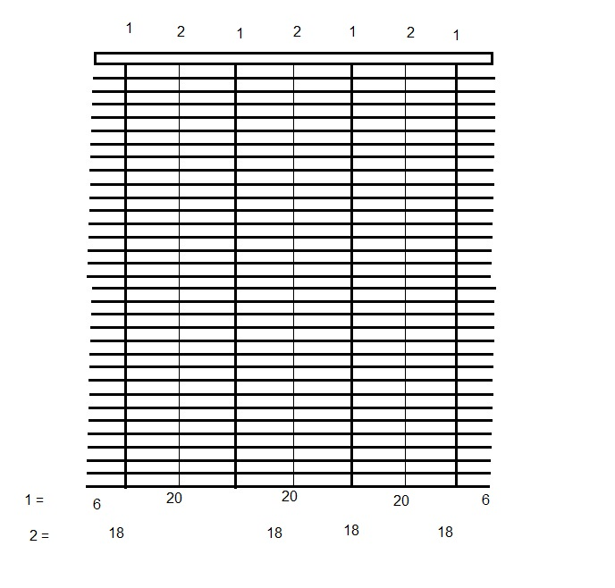

4439. Blind Types > Link Options

At the moment, if a sequence number is negative in the bottom section, then an option does not get changed if it has already been changed. But there are occasions when a specific option is chosen and other options should then go to their defaults, regardless of what has been entered.

Therefore there is a flag in the middle section called ‘Reset to Default Options’ which defaults to false. If it is set to true, then for this record, in the bottom section the sequences are treated as positive numbers.

4440. Filters

The work done for dev 4359 (multi choice filtering) has been done in ‘Quotations’, ‘Order Amend Enquiry’, ‘Archive Enquiry’, ‘Order Enquiry’, ‘Customers’, ‘Suppliers’, ‘Price Table Enquiry’ and ‘Option Price Table Enquiry’ forms.

