Blindata Release Note 7.5.8 

4 September 2015

Bug Fixes and Enhancements

5340. Maintenance > Replace Stock Codes

If the ‘Replace Stock Codes’ maintenance routine was used and there were existing Mappings records, then the outer codes needed to be matched to the inner codes.

5431. Invoice Hold

If an order is on ‘Invoice Hold’ then it should not be possible to post it at all – in ‘Post Invoices’ or from the ‘Order Amend Enquiry’ form.

5460. RE: 3986. Sage 300 Integration

This routine has been changed so it does not change the status to ‘Manufactured’ if there are any errors appearing.
The posting routine has also been speeded up significantly by removing the invoice number check functionality.

5508. Online Ordering > Copy

The ‘Copy’ blind functionality was not working on the online ordering system. Fixed.

5522. Invoice - Bespoke 17b

- The square metre amount was wrong if the size of the blind is below the square metre minimum size. If it is below the minimum, then it now prints the minimum square metre amount.
- The lines between detail lines are thinner.
- The invoice text should come from the Depatment record invoice text, not from Company Details.
- The footer now only prints on the last page of the invoice.

5524. Production Process by Employee by Date

This report was calculating the number of louvres cut incorrectly. Fixed.

5525. Reprint Works Order History Entries

When you reprinted WO in batches through Production Documentation and selected specific orders, history records were created for all orders within the selected period despite the criteria.

5542. Label Print - 3 ½ x 1 Standard

The top line has been moved down slightly and the other lines moved slightly closer together vertically.

5543. Sales Files > Post Receipts

A timeout message occurred when tring to post a receipt for an account with a lot of outstanding invoices. This form needs has been optimised.

5545. EDI Enquiry

When an order is imported that is a multi blind and has been entered as imperial, it imported incorrect sizes. It is now handling fractions properly.

5546. EDI Errors Again

There have been some reports of online orders being submitted with out options (when there should be options).

We have added a check and if an online order consists of detail lines without options, the following message appears:

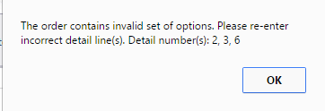

5547. Quotation - Bespoke 34

In Blind Type > Option Setup, the ‘On Quote’ flag now works properly for this report.

5552. Purchase Order Wholesale EDI

The wholesale EDI orders get sent with extra detail lines in them – these are now ignored ie the EDI wholesale file only contains detail lines where the supplier in the stock record matches the supplier in the PO header

5563. Sales Files > Customers

The screen display has been tidied up.

New Work and Customer Requests
4360. Cord Spacing

At the moment there is a ‘First Cord’ field in the Cord Spacing table. This also acts as the last cord field as well. We have a customer that manufactures a blind that will have different first and last cord sizes, depending on the option chosen. In other words, it will mean that the cord spacing on the blind will not be symmetrical.

Therefore we have introduced a new field called ‘Last Cord’, which defaults to 0. If ‘Last Cord’ is 0, then the cord spacing will act as it currently does, but if the last cord is > 0, then the calculation will take into account ‘first cord’ + ‘last cord’ instead of ‘First cord’ + ‘first cord’.

4361. Delivery Docket – Bespoke 52

A new delivery docket layout has been created with a page size of 8.5” x 11”.

4363. Quotation – Bespoke 17B

A new quotation layout has been created called ‘Quotation – Bespoke 17B. It has a similar layout to ‘Invoice – Bespoke 17B’.

4364. Acknowledgement – Bespoke 17B

A new order acknowledgement layout has been created called ‘Acknowledgement – Bespoke 17B. It has a similar layout to ‘Invoice – Bespoke 17B’.

4365. Quotations > Auto Group Number

If the ‘Automate Group No’ parameter is set to true, if an introduction text is added first, it now defaults to group 01.

4366. Quotations > Projects

There is now a context menu on the ‘Projects’ form.

There are now column choice options – added fields for ‘Survey Required Date’ and ‘Completed Date’, ‘Taken By’, ‘Forward To’. It is also possible to do a ‘Copy To Clipboard’, ‘Save Configuration’, and ‘Default Configuration’.

4367. Quotations > Projects

When a survey is completed, the ‘Completed Date’ is filled in – it now also updates the ‘Survey Completed Date’ and changes the related quotations to ‘Survey Completed’.

4368. Reports > System Reports > Sales Forecast Report

Forecast date now prints on this report

4370. Order Processing > Production Lists

A new production report has been created called ‘Production List By Blind Identifier. It is similar to ‘Production List By Blind Type’ except it is by blind identifier. Also it does not contain every detail line, but instead groups them by blind type ie if there are 3 roller blinds and 4 89mm verticals on an order, it prints one line for each, with totals of 2 and 4 respectively.

4373. Quotation – Bespoke 60

For a component line, the stock code (like Acknowledgement – Bespoke 60) is now printed.

4374. Maintenance > Delete Inactive Customers

There is a new option in the Maintenance menu called ‘Delete Inactive Customers’. If a customer is flagged as inactive and there are no quotations, orders or credit notes (in live or archived tables) then the customer can be deleted.

4375. System Tables > Currency Types

There is a new field (1/Currency Rate) that displays the exchange rate the ‘other way round’. For example, if Pound (GBP) is the default currency, and US Dollar was another currency and the currency rate was entered as 1.55, the new field will display this as 0.64516. It is also possible to edit this field, which would then update the ‘Currency Rate’ field.

4385. Financials > Invoice Batch Print

There is a new flag in Sales Files > Customers > FTP Settings called ‘Save PDF Invoice to Disk’. If this is true, then a location to save is shown as well. If this is set to true, when the invoice batch print is done and ‘PDF Only’ is selected, the invoices will be saved as PDF files to this location.

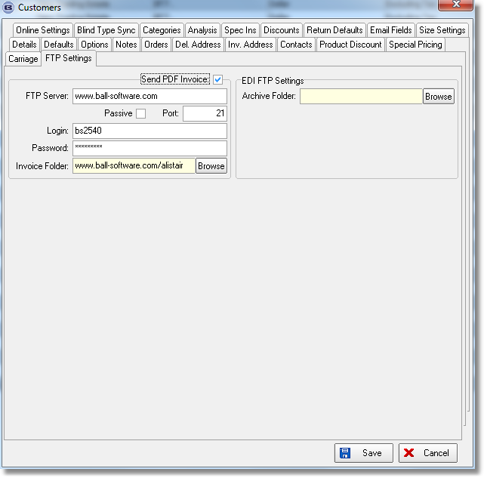

4386. Order Processing > Orders > Create PO

A regular PO can be created in ‘Order Amend Enquiry’ if the following parameter is switched on in Parameters > PO Parameters.

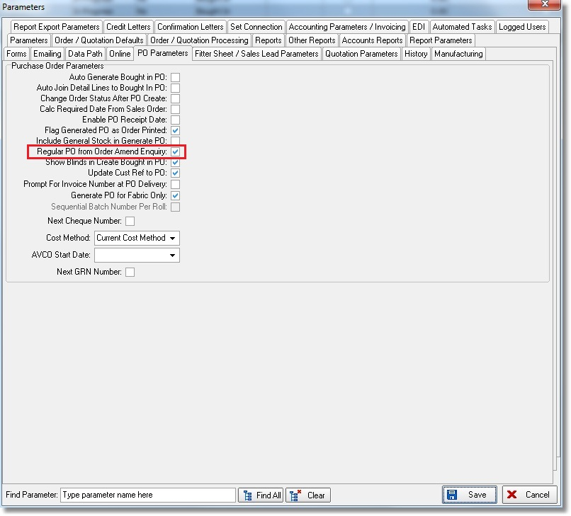

If a regular PO is created using this routine and Sales Order has ‘Direct Delivery by Supplier’ = TRUE then the delivery address from the sales order is stored against the PO and will be used in the PO report print.

4399. Reports > System Reports > Orders By Operator

Removed blind type codes totals from the bottom of the report, and instead have totals by blind identifier under each order status for each operator.

