Blindata Release Note 7.5.3 

31 July 2015

Bug Fixes and Enhancements

5374. EDI Import Duplication

We have had an instance of an EDI order being imported twice. A change has been made which may have resolved this, but it should be monitored.

5381. Stock Items > On Sales Order

We have checked the ‘Stock Control History’ for specific Stock Item at a customer site and it seems the quantity '1' was added On Sales Order when a credit note was copied from a sales order on the 'Archive Enquiry' form.

5392. UPS Carrier File Layout

We have included xmls=”x-schema:openshipments.xdr” and also now have a node for <OpenShipment ProcessStatus>

Below are some comments and instructions how to set up the ‘UPS’ carrier layout to get a similar file as required above. In order to add ‘xmls’ and ‘ProcessStatus’ texts into the XML layout we have added a possibility to enter XML attributes for XML nodes.

So in order to add xmlns=”x-schema:openshipments.xdr” to the parent node you should find ‘OpenShipments’ record, amend it and add a new record to the new table as following:

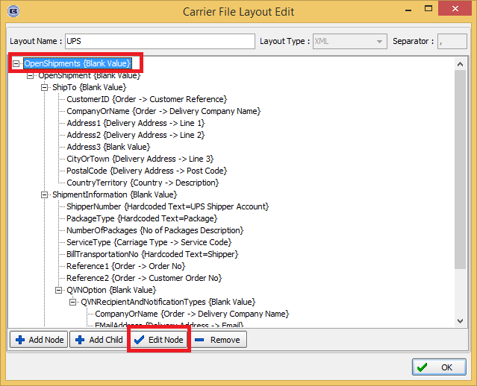

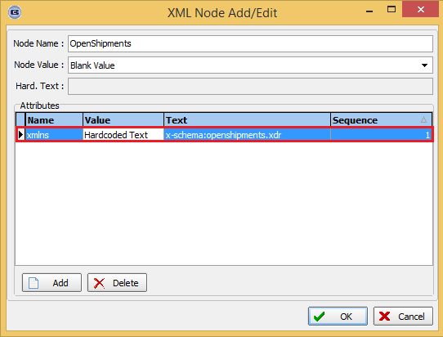

In order to add ‘ProcessStatus’ text to ‘OpenShipment’ node, please amend it and add the following record:

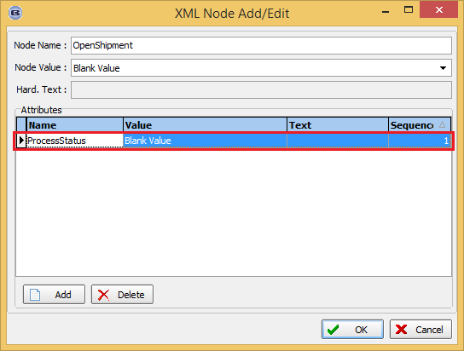

After UPS file generation is done, the program will create a XML file like the one below.
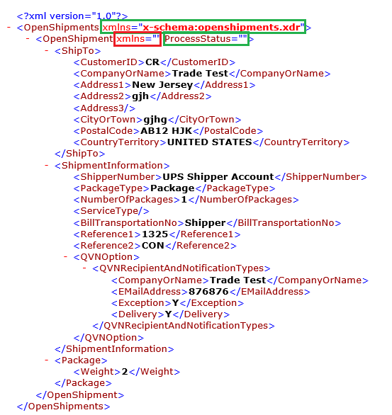

New Work and Customer Requests

4256. Stock Control > FIFO Method

Please also read 4312 before any coding work is done.

At the moment we can set stock control up to be either FIFO or AVCO. However the way FIFO works is only partly correct. When a purchase order is received, we need to hold the cost price against the PO transaction. When stock is used (if FIFO is switched on), the stock should be reduced from the oldest delivered purchase orders. At the moment we have called this FIFO but it is really ‘Current’. We should therefore rename FIFO as Current and have a new choice for FIFO.

If FIFO is used, then the stock valuation should be calculated based on the sum of the value of the transactions, not just on the stock in hand figure multiplied by the current cost figure.

But how should the bill of materials be calculated? Should the cost price be the current cost price or the oldest available one? This could be problematic, as the correct value may not be picked up.

FIFO Example

A purchase order is created for item ABC, quantity of 100. When the goods are received, the cost price is recorded as 5.00.
A further purchase order is created for a quantity of 50. When the goods are received, the cost price is recorded as 4.50.

If a stock valuation is run at this point, the total stock value for this product will be (100 * 5.00) + (50 * 4.50), giving 725.00.

If a quantity of 60 is sold, then this will be deducted from the oldest PO delivery, so this will leave us with a total of 40 from the first PO and still 50 from the second PO.

If a stock valuation is run at this point, the total stock value for this product will be (40 * 5.00) + (50 * 4.50), giving 425.00.

Administration > Parameters > PO Parameters

Renamed ‘FIFO Method’ to ‘Current Cost Method’. Created a new option called ‘FIFO Method’.

Purchase Order Enquiry > Update

If ‘FIFO Method’ = true
There are new fields in the stock transactions for PO deliveries to hold cost price and quantity in stock.

Purchase Orders

When a regular PO is delivered, the quantity in stock figure in the PO transaction is updated, and the cost price is also filled.

When a regular PO is invoiced, the PO transaction that relates to the invoice line is updated with the cost price if it is different from the amount that is held.

Work In Progress / Blind Made / Order Made / Stock Adjustments

When stock is deducted from the system, the quantity in stock is also reduced, deducting from the oldest stock figure first.

Orders > Bill Of Materials

If the oldest stock value needs to be looked at, then this calculation will need to be amended.

4308. Sales Files > Customers

Invoices for customers can now be sent to a ftp folder. There is a new flag held against the customer and also a ftp folder, username and password. The new flag is called ‘Send PDF Invoice’. These fields are in a new tab called ‘FTP Settings’ in the customer record.

Financials > Invoice Batch Print

There is a new option on this form for ‘FTP Only’.

4310. Order Enquiry

When all blinds are scanned as manufactured, the status of the order changes to ‘Order Manufactured’. There is now functionality to jump straight to the despatch status at this point, enter weight and boxes and print the despatch docket. (I thought we could do this already but cannot see a parameter for this).

The ‘Bypass Order Manufacture Status’ parameter needs to be switched on. If this parameter is enabled then the following logic is applied:
If order have WIP status then it can be scanned as despatched (Despatch Blind Scan or Despatch Order Scan) instead of manufactured. In the despatch window, the number of packages and weight now appears.

4316. Order Processing > Orders > Option Size Message

When a size restriction is triggered for an option in order entry, the message only mentioned the upper limits. It now mention the lower and upper limits.

4318. Credit Note Posting

If ‘Blindata Accounting’ is on and ‘Use Stock Nominal’ is on, and ‘Use Stock Nominal’ = true, when a component line is a credit note, the IP nominal stock transactions is now posted (but inreverse compared to the invoice).

4320. Import From Excel

When ‘Stock Additional Options’ are imported there is now a flag called ‘Delete Existing Additional Options by Stock Item’ which defaults to false. If it is set to true, then for each stock record, if there are additional options to be imported, the existing ones are removed. But if there are no additional options to import for a record, the existing ones will remain.

4321. Stock Control > Stock Items

The ‘Stock Image URL’ field is now a hyperlink so the user can double click on the field and see the image.

4322. Stock Control > Stock Items

There is now a ‘View’ button on the ‘Stock Enquiry’ form. This allows the user to view the stock record and all the tabs, but not allow them to change anything.

4326. Works Order – Label Blind Size 2.1

For blind types where ‘Box Blind’ = true, the box blind code now appears on this works order label.

4327. EDI Enquiry > EDI Import

There is now a field for ‘Mid Rail Height’ in the XML file that is imported in ‘EDI Enquiry’. All the fields for an order detail line where blind identifier = ‘Shutter’ can now be imported.

4329. Blind Type > Blind Type Setup > Measure To

A message can now be made to appear if a particular ‘Measure to’ is selected in the online system. There is a new field in the top section of ‘Blind type Setup’ called ‘Online Message’. This is a text field of 200 characters.

