Blindata Release Note 7.4.6 

15 June 2015

Bug Fixes and Enhancements

5102. Bought In Orders Works Order Printed

It was possible to change a bought in order to WOP by running the production documentation routine even though blind types were set up not to print works orders.

There is a new flag in Parameters > Report Parameters > Works Order and Label called ‘Disable WOP for Bought In’, defaulting to true. In this case all will work as at this time.
If new parameter is switched off then detail lines will not change to ‘Awaiting Manufacture’ (which haven’t WO Control record).

5103. EDI Import ‘Undeclared Data Type’ Bug.

If there was an issue with an XML file that caused an ‘Undeclared Data Type’ error, the import routine froze when the message was on the screen. Now the file is moved to the broken folder and the next file is imported.

5106. Authorisation Hold

If an order was taken off authorisation hold and then amended, it was put back on authorisation hold. This now only happens if the value of the order has increased.

5131. Company > Bank > Bank Account Summary
The ‘Balance Per Books’ opening figure was calculating incorrectly.Fixed.
5145. EDI Import

Required date is now correct for online orders after evening cut off.

5146. Order Status Report

Some dates were incorrectly formatted. They were appearing as mm/dd/yyyy instead of dd/mm/yy. Fixed.

5179. Online Ordering

There have been instances of online orders importing to Blindata without any detail lines in them. There is now an entry in the import log to state this this has happened so the order can be investigated further.

5182. Sales Files > Customers

If an email address is changed, it is now recorded properly in the customer history.

5185. Panel Track
The panel track BOM was not being calculated properly. Fixed.
5186. Nominal Ledger > Reports> Day Books
Customer / Supplier names are now included in these reports.
5187. Company > Nominal Ledger > Reports > Cheque / Payment Journal
Cheques for “Payment on account” (PA) are now showing in this report
5188. Invoice – Bespoke 37
The invoice now prints the unit of sale, quantity and the measurement unit.
5189. Nominal Ledger > Reports
All reports now sort by dates (ascending) and not by transaction numbers.
5192. Bank Account Reconciliation and Summary
Customer name now appears for sales receipts.
Unallocated receipts of amounts in decimals that were posted were not appearing in bank reconciliation but only in statements as “In Transit”
5196. Customer Transaction Report
This report did not show Sales Discount separately instead it is added into Sales receipt. Fixed.
5199. Transaction Reports

Purchases>Reports>Supplier Transaction Report
Sales Files>Reports>Supplier Transaction Report

“Reference” has been replaced with “Ref”.
5204. Works Order - Label Blind Size

The ‘Install Height’ field has been moved up to just above ‘Blind Location’ so there is less being printed vertically.

New Work and Customer Requests

4174. Order Enquiry > Quality Scan

Quality Scan Employee Select. When doing a ‘Quality Check Scan’ from the Order Enquiry form, there is a drop down at the top of this form to select an employee when doing a scan, similar to WIP Blind Scan and Blind Made Scan. The dropdown only lists ‘Quality’ type employees. To handle this, there is a new check box to the ‘Employee Edit’ form. If a user attempts to scan a blind on the Quality Check Scan window without selecting an employee a message appears in the text area stating ‘Please select employee.’
In the order history, the selected employee name is displayed in the text.

4175. Redespatch Scheduling

If an order is flagged as a ‘Redespatch’ and scheduling is switched on, these orders are scheduled into the priority minutes, similar to ‘remake’ orders.

4177. Max Drop Dependent on Width

There is a new parameter in the blind type record called ‘Price Table Max Size’ which defaults to false. If it is false, then the program behaves as it currently does. If it is set to true, then the max width and drop for the blind are determined to be the same as the max width and drop in the price table ie if there is no price found for a blind, then a message appears saying ‘A blind of this size cannot be made’ and it is not possible to save the detail line.

4178. Same Day Override by Blind Type

There is a new flag held against customers in the ‘Blind type Sync’ flag that allows users to enter only certain blind type as ‘Same Day Despatch’ orders.

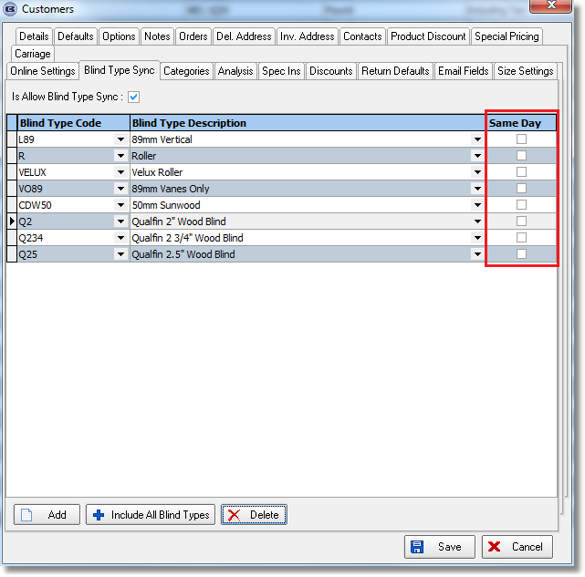

4180. Acknowledgement – Scheduled Date

The chain length has been added to this report beside the Install height.

4181. Order Processing > Global Search

‘SagePayTransNo’ is a new selectable column in the Global Search form.

4260. Invoice – Bespoke 62

A new invoice layout has been created called ‘Invoice – Bespoke 62.

4261. Delivery Docket – Bespoke 62

A new delivery docket layout has been created called ‘Delivery Docket – Bespoke 62.

4264. XML Invoice File

There is a new flag in the customer record called ‘Send XML Invoice File’. This defaults to false. If switched on, the ‘Email Invoice Only’ flag will be switched off. The XML file is sent to a XML file folder that should be chosen for the customer if this new flag is set to true.

There is a new choice in Financials > Invoice Batch Print called ‘Send XML Only’. This applies to customers with the above new field switched on.

4266. Order Processing > Orders > SI Currency Rate

There is a new field in the Order table called SI Currency Rate. When the order is first saved, this new field will be filled with the Currency Rate from System Tables. When an invoice is created from an order, it is written again.
When the sales invoice csv file is generated (if Sage 200 Espi is used) , the currency rate in the csv file is filled with the SI Currency Rate from the order record.

The same process takes place for a credit note, and when a quotation is turned into a sales order.
The csv file that is generated for a purchase invoice also contain the currency rate which will be taken from the currency rate in the Currency types table at the point the purchase invoice is created.

4270. Label Print – 4 x 1

For a component detail line, the label print has been altered a bit.

- Removed ‘Type’ and replaced with ‘Stock code:’
- Move ‘Fabric’ to beneath ‘Stock code’ (where width and drop was) and called it ‘Description:’. This is the stock description.

4271. Acknowledgement – Laser Print (Letterhead Logo)

The chain length now appears on this report in the detail section (only if it is greater than 0). If the order is metric, it appears in metric. If imperial, it is in imperial.

4274. Works Order – Label Blind Size 2.1

- The / is not printed.
- The option names no longer wrap round. There is more space available to the right..
- The cutting sizes are now beneath ‘Measure To’.

4276. Administration > Export Data

There is a new option in this form called ‘Stock Unit Selling Prices’. This exports the records in the Stock Items > Unit Of Sale table.

