Blindata Release Note 7.4.4 

26 May 2015

Bug Fixes and Enhancements

5080. System Tables > Box Blinds

The box blind code in System Tables > Box Blinds field ‘Box Code’ is now a lookup – it was a free text field.

5170. Dimension Codes

If a new dimension code is set up and it has ‘Panels’ in the formula, and the database is set up as ‘Imperial Setup’ = true, the result is multiplied by 25.4. For example, if the number of panels is 5 and the formula is Panels * 1, the result is 127. This happens in validation and in the BOM. Fixed.

5171. Dimension Codes

If a dimension code is set up with a formula and ‘Imperial Setup’ = true, the validation did not work properly if ‘Feet’ is selected. Fixed.

5172. PO Batch Label – Bespoke 37

The supplier name was overwriting the end of ‘SUPPLIER:’. It looked ok on the print preview but not when it was printed. Fixed.

5173. Order Processing > Orders

An error occurred when a second order detail line was entered for a bought in blind. Fixed.

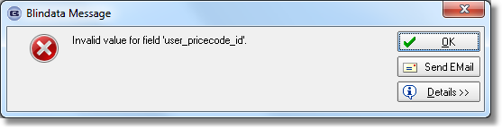
5154. Order Processing > Orders > Cutting Sizes

If ‘Use Imperial’ is switched on then the cutting sizes now appear in imperial.

5175. Reports > System Reports > Orders By Operator

The order value was too high. Fixed.

New Work and Customer Requests

4257. Order Processing > Orders

It is now possible to edit the despatch weight of an order (this is the weight that gets added at despatch. There is a new button on the ‘Order Amend Enquiry’ form called ‘Despatch Weight’.

There is a new flag to display this field in Administration > Users > Button visibility.

Also, it is now possible to enter the weight at despatch, regardless of what carrier has been chosen.

4258. Carriage Charge By State

There is a new system table called ‘Carriage Charge By State’. This has fields for:

Carriage Company Name (Despatch Method)
Carriage Type
Delivery State
Rate Per Kilo

At the ‘Create Invoice’ stage, (unless FOC carriage = true for a customer or ‘Carriage Charge at Order Entry = true), a carriage line will be added and the carriage charge calculated by finding the appropriate rate per kg according to the despatch method, carriage type and delivery state. The despatch weight will then be multiplied by the rate per kg to give the carriage charge. This will only apply if the default country is set to India in Parameters.

4259. System Tables > Department

The following fields have been added to the department record. They will then be required in the invoice header (see dev 4260 and 4261).

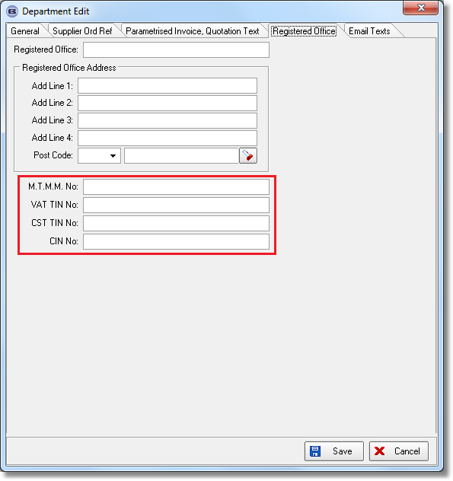
4268. Invoice – Bespoke 4

The ‘Invoice Text’ from Company Details now prints in the invoice footer.

4269. Invoice – Bespoke 41

The text from System Tables > Invoice Terms and Conditions now prints at the top of the invoice footer.

