Blindata Release Note 7.4.3 

26 May 2015

Bug Fixes and Enhancements

5157. Survey Sheet

This was not printing a £ sign properly. Fixed.

5158. Order Processing > Orders

If ‘Imperial setup’ = true, the option prices were not being found properly for certain cut off points. This was caused by an imperial to metric rounding problem. Fixed.

5159. Post Invoices

If ‘Sage 200 Espi’ accounting is switched on, when the csv file is created for sales invoices, column E (SecondReference) now contains the ‘Customer Order Number’, not the ‘Customer Reference.

5160. Order Processing > Order Made

If ‘Sage 200 Espi’ accounting is switched on and ‘Use Stock Nominal’ is switched on, the negative/positive amounts for the nominal transactions are now the right way round.

5161. Stock Control > Stock Transaction Entry

If ‘Sage 200 Espi’ accounting is switched on and ‘Use Stock Nominal’ is switched on, the negative/positive amounts for the nominal transactions are now the right way round.

5162. Sage 200 Espi > Customer Import

Sage supplies a postcode as a single field, and is stored as such in Sage. When this imported into Blindata it was not split over the component parts.

The solution to this is to parse the postcode field when the import is done. This will examine the field character by character. When it finds a space, it will validate what it has found by checking to see if it exists in the ‘First Part Postcode’ table. If the validation is successful, it will be imported to the first part postcode field and then the remainder of the field (after the space) will be imported into the second part of the postcode. If the validation fails, the record will not be imported.

5163. Sage 200 Espi > Customer Import

The contact name has been imported as 3 separate fields: Title, First Name and Last Name. Therefore the import file layout has been changed to handle this.

5164. Order Processing > Orders

There was a problem calculating fabric usage for curtains when a formula was used. If you enter the same figures in ‘Validation’ in the formula it gave a different answer. The problem was actually caused within the validation routine.

To resolve this, we have added in a new field to indicate which measurement unit is being used.

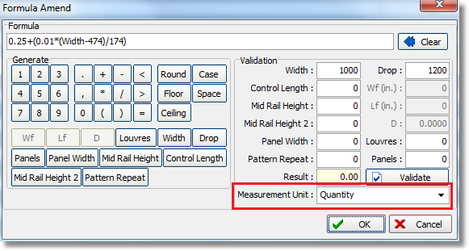

5165. Order Processing > Orders

A customer reported that some orders have gone missing from their system. After investigation, it was discovered that this happened because the ‘Set Order to Quote’ button had been used. This button is dangerous and has therefore been removed.

5168. Quotation – Bespoke 17

If there is a fabric sub description for a fabric, then it now prints in the detail line of the quote instead of the main fabric description.

5169. Sage 200 Espi > Customer Import

When new customers are imported, it now fills the default fields that are set in Accounting Utilities.

New Work and Customer Requests

4211. Cutting Label

It is now possible to print out a cutting label as well as the existing label (both in Order Amend Enquiry > Print Labels and Production Documentation). The new label can be set up in Parameters > Report Parameters > Cutting Label. Layout ‘Catting Label 1’ is a 4” x 2” label and shows the following:

Order No 1 of 2 Customer Name Reqd Date: 99/99/99

Tube Option Cutting size 1 Barcode
Bottomrail Option Cutting size 2
Etc Etc

4229. Administration > Import From Excel > Customer Update

It is now possible to import ‘Auto Email EDI Order Ack’ and ‘Receive Order Ack’ flags.

4233. Peachtree

For Peachtree, when create invoice is done, it is now possible to post the invoice as well. There is a new parameter for this called ‘Post at Create Invoice’ and this only appears when the Sage Peachtree accounting is switched on.
Also there is a new parameter in Users > Advanced Permissions called ‘Peachtree Credit Limit Check. This parameter only appears if Peachtree accounting is being used and defaults to false. If set to true, the credit limit check will be done in the order entry program.

4234. Works Order – 4 Per A4

Removed title on top left and top right label
Removed bottom line of sizes and moved company name left, made company name in italics
Non default options now print in bold on big label.

4246. Projects > Survey Request Sheet

Everything except ‘Surveyors Report’ can now be printed from project record

4247. Order Processing > Orders/Quotations > Window Blind Amend

There is now a column total for base price.

4248. Maintenance > Delete Unused Fabrics

The fabric records are now only deleted if ‘Fabric Not In Use’ = true and the fabric has never been used.

4251. Quotation – Bespoke 54

There is now an option to have an informal title choice in this report ie say ‘Dear Andy’ instead of ‘Dear Mr Jones’. There is a new flag in the Orders > totals tab called ‘Informal Title’ which defaults to false. If this is the case then ‘Dear Mr Jones’ prints, else ‘Dear Andy’ prints.

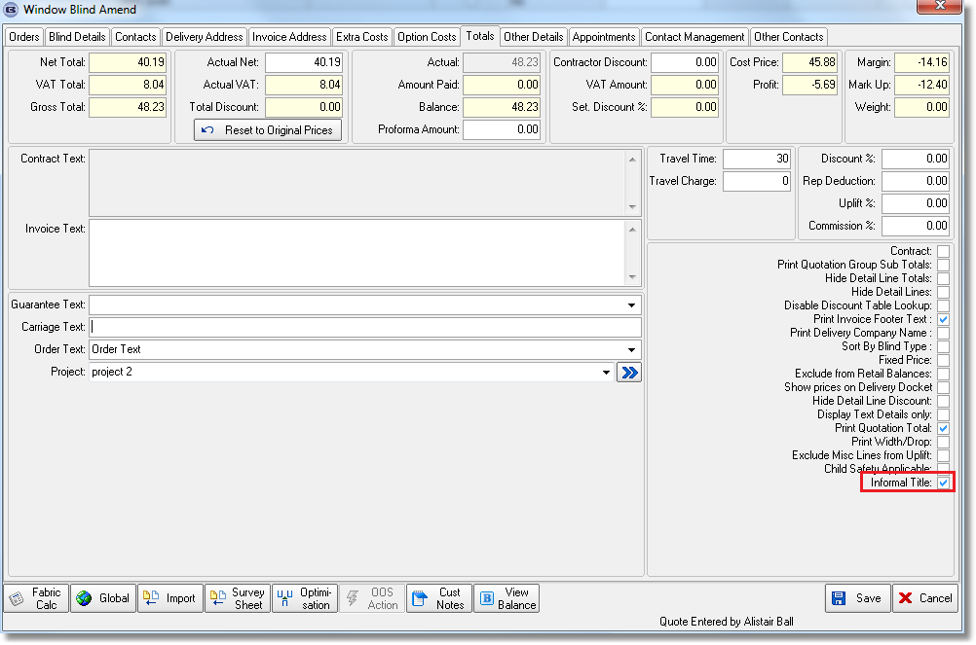

4252. Quotation Stored Text

{Employee}, {EmployeeEmail}, {EmployeeMobile} and {EmployeeTitle} fields are now available in stored texts as fields that can be inserted into the text lines. It is now possible to print these in ‘Quotation – Bespoke 54’.

4253. Option Slat Description

There is a new system table called ‘Option Slat Description’. It contains three fields, ‘Blind Type’, ‘Option Choice’ (stock code) and ‘Slat Description’. When the number of slats is being calculated for a venetian blind, it now looks at this table – if there are any options selected that match an option here, then the slat description that is held in this table is used, otherwise the slat description from the blind type is used.

4254. Works Order – Bespoke 52

If ‘Print Measure To in Works Order Report’ is switched on (in Report Parameters), then ‘Measure To’ now prints on this report.

W209. Component Detail Entry

There is a new button for ‘Component’ so that a component detail line can be added.

When the ‘Component’ button is selected, a new form now displays stock code, description, unit of sale, quantity, Net, discount, VAT, Total. The user is not able edit discount, net, VAT or total.

When submitted, it creates the same XML file layout as is currently sent for wholesale EDI orders.

This allows mixed entries for blinds and components in orders.

