Blindata Release Note 7.3.9 

24 April 2015

Bug Fixes and Enhancements

5120. Invoice – Bespoke 59

This report is now included in ‘Report Export Parameters’.

5121. Credit Note – Bespoke 59

The ‘comment’ text is now being printed out.

5122. Financials > Trial Balance

If you select ‘Brought Forward’ as the start and end period it now puts the brought forward transactions into this report. The same problem existed if you tried to print ‘Balance Sheet’ from Financials.

5124. Company > Nominal Ledger > Reports > Cheque Journal Report

When you tried to print this report, the following message appeared. Fixed.

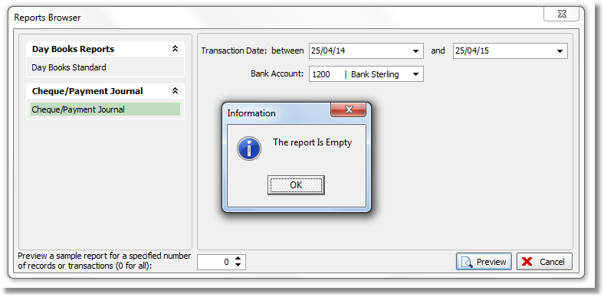
5125. Company > Bank > Reconcile > Send To Excel

When records were exported to Excel, in the ‘Matched Items’ section, the balance was incorrect because it was adding to the balance for payments when it should be reducing. The payments are now exported as negative amounts.

5126. Company > Bank > Reconcile > Balance Report > Bank Account Reconciliation

Changed the sign for journal postings (JD is positive & JC is negative for the bank).
The calculation was incorrect – it is now balance per bank statement – outstanding cheques + deposits in transit + (or -) manual adjustments.

5127. Company > Nominal Ledger > Reports > Day Book Standard

The two columns for department and VAT have been replaced by Customer/Supplier(Vendor) so the customer or supplier (vendor) is printed for SI, SR, SC, Pi, PP, PC transactions.

New Work and Customer Requests

4141. Purchase Order Bought In (Blind Size)

For certain blind types for certain suppliers, the ‘Measure To’ should not say ‘Blind Size’ on this purchase order.

To resolve this, there is now a default ‘Measure To’ field held against the record in Blind Types > Bought In Blind and this is printed on the column for ‘Measure To’ in this report.

4144. Sales Analysis

There is a new criteria for the sales analysis report that will allow the filtering of records by fabric type.

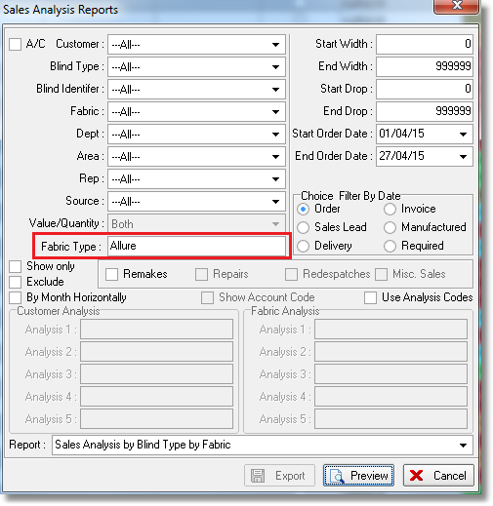

4184. Import From Excel > Suppliers

‘Date Account Opened’ has been added to the import for suppliers.

4185. Currency Types

There is now a selling rate and purchasing rate for currency type. A new field has been created for selling rate and the existing rate copied into it. All sales orders now look at the selling rate (for both blind and component detail lines). All purchasing will still look at the original currency rate.

4186. Order Enquiry > Print Labels

This looks at the label print at the moment – it needs to print the works order label. Therefore there is another button called ‘Print Works Order’ that has the same functionality as ‘Label Print’ ie selection of records, but will print the works order instead.

4187. Suppliers

There is now a column choice for Currency

4188. Purchase Order Regular – Bespoke 59

There is a new regular PO report based on ‘Purchase Order Regular – Bespoke 46’ but includes stock code and supplier part no. Also include both VAT numbers, Order Required By

4194. Stock Control > Fabric Group Setup

‘Fabric Optimise’ and ‘Measurement Unit’ have been added as field choices.

4195. Order Processing > Orders

There is a new parameter in the blind type record called ‘Display Roll Width’ if the blind identifier = Roller or Roman or Curtain. It defaults to false, but if true, the roll width for a fabric is displayed in the detail line entry.

4197. Invoice – Bespoke 34

Two new fields have been added in Administration > Company Details for Swift and IBAN numbers and they now print on the bottom of this invoice.

The carriage type is now printed in the invoice footer if there is a carriage surcharge

4198. Order Processing > Orders

The import detail lines process has been speeded up by changing the way records are validated. Instead of them all being validated before importing, the records are validated and imported one by one.

4205. Acknowledgement – Bespoke 60

A new order acknowledgement report has been created called ‘Acknowledgement – Bespoke 60’ which is based on ‘Acknowledgement – Bespoke 17’. The company name etc is taken from Company Details, not the department record. The page size should be 8.5” x 11” as it is for an American customer.

4206. Quotation – Bespoke 60

A new quotation report has been created called ‘Quotation – Bespoke 60.

4207. Works Order Portrait 8.5 x 11

If ‘Print Measure To in Works Order Report’ is set to true, then ‘Measure To’ now prints in the detail section. It should print underneath the width and drop.

