Blindata Release Note 7.3.6 

28 March 2015

Bug Fixes and Enhancements

5097. Blind Types > Cutting Options > Copy

The ‘Copy’ now works properly – it did not copy all the lines in the final section.

5098. Quotation – Bespoke 59

If the quotation has proforma = true, the report now says ‘Proforma Invoice’ and not ‘Quotation’.

New Work and Customer Requests

4107. Order Processing > Orders > Components

Uplift % can now be pulled into the component detail line from a stock record. The new parameter to do this is called ‘Use Stock Uplift % in Component Detail Entry’.

4108. Cornices and Valances

There are now two new blind identifiers in the system, ‘Cornices’ and ‘Valances’. We have used ‘K’ for cornice and ‘VL’ for Valance.

For these blind identifiers, there is a new flag called ‘Use Pricing Width’ in the blind type form. If this is used, then the price is calculated by adding the left return, width and right return and then looking up ‘Price Table Enquiry’ where the width is the total of these three sizes.

There is another flag called ‘Display Miter Sizes’. If this is set to true, then the user is also able to enter a ‘Left Miter’ and ‘Right Miter’ size.

In the blind detail entry, the following size fields can now be entered (instead of just width and drop).

CORNICES
Drop (use Drop)
Face Width (use Width)
Left Return
Right Return
Dust Cover (projection)

VALANCES
Width (use Width)
Drop (use Drop)
Left Return
Right Return
Dust Cover

The pricing will be done by looking up the price table as normal, but if ‘Use Pricing Width’ is set to true, the width will be left return + width + right return.

4123. WIP Progress Report Detailed

There is a new report in Reports > System Reports called ‘WIP Progress Report Detailed’ to show the details of the outstanding processes that are in the WIP Progress Report.
This shows order number, blind id, process and customer. It is possible to filter by required date, scheduled date, blind type, process, customer.

4124. Stock Control > Fabric Group Update > Unit Cost Prices

If the unit cost unit value is updated using this form, the unit cost price that is held in the Unit costs tab is also updated.

4125. Contact Management

There is a new flag held against ‘Contact Status’ to stop related contact records appearing at login. This is called ‘Hide At Login’ and defaults to false. If it is set to true, then contact records with this status will not appear at login or when CTRL/T is used.

4126. Reports > System Reports > Orders By Operator Detailed

There is now a total for each blind type by operator eg 76 R, 23 L89 etc.

4130. Works Order – Bespoke 52

There is now an extra column for cutting options.

4137. Quotation – Bespoke 54

- The address has been moved down.
- The logo has been moved slightly.
- The project name now prints out.
- The logos now only go on the first page.

Summary Sheet

A smaller logo now prints on top right only on the summary sheet. The summary sheet contains the detail lines, split by blind type.

When you print or email ‘Quotation - Bespoke 54’ report, the following new form is displayed:

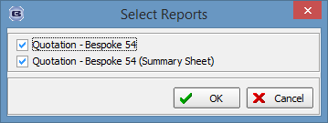

So you can select what report(s) should be printed or emailed.

In order to display the quotation total, the user can put special tag {GrandTotal} into the quotation text detail, for example:

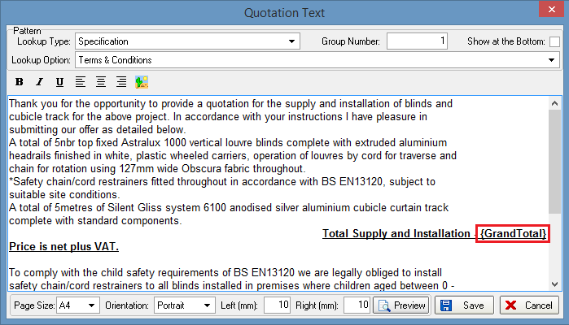

It will be replaced with the value and displayed on the quotation print.

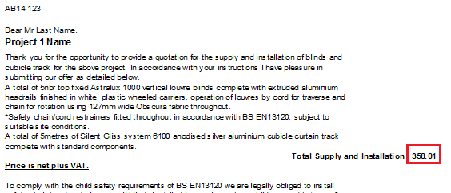

4154. Indian VAT Calculations

Sales Files > Customers

There should be a new true/false field in ‘Customers’ called ‘Form C’ which will only be used if the ‘Default Country’ in Parameters is set to India.

If the state (ie first part of postcode) in the customer record matches the state in ‘Company Details’ then ‘Form C’ = false, otherwise it is set to true.

System Tables > VAT Rates

If the country is set to India in Parameters, two more fields now appear in the VAT Rates form, ‘Description’ and ‘Type’ as they need to store the following information.

Tax Code Table
Taxcode | Tax Rate ( % ) | Description | Type
VAT12.5 | 12.5 | 12.5 % VAT on Local Sales | VAT
CST 2 | 2 | CST 2 % against form C | CST
VAT 4 | 4 | VAT 4 % Local Sales | VAT
VAT 1 | 1 | CSt 1 % Against Form C | CST
CST 3 | 3 | CST 3 % against form C | CST

TYPE is either VAT or CST , Tax Rate can be ZERO also.

Tax Group

A new system table is now available if the country is set to India, called ‘Tax Group’. It can be used to hold the following.

Tax group Table Structure

TaxGroup | Description
1A343 | Hand Made Blinds, Fabric Curtain, Wooden Blinds, Wooden furniture
1A0004 | Machine Made Curtains

Tax Code Tax Group

A new system table is now available if the country is set to India, called ‘Tax Code Tax Group’. It can be used to hold the following.

TaxCode-Taxgroup Table

TaxCode | Tax group | W.e.f Date | TO Date
VAT12.5 | 1A343 | 01/04/2014
CST 2 | 1A343 | 01/04/2014 | 30/09/2015
VAT 4 | 1A0004 | 01/04/2015
VAT 1 | 1A0004 | 01/04/2015
CST 3 | 1A343 | 01/10/2015

To date can be blank, means the value is infinite. From Date is compulsory

Blind Details > Blind Types

If the country = India, then the tax group needs to be stored against the blind type, so there is now a lookup for this.

How Tax is Calculated

The system will first check the Sales Order and find the Tax Group from the Blind Type record. From Tax group, system will get max of 2 Tax codes active for that Tax Group.

From delivery address tax code will be decided from below

“ if the State is Same as the Company Details > State, then the Tax code of VAT type will be used and based on tax rate , tax amount will be calculated. Tax rate and amount will be printed in Invoice

OR
“ if the State is Difference from the Manufacturing company State” then Tax code of CST type will be used and based on tax rate , tax amount will be calculated. Tax rate and amount will be printed on Invoice.

Reports > Financials Reports > Tax Report

A tax report is now available here. There are criteria for start and end invoice dates.

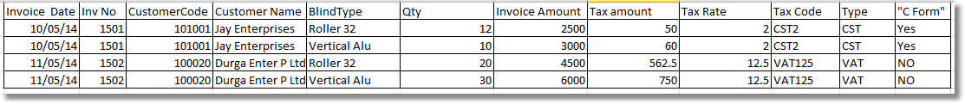

4158. Administration > Parameters > Postcode / ZIP

There is a new ‘Postcode/ZIP’ choice for India. It works in a similar method to the USA. The state is held in the first part of the postcode (same as USA) and the second part holds a 6 digit code.

4159. Blind Details > Blind Types

There is a new field called ‘Blind Type Model No’ which will hold the number that is passed into the string for the visualisation.

4160. Purchase Order Regular – Bespoke 46

If a +Misc detail line is entered, the notes text is now printed in this report.

