Blindata Release Note 7.3.4 

20 March 2015

Bug Fixes and Enhancements

5075. Maintenance > Repricing

This was not working properly if you repriced using cost and ‘Use Square Cost’ and the ‘Processes’ form is being used. Fixed.

5076. Quotations For Never Bought Customers

Some addresses were not appearing in the export. Fixed.

5083. Order Processing > Orders

The ‘Scheduling’ button was being greyed out when it shouldn’t. Fixed.

5087. Sales Files > Post Receipts

If you allocate a credit note against a sales invoice, it did not update the foreign currency amount properly.

This has been fixed but we also need to fix records that are already affected by this. The Corrections form has been changed so the foreign currency amount can be edited.

5088. Quotations

If ‘Quotation Reqd By’ is mandatory, the warning message now says ‘Quotation Required By’, not ‘Customer Promised Date’.

5089. Quotations

If ‘Quote Required By’ is mandatory, and it is not entered, when you click ok on the warning message, it now returns the user to the ‘Quote Reqd By’ field.

5090. Sales Files > Customers > Activity

IP transactions no longer appear in the Activity form.

5091. Stock Items > Stock Transaction Entry / Import

If Sage 200 Espi is switched on, the ‘UniqueReference’ field in the csv file should be filled with the stock transaction id. This happens for both the manual entry and the import.

5092. Purchase Order Enquiry > Update > Post Purchase Invoice

If Sage 200 Espi is switched on, then the purchase invoice file that is generated has a ‘LineNo’ field in column F – same as the sales invoice.

5093. Order Processing > Orders > Order Made

If Sage 200 Espi is switched on, then the file that is sent to the stock transactions folder has this layout..

AccountCostCentre - blank
AccountDepartment - blank
AccountNumber – nominal code, either stock nominal or cost nominal from stock code
TransactionType - 1
TransactionDate – date of ‘Order Made’ status change
GoodsAmount – total of cost of goods, negative if cost, positive if stock
Reference – sales order number
Narrative – stock code
UniqueReferenceNumber – stock transaction id
UserNumber - blank
Source - blank
PostedDate – date csv file created

New Work and Customer Requests

4073. Order Enquiry > Blind Process Scan

There is a new flag in Users > Advanced Permission > Order Enquiry called ‘Blind Made Scan Lookups’ which defaults to true, which means they are displayed and can be edited manually. If this is switched off, then the lookups will be displayed but they will only be updated by a blind process scan and it will not be possible to change the process or the employee via the lookup.

4103. Invoice - Bespoke 57

A new invoice layout has been created called ‘Invoice – Bespoke 57’. It is based on 'Invoice - Laser Print (Letterhead Logo), but the company details come from the ‘Company Details’ form, not from the department record.

4112. Works Order A4 Packing Slip

- ‘Notes 2’ from the order now appear instead of ‘Notes’.
- The ‘Notes’ field from the fabric record now appears.

4113. Stock Control > Stock Enquiry

The ‘Notes’ field (from the ‘Characteristics’ tab) is now a column choice.

4117. Order Processing > Quotations > Scanned Documents

There is now a button on the quotation enquiry form called ‘Scanned Documents’. This is the same as the ‘Scanned Documents’ button in the order amend enquiry form except it will look in a new scanned documents folder called ‘Quotations’ which is held in Administration > Parameters > Data Path. There is also a button visibility flag for ‘Scanned Documents’ in quotations in Administration > Users > Button Visibility.

4118. Label Print – Bespoke 33A

The serial id now prints on the top right label.

4119. Dimension Codes > Formula

‘Pattern Repeat’ has been added as a button here. The pattern repeat figure is taken from the stock record for the relevant stock item.

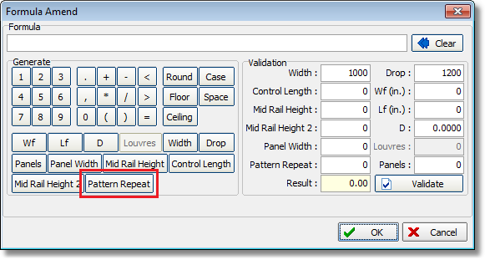

4148. Blind Type > Cutting Options

There is now a ‘Copy’ button in the cutting name section, which means that a cutting option can be copied, along with all underlying related records.

