Blindata Release Note 7.3.3 

13 March 2015

Bug Fixes and Enhancements

5068. Financials > Post Invoices

The csv file layout if Sage 200 Espi is switched was incorrect. Fixed.

5069. Customer Import

This relates to ‘Sage 200 Espi’ accounting being set to true. When the customer csv file was imported, it did not import properly. Column Q now holds the currency column and this must match the ‘Currency Name’ in Administration > System Tables > Currency Types.

5070. Label Print – Bespoke 29

The barcode for the serial id now prints instead of the blind id.

New Work and Customer Requests

4004. Deficiency Report

A new contact management report has been created that show all records where there was an internal issue which therefore affected an order. There is a new flag in ‘Contact Record Type’ to indicate it was an internal fault, called ‘Internal Issue’.

The new report is based on ‘Contact Management Deficiency Report’. It shows the same fields but only show contact records where the contact record type has ‘Internal Issue’ = true.

It also has the same criteria as the ‘Contact Management By Customer’ report.

4013. Order Processing > Orders > Print Proforma

There is a new button called ‘Print Proforma’ that can on the ‘Order Amend Enquiry’ form. This has an advanced permission flag for it.

If the ‘Print Proforma’ flag is set to true in advanced permissions, there is a new field displayed in the order totals tab called ‘Proforma Amount’. This field will print as the net amount on the proforma. The proforma layout used is the one that is held in Administration > Other Reports > Proforma Invoice.

4061. Order Processing > Orders

Previously if ‘Print Batch Documentation’ was switched on in Parameters > Report Parameters, a hardcoded form appeared. This has been changed so that specific reports can be set up.

This can be done in Administration > System Tables > Batch Documentation Reports.

4074. Global Search > Process Transactions

Three changes have been made here.

In the main ‘Global Search’ form, there is now a column choice for ‘Products’.

It is now possible to see ‘1 of n’ in the ‘Process Transactions’ form (‘View Process Transactions’ button).

In the context menu, there is a ‘View Processes’ button in the ‘View Serial Details’ form.

4075. Order Processing > Orders > Multiple Record Choice

At the moment there is an option to print out works orders and labels for multiple orders by using the CTRL key. We have had an alternative solution from a customer that the new filtering could be used to select records instead. Use the filter to print works orders and labels.

There is a new option on the context menu in ‘Order Amend Enquiry’, but this will only be visible if ‘Enable Line Selection’ is switched on in Administration > Parameters.

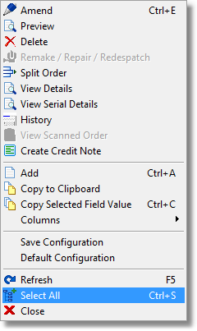
Please note that CTRL+S can also be used as a hot key.

4076. Label Print – Bespoke 33A

If the order of the blinds is changed within the order (by using the ‘Move Up’ or ‘Move Down’ arrows), the labels did not print in the same order as they appear on the form. They now print in the same order.

4077. Wood Usage Report

There is now an option just to print the total for each stock item. This is called ‘Total By Stock Code’ and shows only one record with a total quantity for each stock item.

4078. Fabric Group Update

If the cost price is updated, then the unit cost price(s) in the unit cost tab is also updated.

4079. Stock Items > Duplicate

If a stock code is entered that is already there, it is now kept on the screen so it is not re-entered again.

4097. Sales Files > Customers

There is a column choice for 'Date Account Opened'.

4098. Suppliers

There is a new field for 'Date Account Opened'. It is also a column choice in the ‘Suppliers’ form.

4099. Bought In BOM

There is now a flag on the blind type record to create BOM records for blinds that are flagged as bought in blinds. The flag is called ‘Create BOM for Bought In’ and it only appears if ‘Bought In’ is switched on.

This means when an order is entered or imported a BOM is created if this flag is set to true. The flag defaults to false.

4102. Purchase Order Processing

This is required if Sage 200 Espi is switched on and ‘Use stock Nominal’ is switched on.

Stock nominal transactions are now created when the purchase invoice is posted. As well as a file going into the ‘Purchase Invoice Folder’, there is one that goes to the ‘Stock Transaction Folder’.

There are two stock transactions for each detail line, one going to the cost nominal, which will be a minus number (Cr) and one going to the stock nominal, which will be a positive number (Dr).

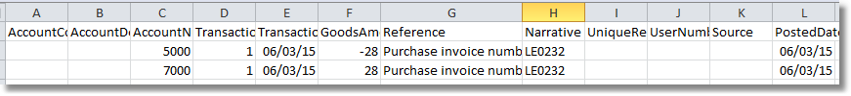

4104. Financials > Post Invoices

If Sage 200 Espi is switched on, only the ‘Print Audit Trail’ and ‘Post Invoices’ buttons are now shown..

4110. Export to ERP

The width and drop now appear in the <ORDERLINEDATA> section and the fields are called <WIDTH> and <DROP>. They are taken from the width and drop that are entered in the order.

4111. Order Acknowledgement Email

If ‘Send Order Ack To Customer Email’ is switched on, then the email is sent to the email address in this field, and not to the ‘Default Email’.

