Blindata Release Note 7.3.2 

6 March 2015

Bug Fixes and Enhancements

5057. Posting Sales Invoices

If Sage 200 Espi is switched on, and if a customer is in a foreign currency, then the csv file now contains the foreign currency amount.

5058. Importing Suppliers/Customers for Sage 200 Espi

It is now possible to import the currency field for customers using column Q.

5059. Importing Customers / Suppliers for Sage 200 Espi

It now looks for a csv file, not a xls.

5060. Financials > Post Credits

For Sage 200 Espi accounting, the credit file now has ‘Credit’ in the second column and ‘CN’ instead of ‘IN’.

5063. Order Processing > Orders

If a base price is zero but there is an option price in a detail line, the detail line can get saved without a warning appearing. This no longer happens – the zero price warning now appears if the base price is zero, not if the net price is zero.

5064. Order Processing > Orders > Order Made

This issue and relates to the stock nominal posting at ‘Order Made’ and the Processes form in ‘Order Enquiry’. If there are processes other than ‘Fabric Cut’ done, an incorrect amount was posted for the stock nominal posting. The stock nominal transaction is made up of the ‘Fabric Cut’ process amount added to the bill of materials amounts for all the other amounts.

5065. Archive Enquiry > Print Bill Of Materials

When you printed a bill of materials, it did not match the cost price in the order. This was because the cost price was being taken from the stock record and not from the stock transaction record. Fixed.

New Work and Customer Requests

4014. Order Processing > Orders

At the moment there is a ‘Self Bill’ flag in the ‘Totals’ tab of the order. If this is set to true, then a new tab now appears called ‘Self Bill Valuations’. In here it is possible to add multiple valuation records with the following three fields: date, description, valuation amount (2 decimal places).

4020. Stock Records

We have had several instances where imported stock records have had tabs and/or spaces at the end of the stock code and the description. Therefore we have created a routine that removes spaces and tabs from the end of stock codes and descriptions. There is now an extra item in Administration > Maintenance called ‘Remove Tabs Etc From Stock Codes’ to do this.

4087. Reports > Purchase Analysis Reports

A new report has been created called ‘Purchase Analysis By Product’. There is now an additional criterium for ‘Delivery Date’ in the ‘Filter by Date’ section. The existing purchase analysis reports have been be adjusted to take this into account.

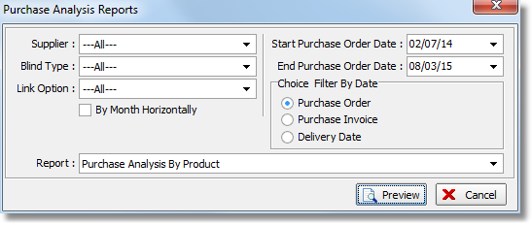

The new report is grouped by supplier, and has columns for stock code, stock description, unit quantity, value (in base currency). There is a total for the value for each supplier.

4088. Suppliers > Purchase Order Enquiry

There is now a column that shows the supplier currency and there is also a net total at the bottom of the form. This means that the records can be filtered by currency to give meaningful totals.

4089. Reports > System Reports > Quotations for Never Bought Customers

There is a new report called ‘Quotations For Never Bought Customers’ that will be exported to a spreadsheet. It shows, between a start quote date and end quote date, each quotation that has been sent to a customer, and that customer has never bought anything ie they have never had a quotation converted to an order.

The spreadsheet shows: quote date, customer company name, contact name, tel number, customer address, email address, quote value.

4100. Order Processing > Orders > Order Manufacture

If ‘Sage 200 Espi’ accounting is switched on, stock nominal transactions are now generated for component detail lines. These transactions have the same layout as the stock transactions that are created in Stock Control > Stock Transaction Entry.

Stock nominal transactions are created when the status changes to 'Order Manufactured'.

