Blindata Release Note 7.3.0 

20 February 2015

Bug Fixes and Enhancements

5045. Order Processing > Orders

An error message appeared if you tried to add a new sales lead in this form. Fixed.

5046. Purchase Order Enquiry > Regular PO > Deliver

When opening a PO, the delivery date column did not display anything, even when a purchase order was complete. When the item is delivered, the delivery date is entered. Fixed.

5047. Order Processing > Quotations > Window Blind Amend > Discount %

- The ‘Discount %’ button no longer updates text lines.

5048. Order Processing > Orders

When adding an appointment, an appointment would not save if the title in order header was not filled. Fixed.

New Work and Customer Requests

3981. Delivery Docket – Netherlands

A new report has been created which is similar to ‘Delivery Docket – France’ but contains Dutch text.

4050. Quotation - Bespoke 37
If “Print Quotation Group Subtotals” and “Display Text Details Only” is checked, the total is now aligned horizontally with the first line of the description.

4062. Order Processing > Orders

There are new fields for surveyor (which should look up ‘Employees’ where Surveyor = true), and a ‘Reqd Week Survey Date’. There are also column choices for both of these.
To accommodate these extra fields, the order entry form has been expanded as follows.

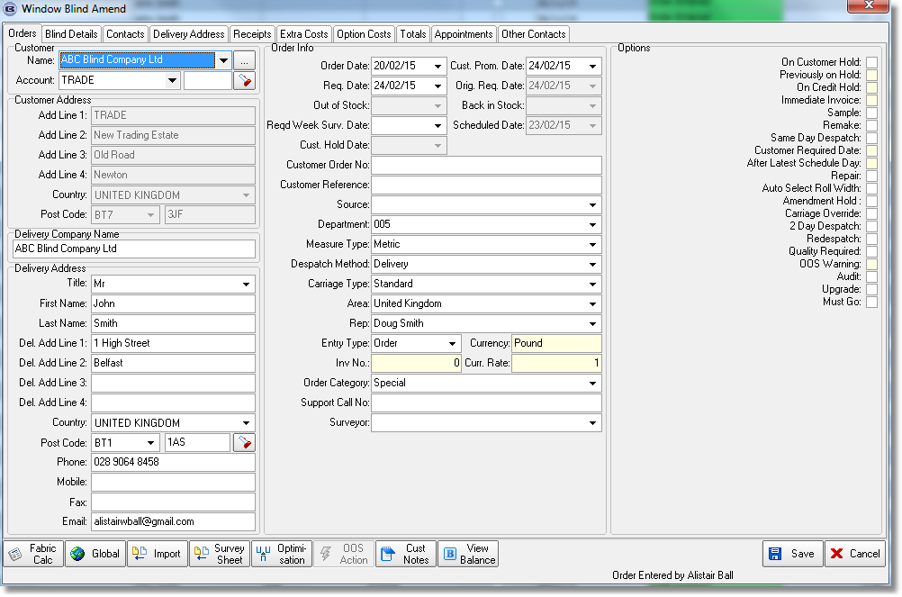

4065. Label Print – Bespoke 37

The ‘Required Date’ and website name are now printed on this label.

4066. Works Order – Bespoke 17a

A new works order report has been created. It is identical to ‘Works Order – Bespoke 17’ except that the blind type has replaced category.

4067. Order Processing > Orders > On Credit Hold

If an order goes on credit hold, an email can be sent to credit control with all the details in it. But if the customer is on stop, only one line of text appeared on the email. If the customer is on stop but the order is allowed through and is not on credit hold, an email is no longer sent, but if it was on stop, then allowed through, but is on credit hold, the email is sent with full details.

4068. Sales Files > Customers > Customer Activity

There are now buttons for ‘Email Invoice’ and ‘Print Credit’ and ‘Email Credit’ on this form.

4069. Label Print – Bespoke 33A

The width deductions now appear for all blind types where box blind = true, in the same way as they are printed for box blinds.

4070. Reports > System Reports > WIP Progress Report

There is a new report called ‘WIP Progress Report’. This will print out records, by either required date or scheduled date, a list of processes already completed and also the outstanding ones.

The report can be grouped by blind type and show the following for each blind type.

4083. Order Processing > Orders

Prompt for order default changes – Dev 3977. If the user clicks cancel when the default pop up appears, the default change is reverted, but the users original change is not meaning the order could have options that are not possible to make. We would prefer that the original change made by the user is undone if cancel is clicked.

The ‘Cancel’ button has been removed for the time being.
4084. Order Processing > Orders > Notes

The carriage returns have been removed from the notes form.

4085. Works Order Label 1 - Zebra Machine
There is now a field on the Blind Type where we can enter the punch code if blind identifier = Venetian and ‘Box Blind’ = false.

There is a new barcode on this report that is in Code 39 format and contains the following:
2 dig. TYPE + 4 dig. WIDTH + 3 dig. SLATS
Eg *011750012* = Type 01, Width = 1750, Slats = 12

4086. Order Enquiry

This related to bug 5001. This was changed so that QC scan was done against the serial detail line rather than the detail line. However, if you created a detail line with a quantity greater than 1, then QC scanned the first blind, and then tried to manufacture scan the same blind (before any other blinds on the detail line were QC scanned), an error occurred. Fixed.

W236. Sub Accounts

Online Sub Account Email Addresses – Not Done.
In Blindata version 7.0.7 we implemented flag called ‘Send Order Ack to Customer Email’ in the Customer record.

3648. Emailing Order Acknowledgements

We have customers that import EDI orders that come from internet companies. The email that is in the XML file is the email for the end user ie the person who has placed the order with the internet company.

For some customers, the order acknowledgement should be emailed to the email address that is held against the customer record and not the email address in the order. Therefore we need a flag in the customer record Email Fields tab called ‘Send Order Ack to Customer Email’.

This request was made by Decora and they would like to implement a version of this asap. They said they would be happy if there was a script written for them so that all orders will have the email order ack sent to the customer email address for ‘Order Ack’ and not the order email.

If this flag is ticked then acknowledgements will always be sent to the Default Email address held against the customer record.

Also the email address has been completely removed from the online order entry if a sub account is used to log in.

