Blindata Release Note 7.2.9 

13 February 2015

Bug Fixes and Enhancements

5039. Purchases > Suppliers > Invoices

The currency that appears in the line is now the currency that is set up in that supplier, not the one that is set up for the nominal code in the detail line.

5040. Export to ERP

A different XML file is now created for each order. Previously if there were multiple orders that were ‘exported to ERP’, they all went into the same file.

5043. Works Order – Bespoke 31

Install height / chain length now print in metric, even if the order is entered in imperial.

5044. Stock Items > Shortfall

The ‘On Purchase Order’ column now appears on this form and is also included in the ‘Shortfall’ calculation. Therefore the shortfall is calculated as Stock In Hand + On Purchase Order – On Sales Order – Reorder Level.

New Work and Customer Requests

4024. Administration > Parameters

The ‘Update Schedule Time By Process’ parameter flag was not working properly.

If ‘Update Schedule Time By Process’ = false, then it always uses the average manufacturing time in the blind type record as the time in scheduling.
Even if there are process times entered against the blind type, they will not be used at all and a detail line will be always scheduled to the man. location selected against blind type record.

If ‘Update Schedule Time By Process’ = true, then it always uses the time held in Blind Types > Process Times as the time in scheduling.
In this case the scheduling won’t look at the average manufacturing time and the manufactured location against blind type record.
It will be scheduled in the man. location(s) entered against process times records and the man. time will be calculated from the process times records only.

4039. Order Processing > Orders > Additional Prices

It is now possible to have an additional price added to the order based on certian link options being selected.

This means that when an order is saved, it is possible to automatically add a detail line with a price, a bit like the way a carriage line can get added when an order is saved.

It is possible to identify an option choice that should have an additional price added. This can be done by entering ‘ap’ (for ‘Additional Price’) in the ‘Special’ field in the stock record. We also need to hold the order value over which the additional price will be applied. This is done by entering the ‘Additional Price Limit’ field in Administration > Parameters > Order/Quotation Defaults.

We then need to hold a stock record that will be used in the order detail line that is added. This can be done by creating a new link option with the code ‘Additional Price’.

4040. Order Processing > Orders > Size Restrictions

Previously there was only a a ‘Minimum Width’, ‘Maximum Width’, ‘Minimum Drop’ and ‘Maximum Drop’ held against the blind type record. If the sizes fell outside these parameters then a message comes up saying that the blind cannot be made.

This has been extended so that it can look up a table of sizes. There is a new tab in the blind type record called ‘Size Restrictions’, where multiple size restrictions can be held, including extra restrictions if specific options are chosen.

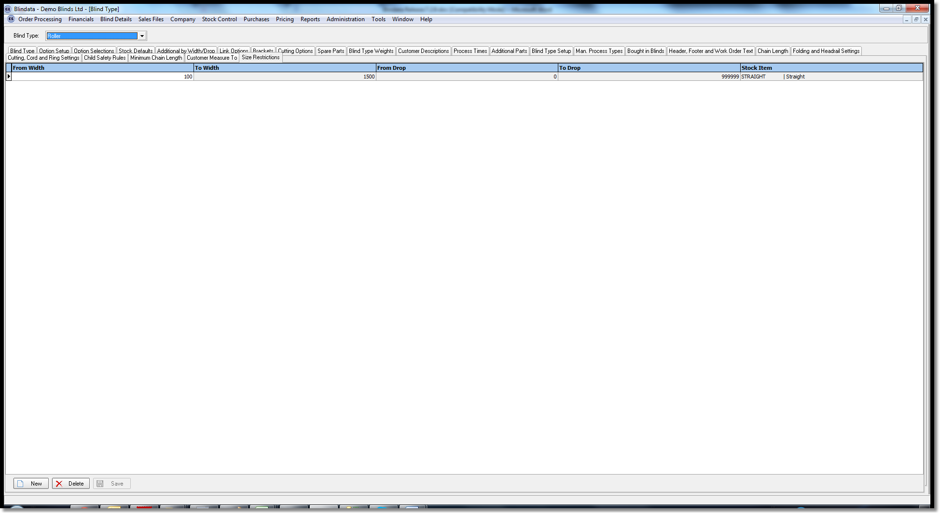

4044. Financials > Invoice Batch Print

‘Fax Only’ is not required anymore so it has been removed from this form.

4046. Stock Nominal Transaction Posting

If the ‘Stock Nominal’ flag is switched on in Parameters for Blindata Accounting, when a MI or IP financial transaction is posted, the sales order number goes into the reference field.

4047. Picking List – Bespoke 37

The ‘Required Date’ now appears in the header of this report.

4049. Purchases > Purchase Order Enquiry - Sent to Supplier
The ‘Send’ flag is not editable, but there is now an option to re-send the purchase order. However a message also appears saying ‘This PO has already been sent. Are you sure you want to re-send it?’. If it is re-sent, then a history record is written.
4051. Purchase Order Enquiry (related to 3913)
With the new PO GRN Scan and PO Invoice Scan buttons, files that are named with the PO number are automatically linked to the PO. However, this limited the number of files per button to 1 per order number. This has been modified to look at files based on a prefix in the file name. For example, a file could be named “1097 invoice1.pdf” and “1097 invoice2.pdf” and both will show up when the scan button is clicked.
4052. Order Processing > Quotations

When adding a new quotation and selecting a project, the drop down project list is now in reverse chronological order ie. shows the latest one first.

4053. Order Processing > Quotations

Rather than coming out of a quote and pressing ‘Print Quote’, it is now possible to preview the quote whilst still in it, so there is a ‘Preview Quote’ choice in the ‘Window Blind Amend’ form context menu (right click on the ‘window Blind Amend’ form to see this).

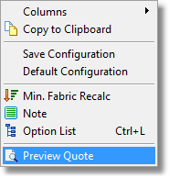

4054. Order Processing > Quotations

It is now possible for the Autotext product entries to be linked to a selected product i.e. if you select a particular roller blind for example, the autotext will automatically appear. To do this we now hold a related quote text against a product, and when you save a blind detail line, it adds the related quote text as a detail line as well, but only once for a blind type (because you will normally enter multiple blinds of the same type).

The related autotext records can be added in Blind Types > Image/Texts.

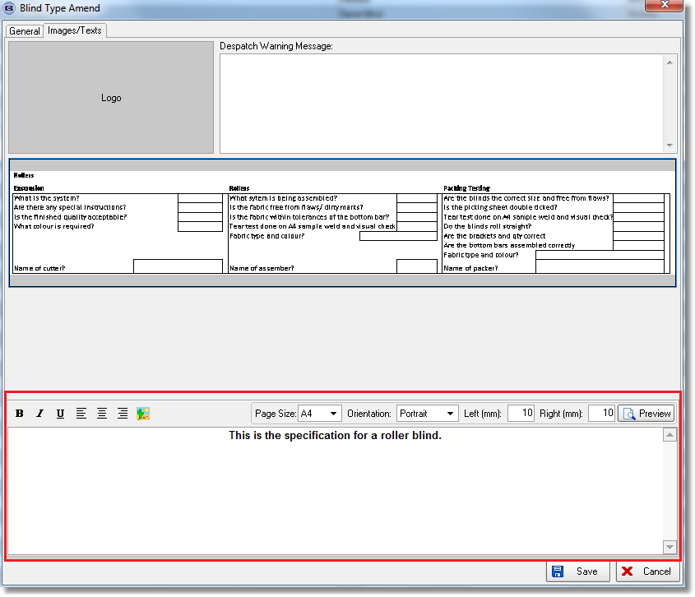

4056. Order Processing > Quotations

When you log in or do CTRL/T, the system brings up the contact records for that user. It now defaults to bringing up the contact records where the current date = ‘Next contact Date’ (for quotations) or ‘Action Date’ (for orders). Also, the ‘Next Contact Date / Action Date’ column is also shown on this form.

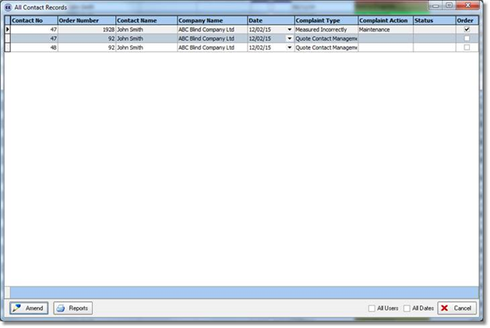

4057. Order Processing > Quotations

When entering a quote and saving for the first time, if Contact Management appears, it is now mandatory to enter something rather than having the option to cancel. There is a new parameter for this called ‘Mandatory Contact Record’ which defaults to false.

4058. Order Processing > Quotations

If ‘Auto Create Quotation Contact Record’ flag is set to true, a Contact management record is now created automatically which says Quote Required (in the text field), with ownership defaulting to the rep. This is created as well as the contact management record that is brought up when a quote is saved for the first time.

4059. Order Processing > Quotations

The ‘Cust. Promised Date’ has bene changed to say ‘Quote Reqd By’ in the quotation entry, and this date is now used as the ‘Next Contact Date’ in the contact management record generated in dev 4058.

4063. Acknowledgement – Bespoke 20

The ‘Install Height’ and ‘Chain Length’ now print on this report.

4064 Reports > System Reports > Order By Operator (Detailed)

The number of blinds and blind type now print next to the order number.

