Blindata Release Note 7.2.8 

6 February 2015

Bug Fixes and Enhancements

5033. Sales Files > Reports > Statements

When you tried to email the A4 Statement With Running Total, and error message appeared.

5034. Stock Control > Reports > Stock Usage Report

The ‘Stock In Hand’ column now says ‘Current Stock In Hand’.

5035. Purchases > Suppliers > Invoices
When a non-inventory invoice was created for a supplier set up in a foreign currency, the currency defaulted to base currency. It now defaults to the supplier currency.
5036. Sales Files > Customers > Invoice

If an invoice is entered, the currency that is set up against the customer is used.

5038. Order Enquiry > Processes

This form has become very slow at a customer site. To resolve this, it is now possible to archive records including processes (this can be done in Administration > Parameters).

New Work and Customer Requests

4030. GRN Report

It is now possible to print out a GRN from Blindata. This can be printed from the ‘Purchase Order Stock Delivery’ form. There is a new button called ‘GRN Report’, and it prints out a report for the GRN record that is being pointed at.

The report has a header with the supplier company name and address, GRN, delivery date, then a detail section containing stock code, stock description, supplier part no, quantity received, quantity ordered.

4035. Order Processing > Orders

It is now possible to export all orders to a specific location in a XML file format.

Therefore there are two new fields in Administration > Parameters > Automated Tasks called ‘Export Folder’ and ‘Check Every … minutes’. The first field holds the folder the XML files are being exported to and the second field holds the time interval for when the files are exported.

Once an order has been exported, it is not possible to export it again.

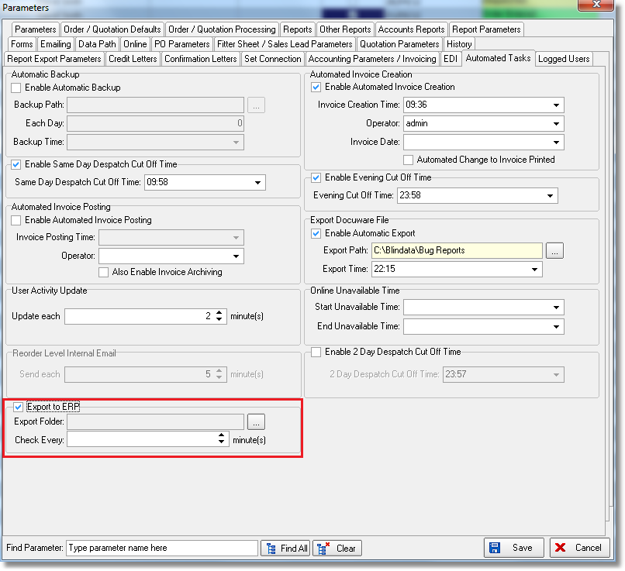

Also, this advanced permission should be switched on.

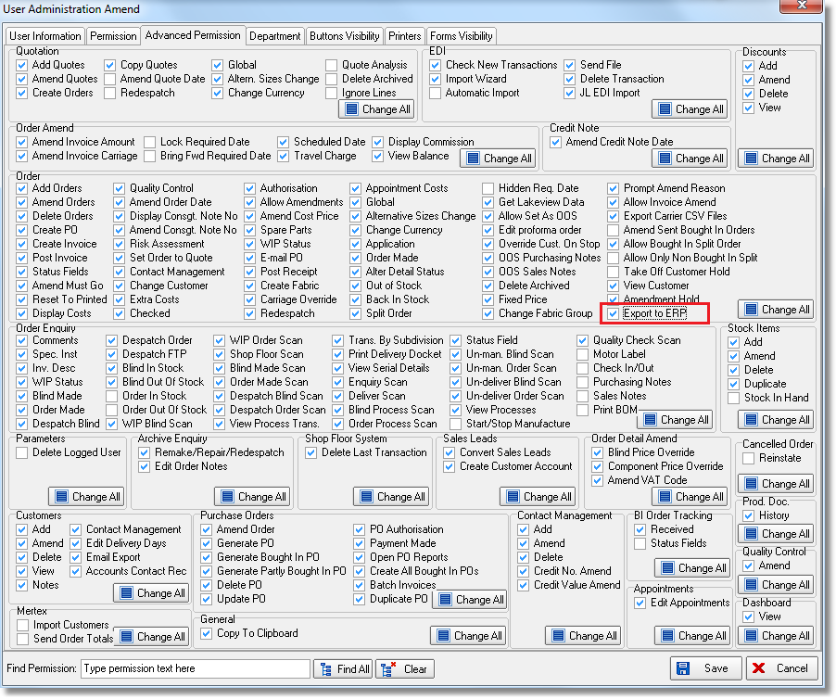

4037. Order Processing > Orders

Some customers have a lot of braid options stored in Blindata, and this can sometimes mean holding a very large number of braid option prices. There is now a solution to this because they can be stored in ‘option price groups’ and then priced by option price group.

The following needs to be set up.

Create at least one option price group in Administration > System Tables > Option Price Group.

Enter an option price groups against braid records ie in the stock record.

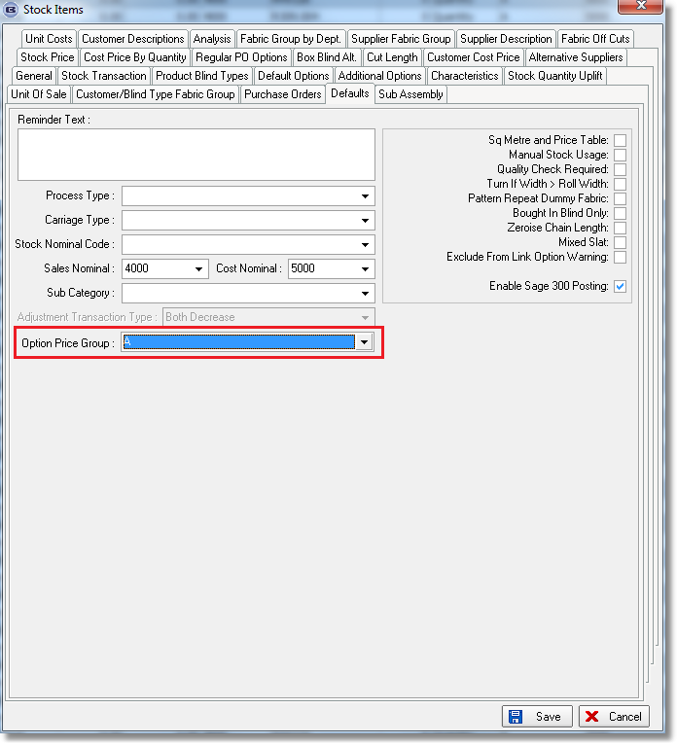

Enter this option price group in ‘Option Price Enquiry’ so that if anything in that price group has been selected (ie another option) it will be priced that way eg a scallop finish with a braid on it (but the braids could fall into 3 different categories).

Changes Made

There is a new field in the stock record called ‘Option Price Group’, which is a character field.

There is a new field in ‘Option Price Enquiry’ called ‘Option Price Group’. This is not a mandatory field and all existing option price records work as they currently do.

When option pricing is done, the option price method checks to see if any of the options selected have an option price group, and if so, see if there is an option price record that matches.

For example, we could have 3 braid records set up in stock, with stock codes BRAIDA, BRAIDB and BRAIDC, with option price codes A, B and C respectively.

Let’s say there is a different option for finish and one of the choices is ‘Straight with Braid’. Thi actually has different prices depending on which braid is selected, so in ‘Option Price Enquiry’ there will be 3 option price records set up, for option price groups A, B and C.

4041. Stock Items > Stock Enquiry

‘Scrap Allowance %’ is now a column choice.

4042. Stock Usage

There is a new parameter in Parameters called ‘Include Scrap Allowance In Stock Usage’, which defaults to false. If it is set to true, when stock usage is calculated in stock transactions it includes the scrap allowance %, then when stock is reduced, it is reduced by the amount that includes the scrap allowance.

If this new parameter is switched on, then ‘Include Scrap % in cost’ is switched on as well.

4043. Sales Files > Customers

Previously ‘Address Line 2’ was a mandatory field if the ‘Postcode/ZIP’ choice was set to ‘UK Postcode’. This is no longer a mandatory choice

W234. Quotation / Order Acknowledgement Print

The prices were not showing on this report. They are now shown regardless of whether there is discount or not.

