Blindata Release Note 7.2.7 

30 January 2015

Bug Fixes and Enhancements

5025. Order Processing > Orders

The multi blind check is now working properly for imperial orders (‘Use Imperial’ = true in Parameters).

5026. Label Print – 5161 + others

An error message was appearing on this label print and others that print to A4 size paper. Fixed.

5027. Roll Out Production Report

The contact name that appears is now from the sales order, not the customer record.

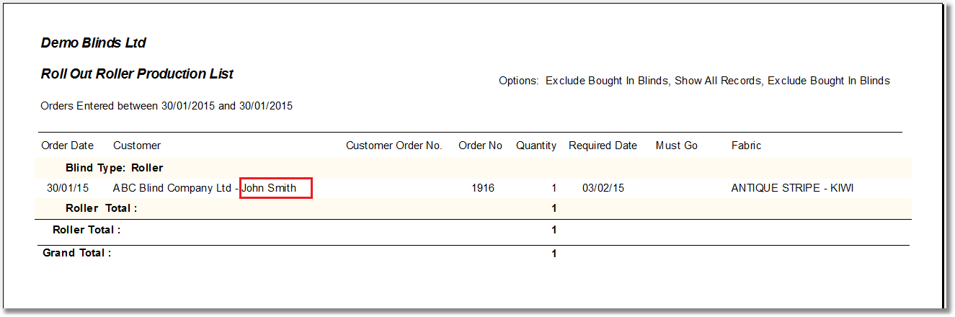

5028. Purchase Order Regular – Bespoke 34

The footer text now appears in the bottom left.

5029. Sales Files > Customers

In one customer database there are some customer records that had been copied to new customer records (using ‘copy’ in Customer Enquiry), and they had the same address id. When you went to change an address in one record, it changed in another record. Fixed.

5032. Label Print – Bespoke 33A

The blind type description is now a bit longer on the main label.

New Work and Customer Requests

3986. Sage 300 Integration (Finished)

The ‘Update Stock Item from Sage 300’ routine is now available with time intervals between updates.

The ‘Update Customers from Sage 300’ routine is is now available with time intervals between updates.

The database connection for Sage 300 is now available to edit.

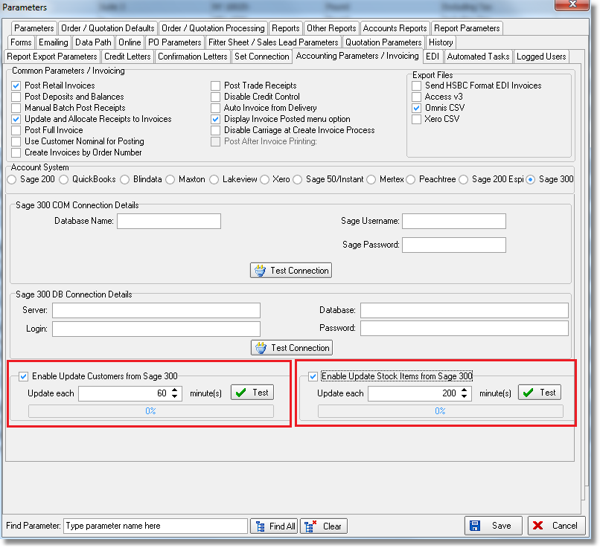

At the Order Entry stage the credit limit and balance are taken from Sage 300 (when Order is saved). However, if the customer is on hold in Sage and not updated in Blindata, it meant the customer was still not on hold in Blindata. It now puts an order on credit hold if it is on hold in Sage.

The ‘Adjustment Posting’ routine is running at the ‘Order Manufacture’ stage (‘Order Amend Enquiry > Order Made’). It is now possible to exclude blind types – there is a new field in the blind type form called ‘Enable Sage 300 Posting’. It is also possible to exclude stock records - there is a new field in the stock record form called ‘Enable Sage 300 Posting’.

4019. Contact Management

There is now a separate button on the Customer form, ‘Accounts Contact Rec’, that has an Advanced Permission flag and a Buttons Visibility flag. Therefore it is possible only allow accounts users to see this, and only allow accounts users to view these contact records.

4026. Purchase Order Enquiry

There is now a confirm flag held against the Purchase Order Enquiry. There is a new button on this form called ‘Confirmed by Supplier’ (or ‘Confirmed by Vendor’ in USA or Canada).

This new flag is also a column choice on the ‘Purchase Order Enquiry’ form. When the button is selected, a message appears saying ‘Has this PO been confirmed?’. If ‘Yes’ is selected, then the field is set to true and a ‘PO Confirmed’ PO history record created. It can only be confirmed if the field is false.

4028. Purchases > Purchase Order Stock Delivery

There is a new menu option called ‘Purchase Order Stock Delivery’. This appears below ‘Purchase Order Enquiry’ in the Purchases menu. The purpose of this new form is to allow a user to select a supplier, which will then display all the outstanding regular PO detail lines for that supplier. The user will then be able to select detail lines from multiple regular purchase orders. This is required because quite often suppliers will send out more than one PO delivery at a time and they will both need to be delivered at the same time.

Once the supplier is selected, records are displayed with the following columns:

PO Number, PO Date, Expected Delivery Date, Revised Delivery Date, stock code, suppler part number, stock description, and all the other column choices that are available in Purchase Order Enquiry > Amend. There are also column choices, related sales order numbers, save configuration and default configuration choices in the context menu. There is also a ‘Copy to Clipboard’ option on the context menu.

When the detail lines are first displayed for the supplier, they can be filtered to only show outstanding records ie not delivered. But it is also possible to unfilter the records so all detail lines can be shown – although we have restricted this to between dates – same as ‘Purchase Order Enquiry’.

4029. Automatic GRN

There is now an option to automate the GRN number. There is a new parameter in Parameters > PO Parameters called ‘Automatic GRN’, which defaults to false. There is also a new field for ‘Next GRN’.

If ‘Automatic GRN’ is set to true, then when goods are selected and delivered in ‘Purchase Order Stock Delivery’, the next GRN is used instead of it being entered manually.

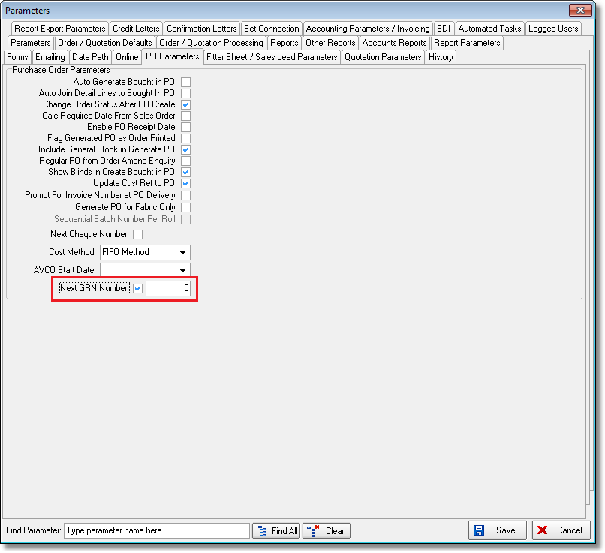

4034. Administration > Import From Excel > Fabric Off Cuts

There is a new button on this form called ‘Import Fabric Off Cuts’. When selected, the user will be able to import a spreadsheet of fabric off cuts. The spreadsheet contains column headings and columns for stock code, width, drop, location, rotation (this field not mandatory).

