Blindata Release Note 7.2.6 

23 January 2014

Bug Fixes and Enhancements

4830. Sales Files > Customers

It is now possible to remove the content in ‘Invoice Terms’ from a customer record. Previously once something was saved (for example, accidently) in this field, it could not be removed. The ‘Delete’ key will now do this.

5013. Purchase Order – Bespoke 34

- Make stock code column wider so 35 characters will display, showingstock code / supplier part no.
- Print as many description characters as we can – so this field now displays all the way across to just before ‘Unit of Sale Quantity’.
- Moved ‘Free Text’ down to the next line and started it in line with the stock code – it can print across the just before ‘Unit of Sale Quantity’.
- The unit price now prints.
- The notes box has been reinstated.

5017. VAT Report > VAT Report Detailed

VAT Box 3 is now 4, 5 is 7, 4 is 6. Numbers now match the summary report.

5019. Purchase Payment Optimisation

The purchase payments functionality has been optimised.

5022. System Tables > Currency Types

When you tried to add a currency, an error appeared. Fixed.

5023. Order Processing > Orders

The Multi blind width check was wrong for imperial measurements. Fixed.

5024. Production List > Production Roll Out Report

If scheduled date is selected, it now shows the scheduled date instead of the required date in this report.

New Work and Customer Requests

3986. Sage 300 Integration (Partly)

We have introduced Sage 300 integration for sales invoicing and customer updating. There is a new option choice in Administration > Parameters > Accounting Parameters called ‘Sage 300’.

The following fields then need to be set up.

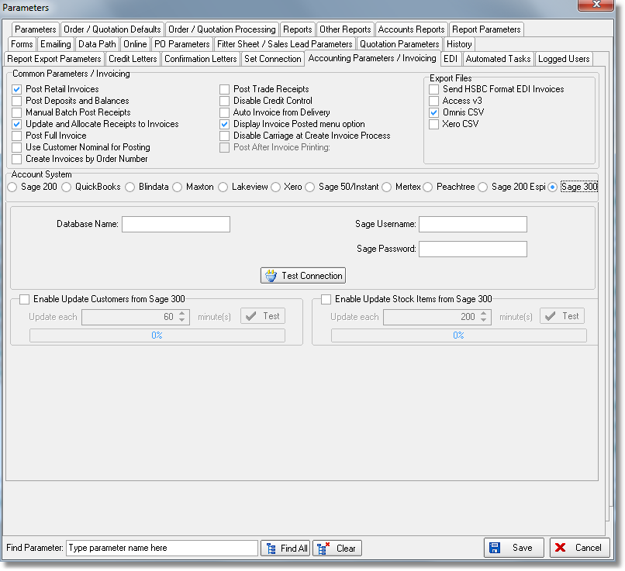

PS: Inventory integration is not completed. We have implemented Sales Invoice Posting, Customer Update and part of Stock Item Update. We have added advanced permissions for automatic routines (customer update, stock item update). The credit limit will try to connect to Sage 300 and give actual data (this might influence on the performance).

4002. Projects

- Successful S/C (Sub Contractor) – this is a lookup field, which looks up a new system table called Sub Contractor.
- Specified Products – a new lookup field has been inserted above ‘Specified Products’. A new system table called ‘Manufacturer’ can now be looked up for this.
- Tender Type and Contract Type are no longer mandatory.
- There is an ‘Add’ button beside the ‘Architect’ lookup so architects can be added without leaving the Projects form.

4005. Orders > Contact Management Internal Email

When an internal email is sent in contact management, it now shows order number, project name, type, action, status, further details, action required, action date on the email that is sent as well as the current text that is already sent.

It is also now possible to cc emails to multiple people. We therefore need a way of selecting other employees in the contact management record.

We need to display the operator in the form (same as quote contact management does).

We also changed ‘Employee’ in top right to be ‘Negotiator’ (or ‘Rep’ or ‘Salesperson’ depending on Parameter > Rename Rep To setup) and made readable only.

4006. Quotations > Contact Management

When internal email is sent, it now have project name, quote number, text, next contact date, as well as the current text that is shown.

4007. Quotations > Contact Management Reports

The ‘Live’ choice is no longer shown if Projects switched on.

4008. Order Processing > Quotations

When ‘File Attachments > Add’ is clicked, a folder name is created which is the quote number (if it does not already exist). This folder name will be created within the folder that is set up in Company Details > Attach Docs Root Location’.

4010. Administration > Parameters

When doing a ‘Find’, the tabs are highlight in green as well as text. Previously it was not easy to find fields if they were in other tabs.

4011. Quotations > Create Order

Previously, if ‘Survey Required’ was set to true, you cannot convert the quote to an order. There is now a new parameter called ‘Convert to Order Ignoring Survey Required’. If this is set to true, the ‘Survey Required’ button is now displayed on the order entry form.

4012. Order Processing > Orders

There is now a column choice for Project in the ‘Order Amend Enquiry’ form. Also the Project name is shown in the order (in same place as quote).

4015. Order Processing > Orders > Detail Line Import

A column (L) has been added in the detail line import for ‘Install Height’.

4018. Credit Control Email

Previously the text only said ‘Order 0 has been placed on credit hold’. It now shows order number, customer account code and name, order value, amount credit limit is exceeded by, credit limit, customer balance.

4022. Blind Process Scanning

The fields are now shown in employee, process, blind scan order.

4023. System Reports > Reports

There is a new report called Production Process by Employee by Date Detailed which prints by employee that shows individual processes.

