Blindata Release Note 7.2.5 

16 January 2014

Bug Fixes and Enhancements

5007. EDI Import

The EDI import now takes fullness ratio into account for curtains.

5009. Sales Files > Post Receipts

The way ‘Post Receipts’ works if a discount is being entered has been changed. Previously when you entered the discount amount, it reduced the ‘Receipt’ amount by the amount of the discount.

The receipt amount and the discount are now added together to give the amount that is being posted against the invoice. The amount that gets posted to the bank is the receipt amount and does not include the discount. The discount amount gets posted to the discount nominal account.

5010. Stock Control > Reports > Stock Take Report

The columns in this report have been adjusted to stop overlapping and the font has been changed to Arial 8pt.

5011. Suppliers > Invoice

A nominal code error occurred when you tried to post a manual purchase invoice. Fixed.

5012. Suppliers > Invoices

It is now possible to edit the VAT amount in a manual purchase invoice and credit note. Previously when the record was saved it reverted back to the calculated figure.

5014. Label Print – Bespoke 50

The small top hand label has been moved 2mm to the right.

5016. Sales Analysis by Blind Type by Month (Value/Quantity)

The total figures overlapped each other so the font has been made smaller.

New Work and Customer Requests

3983. Order Processing > Orders

There is new functionality called '2 Day Despatch'. This works similarly to thee same day despatch functionality, the difference being that ordering before the cut off will set the required date to the next working day and ordering after the cut off will set the required date to the day after the next working day.

This means there is now a new flag in the order entry called ‘2 Day Despatch’. There is also a new flag in the customer record called ‘2 Day Despatch’. If this flag in the customer record is not set to true, then it is not possible to set the ‘2 Day Despatch’ to true in the order.

3985. Box Blind Functionality

The way the box blind functionality works in relation to the number of slats that have to be added or removed from a blind has been redesigned. This is because it did not work for box blinds that were purchased with only one drop.

There is a new flag held against the blind type record called ‘Single Box Blind Drop’, which defaults to false.

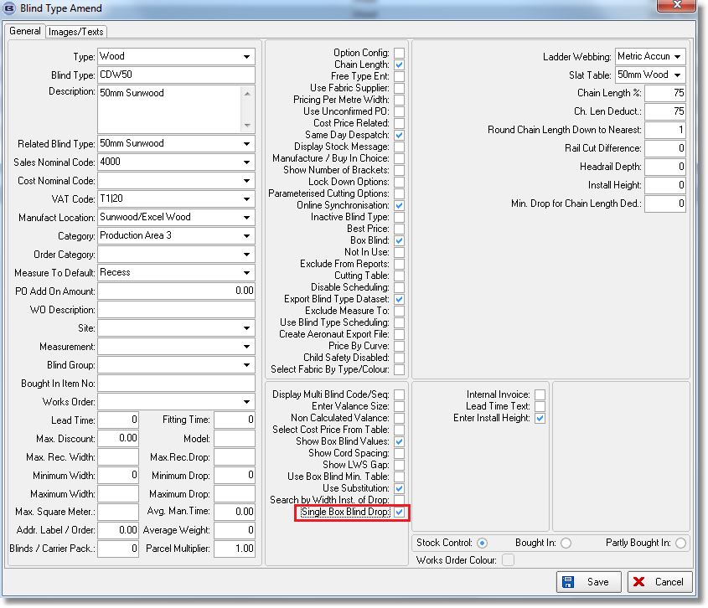

If this is switched on, the program will not look at the ‘Box Blind Minimum Width’ and ‘Box Blind Slat’ tables for the ‘Slat Add/Deduct’ calculation.
Instead of that it will find the relevant record in the ‘Box Blind’ system table depending on what box blind option is selected in the detail line.
If a record is found in the ‘Box Blind’ table, the ‘Drop’ value will be used for the calculation.

3993. Stock Usage Report

It is now possible to filter this report by Link Option in the same way that the Stock Take Report does.

3994. Auto EDI Download

An Auto download start time field has been added. This is called ‘Auto Start On Hour’ and is a tick box in the Parameters EDI tab. If set to true, then it will start at the start of an hour eg 1100. If ‘Check for new transactions automatically’ is set to 15 minutes, then the import will be done at 1100, 1115, 1130, 1145, 1200, 1215 etc.

3995. Stock Shortfall Report

It is now possible to generate records for a ‘Stock Shortfall Report’. There is a new button on the ‘Stock Enquiry’ form called ‘Shortfall’ which generate a form showing what stock is required. This l ignores the ‘Stock Held In House’ and ‘Purchase Order Generation’ flags and looks at all stock records (that are not inactive). There is then be an option to print the records that are in the form, along with the fields.

The records will print out in supplier then stock code order. There is also a choice of which columns to print. This will also look at filtered records.

It will show all stock records with Not In Use = false and where Stock In Hand value < Re-Order value.

3996. Roman Blind Fabric Optimisation

It is now possible to do fabric optimisation for roman blinds. This means that it is possible to optimise fabric for roman blinds and there is also be a flag ‘Optimise Fabric At Order Entry’ in the blind type record if blind identifier = Austrian/Roman. Therefore all the functionality that exists for optimisation in roller blinds at the moment also work for Roman blinds.

3997. Roll Out Production List

Contact name is now in this list, and also an option to print in fabric description order within blind type.

3998. Sales Analysis By Fabric Class

Net price has been added in this report.

3999. Stock Valuation Report

If stock is negative, it is now show as a zero value stock.

4016. Despatch Method > Extra Long Length

There is now functionality in the system to hold an ‘Extra Long Length’ field as well as ‘Long Length’. For example, a customer may want to send out blinds using the following carriers.

Standard Lengths (up to 1.9mts) – Main Courier
Long Lengths (1.9mts to 3mts) – TNT
Extra Long Lengths (3mts +) – Tuffnells

This functions exactly the same way long lengths do now, but the system now checks if it is a ‘long length’ or an ‘extra long length’ and assigns the relevant despatch method.

To do this, there is a new field in the Parameters form Order/Quotation Defaults tab called ‘Extra Long Length Width’.
There is also a new field on the Despatch Method form called ‘Alternative Extra Long Length’. This holds the extra long length alternative despatch method.

