Blindata Release Note 7.2.2 

29 December 2014

Bug Fixes and Enhancements

New Work and Customer Requests

3925. Import Projects and Quotations

It is now possible to import projects and order enquiry headers into Blindata in Administration > Import From Excel.

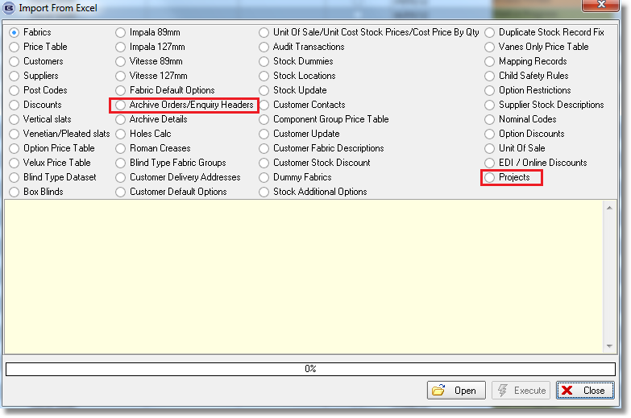

3954. Contact Management

There is a new parameter called ‘Email Contact Record Details to New Owner’ in Administration > Parameters that defaults to false.

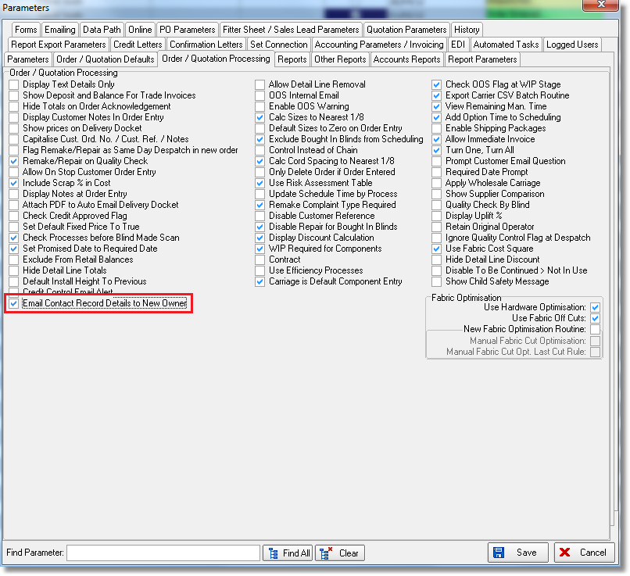

If this new parameter is set to true, there is an option to email the new owner of the contact record, in both quotation and order contact records, and for purchase order contact records as well. It also applies to customer and supplier contact records.

If the owner of a new contact record is changed, an email is sent to that owner stating that they now have ownership of the record. The message says ‘You now have ownership of contact record nnnn in quotations/orders/customer name/supplier name’.

3955. Fabric Off Cuts

More functionality has been added to ‘Fabric Off Cuts’.

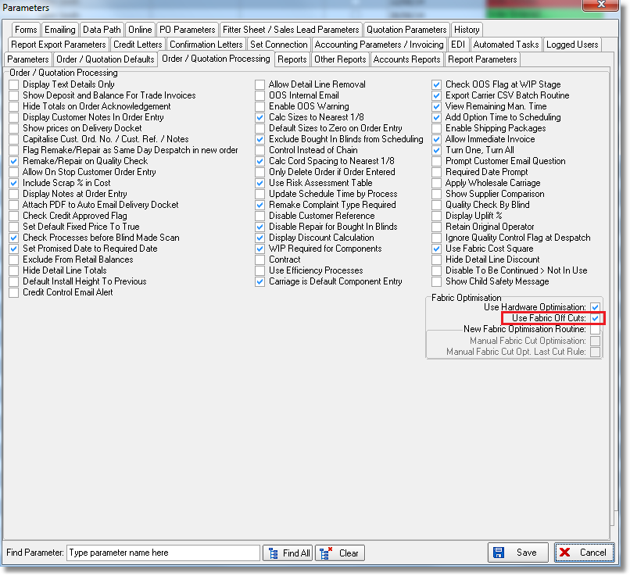

At the moment a flag is held against the blind type record called ‘Use Fabric Off Cuts’ to say if they are used or not. But this means they then apply to all fabrics in that blind type. It is now possible to specify that only certain fabrics will hold fabric off cuts.

There is a new flag against the stock record called ‘Use Fabric Off Cuts’. Regardless of whether the ‘Use Fabric Off Cuts’ is true or not, if it is set to true in the stock record, then fabric off cuts will be used. The rule should be that if it is set to true in the blind type record then fabric off cuts are held, but if false then only those stock records with the flag set to true will be used.

The new flag is also now a column option in ‘Stock Enquiry’ and it is also possible to import the field in Administration > Import From Excel > Stock Update.

There is a new report in Stock Control > Reports called ‘Fabric Off Cuts’. This lists by fabric, the off cuts that exist. It shows group no, date created, width, drop, location.

At the ‘Order Made’ stage, it is now possible to amend the width and drop of the record that is being stored.

There is another new report in Stock Control > Reports called ‘Fabric Off Cuts Matching’. This will look at all blinds that have not yet been manufactured and check to see if there is a piece of fabric that can be used to make a blind. The report only shows detail lines where there is a match, and shows order no, order detail id, fabric description, width cut, drop cut, group no*, location*, width*, drop*. (* = from ‘Fabric Off Cuts table).

If a fabric off cut is used, then we need a method of recording this. This work will be done in a new development item in the ‘Bill of Materials’ View in ‘Window Blind Amend’.

3960. Blind Details > Blind Types > Customer Measure To Defaults

It is now possible to hold default customer measure to records in Blind Types. If there is a record in here, then it will be used in order entry and in the EDI import.

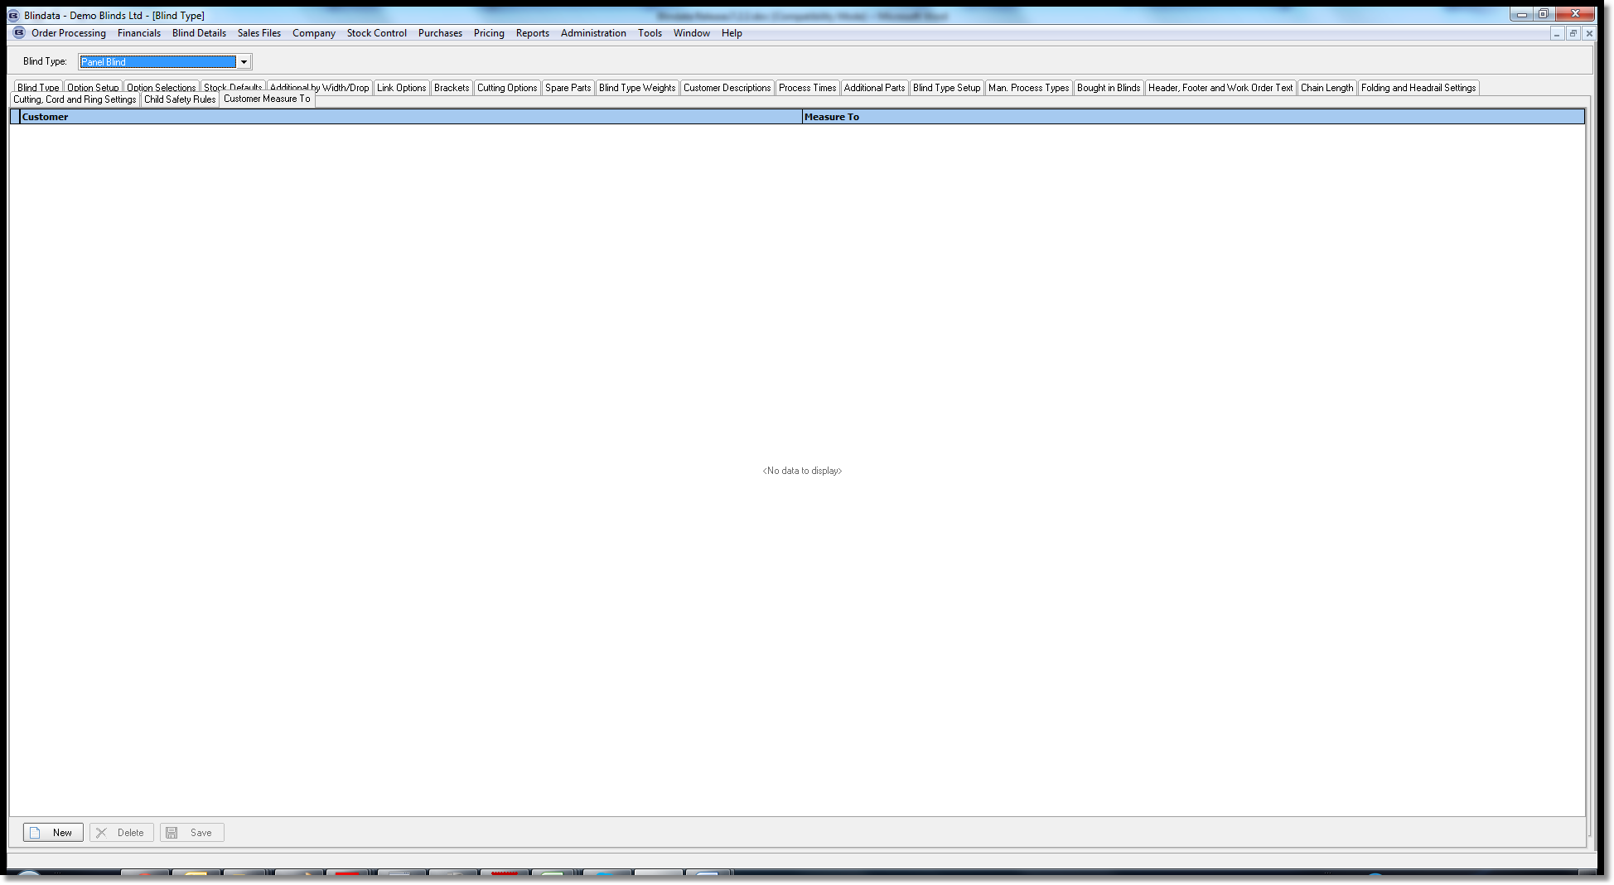

3961. Reports > Wood Usage Report

As well as by order, it is now possible to group this report by stock code and only show totals used between dates.

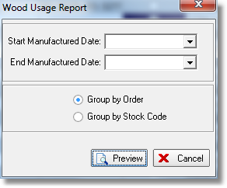

3962. Daily Status Report

There is now a disclaimer on the bottom of the report which says: ‘Please note that information for orders with status ‘Order Entered’ or ‘Order Printed’ may not be up to date’.

3963. Order Processing > Orders

If there are more customer notes than the size of the ‘Customer Notes’ form, a scroll bar now appears.

3966. Blindata Synchro

This program can now only be run once at a time ie it cannot be started if it is already running.

3971. Purchase Order Regular – Bespoke 34

There is a new report based on ‘Purchase Order Regular - Bespoke 31’, called ‘Purchase Order Regular – Bespoke 34’. The blind type grouping has been removed, but it now prints notes for detail lines and prints cost price.

3972. Order Processing > Orders > Import

When importing a line in ‘Import’ if the blind is too big ie the width is bigger than Blind Type > Maximum Width or drop > Blind Type > Maximum Drop, a warning message appears.

