Blindata Release Note 7.1.8 

28 November 2014

Bug Fixes and Enhancements

4924. Processes
Sometimes if there were several serial details to be completed at once (i.e. with one batch number), some serial details did not change to “Completed”, but the cut length of those records changed to either 0 or a few inches. Fixed.
Stock Items > Stock Transaction tab:
If the detail lines were not completed, the status of the order would not change to ‘Order Manufactured’. Fixed.
4946. Order Processing > Orders

One product at a customer site (LC200) had ‘on sales order’ going into negative amounts. Fixed.
4970. Costs of Goods Sold
The Cost on the Bill Of Materials report was not the same as the Cost displayed in the Totals tab in a quote/orders if ‘Cost Square’ was switched on. This was happening with component detail lines. Fixed.
4971. Order Enquiry > Processes > Fabric Cut Process & Stock Transactions
When the amount used was greater than the amount held against the batch and the user clicked OK to update the batch quantity, the calculations of On Sales Order, Stock in Hand, Batch Quantity and the Stock Transaction record were incorrect. Fixed.
4973. Quotations > Contact Management

Text box is now expanding.

4974. Survey Sheet

It was not displaying the surveyor properly – it is taken from the appointment.

4975. Quotation – Laser Print (Letterhead)

The tops of the detail lines are now printing properly on the printed version.

4976. Acknowledgement – Laser Print (Letterhead Logo)

The ‘Measurement’ and ‘Spec Ins’ fields were overlapping the options – fixed.

New Work and Customer Requests

3913. Purchase Order Enquiry

There are now buttons for scanned delivery notes and scanned invoices. These are linked to specific set up folders.

There are two new folder choices in Administration > Parameters > Data Path, called ‘PO Delivery Note’ and ‘PO Invoice’. The current text of ‘Scanned Documents Folder’ has been renamed ‘Sales Invoices’ and the section is now called ‘Scanned Documents Folder’.

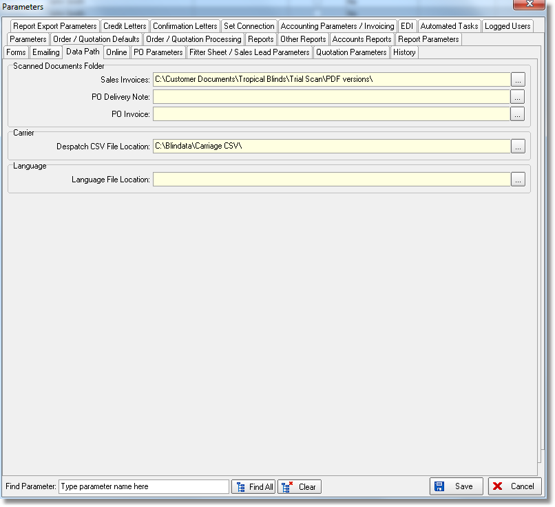

The new buttons in ‘Purchase Order Enquiry’ are called ‘PO GRN Scan’ and ‘PO Invoice Scan’. The scanned documents will be given the same number as the PO number so when the relevant button is clicked, the PO that is being pointed at will display the relevant document.

3933. Order Processing > Quotations

There is a new button on this form called ‘All Contact Records’. This shows the same form that is shown when logging on to Blindata (if ‘Display Current Order Contact Info’ or ‘Display Current Quotation Contact Info’ is switched on).

3934. Reports > Sales Analysis

There is a new report choice that just sends information to a spreadsheet. The report is called ‘Sales Analysis Export’, but there will be no print preview – it saves to a spreadsheet called ‘Sales Analysis Export’ instead.

3935. Invoice – Bespoke 2

There is now a choice for this report in Parameters > Report Export Parameters > PDF Invoice and PDF Batch Invoice.

3936. Multi Blinds

The multi blind functionality has been improved so it can now be used by all blind types, not just wood blinds. If the blinds that are part of the multi blind are not wood blinds, the functionality to calculate the cord spacing on a multi blind head rail is not applicable.

The original spec was to create a blind identifier = ‘Multi Blind’.

If a blind type is entered that has blind identifier = ‘Multi Blind’, then the user can set up the ‘Gap Between Blinds’ and also switch on a flag to check that the widths of the sub blinds and the gap add up to the overall width.

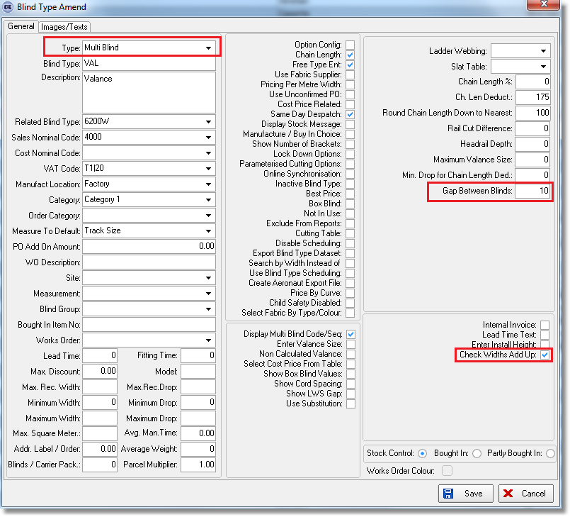

If this was set for a blind type, then when an order detail line was entered, the user had to fill in these two fields (which display if blind identifier = Multi Blind).

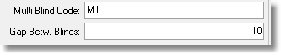
If ‘Display Multi Blind Code/Seq’ is set to true in any other blind type (all except those where blind identifier = Multi Blind), then when an order is entered for a blind type that has ‘Display Multi Blind/Code Seq’ = true, the following fields appear:

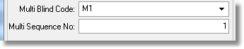
But these fields only appear if there is already an order detail line which is for a multi blind.

If ‘Check Widths Add Up’ = true, and the widths do not add up, the error message now gives more information and will say, for example:

‘The multi blind width does not match the sum of the widths and gaps for the sub blinds.
M1 = 1800, M1-1 + gap + M1-2 = 890 + 10 + 890 = 1790.
Please adjust the relevant figures’.

