Blindata Release Note 7.1.5 

10 November 2014

Bug Fixes and Enhancements

4926. Order Processing > Bill Of Materials Report
For component detail lines, the quantity was not appearing properly on the bill of materials report, but was calculated correctly in the BOM.
4940. Order Enquiry > Work In Progress (re-release of 7.1.1)

A prompt now appears when changing an order from WOP to WIP. It was also possible to put an order on amendment hold even though the orders status was Order Manufactured’. This can no longer be done.

4947. Dimension Codes > Formula

For certain formula calculations, the formula validates correctly, but the actual BOM calculation is wrong. Here is an example of a ‘Vertical Chain’ formula:

The Formula for this is - CASE WHEN Drop<1330 THEN ((Drop*0.75)*2) WHEN Drop>2500 THEN (Drop-1500)*2 ELSE (1000*2) END

The BOM for this should be 2000mm but it was calculating as 2922mm which is Drop*2

Am I, as usual, missing the obvious?

The problem is in the formula logic complexity. During the formula validation it calculates this in millimetres by default.
However when the BOM is calculated by formula, it takes into account the ‘Measurement Unit’ held against stock item and this is ‘Metres’ in this case.
So when we changed the formula to ‘Metres’ measurement it calculated the BOM value as 2.000.
Here is the changed formula:

CASE WHEN Drop<1.330 THEN ((Drop*0.75)*2) WHEN Drop>2.500 THEN (Drop-1.500)*2 ELSE (1.000*2) END

4948. Financials > Post Credits

If a credit note is posted to Quickbooks, it was being posted as an invoice. It is now posted as a credit memo.

4949. Administration > Accounting Utilities

If Quickbooks customers were updated to Blindata, an error message occured if you have VAT rates (sales tax0 set to ‘Non’ and ‘Tax’. Fixed.

4950. Order Processing > Orders

If a customer is on stop, it brings up the address when the ‘on stop’ message box appears. This is required because there could be multiple customers with the same name. This did work but only after the username and password had been entered. The window now appears before the username and password is entered.

4952. Stock Take Import

If a purchase order delivery was done on the same day as a stock take import, and the purchase order quantities were updated before the stock take import was done, the stock in hand was incorrect afterwards. Fixed.

4953. Purchase Order Regular – all reports

If there was no ‘Expected Delivery Date’, the ‘Expected Delivery Date’ on the report appeared as 31/12/1899. If there is no date for this, then it is now blank on the report.

4954. Order Processing > Credit Notes

If a component detail line is added in a credit note, it created a ‘sales order’ stock transaction. It no longer does this. A bill of materials is not created for a credit note detail line.

4955. Picking List 1

The ‘Location’ field in this report is now taken from the stock record, not from the order detail line.

4957. Invoice - Bespoke 35

If a component detail line is entered, the price was not printing properly if it was for a large amount. The 2 decimal places were missing. Fixed.

4958. Purchase Order Enquiry > Post Invoices

If there are multiple detail lines on the invoice, it now only posts one line with the total on it. Previously it was posting an invoice for each detail line.

4959. Fitters Sheet / Sales Lead

If you double left click on the diary, the form to select orders that have been manufactured has returned. It was missing for several versions.

New Work and Customer Requests

Grid Component

A small change has been made to the filter functionality in the grid component, which makes it perform in a similar way to the filtering in Excel. It is now possible to make multiple selections of records for the filter. The ‘Custom’ functionality remains the same.

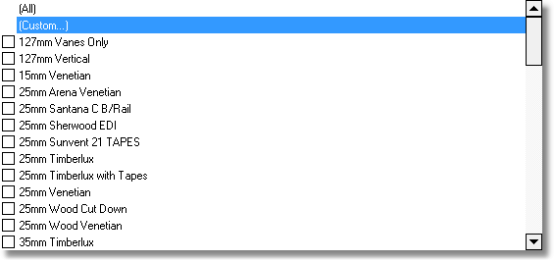
3886. EDI Enquiry > EDI Import (re-release of 7.1.1)

If an order imported with no child safety issues but where the drop itself causes the import to fail as it is below the minimum chain drop, rather than just failing the import, the import now proceeds and the chain length is set to be equal to the minimum chain drop.

If an order fails to import due to child safety rules reducing the chain length below the minimum chain drop, the order is still imported but is flagged as an EDI exception and left unchecked . A note is added into the import report for the order stating there is an issue with the chain length in blind no x. Also, if a user tries to manually check an order with an EDI exception flag, the program checks that the blinds are OK and do not fail the child safety check. If they do fail an error message is displayed to inform the user and the order is not checked. Alternatively if the user has modified or deleted the blind to make it compliant then the order is checked and then scheduled as per the standard process.

3887. Order Processing > Quotations > Print Quote

Previously the ‘Print Quote’ button printed quotations and proforma invoices. Now, if ‘Proforma’ = No, the quotation prints. If ‘Proforma’ = Yes, then the following question is asked: ‘Do you want to print a proforma invoice (Yes) or a quotation (No)’. The answer then determines if a quotation layout or a proforma layout is printed.

3890. Quotation – Bespoke 54

There is now a way of specifying the text for the sub totals. Previously it just said ‘Total’.

For example the following could be held in a text line
‘Quote text …. To Supply and Installation - {TotalForGroupNo1}’, where 1 is the group number.

There is also an option to print the grand total using {GrandTotal}.

The detail lines are now printed on a separate page – only on this report.

3891. Order Processing > Quotations > Create Order

‘Location’ is now a column in this form.

3892. Order Processing > Orders

It is now possible to record in the detail line whether a blind has been surveyed or not. There is a new flag in the order detail line called ‘Surveyed’. It is also a column choice in ‘Window Blind Amend’ and the user is able to amend the flag in this form.

3893. Order Processing > Orders

There is a new parameter called ‘Show Child Safety Message’.

If ‘Child Safety Applicable’ is switched off, when the order is saved, a warning message now appears. This says ‘The child safety regulations have not been applied to this order. Please ensure that the necessary paperwork has been processed’.

3894. Order Processing > Quotations > Survey Sheet

There is a new survey sheet called Survey Sheet (Landscape).

3901. Projects

There is now a field for ‘Specified Supplier’ instead of the hardcoded ‘Silent Gliss’. It has been removed and the ‘Specified Supplier’ put above ‘Specified Products’. The ‘Specified Supplier’ looks up the supplier company name.

The screen work was tidied up and ‘Pre DB Q’ removed.

If QS details are known, they are pulled them through to the quotation.

3904. Sales Files > Quotation Stored Text

It is now possible to edit stored text with bold, italics and underlining.

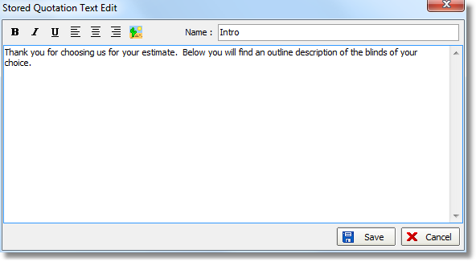

3905. Order Processing > Quotations

There is now a column for fitting price in ‘Window Blind Amend’. At the moment we can only have a column for ‘Option Price’ but we need to separate out the fitting price (‘Fitting’ will be an option choice and will have an option price or the option can be entered manually. This means we need to identify the option price that is the ‘Fitting’ option and be able to show it in a column.

It is also now possible to amend the fitting charge per blind in the column in ‘Window Blind Amend’. It is also possible to filter records here and globally change detail line discount and fitting charges for only those filtered records.

For example, there might be 30 detail lines on the order, 20 for roller blinds and 10 for 89mm verticals. They have individual discount percentages and fitting option prices set up. The user might want to change the discount % or the fitting charge for just the roller blinds, so the first thing that would happen is that the records would be filtered. There are now totals shown for filtered records, and also buttons to globally change the ‘Discount %’ and the ‘Fitting’ (if these columns are shown).

The two buttons for globally altering ‘Discount %’ and ‘Fitting’ are below the button that displays the option list. If one of these buttons is selected, then the user will be asked to enter either the new ‘Discount %’ or ‘Fitting Amount’ and this will then be applied to all the detail lines that have been filtered (or all if the filter was not used).

