Blindata Release Note 7.1.3 

24 October 2014

Bug Fixes and Enhancements

4923. Order Enquiry > Processes - Fabric Cut & Stock Transactions

When the fabric cut process was completed, the transactions were logged incorrectly in the stock transaction tab of the stock record. Fixed.

4925. Inventory > Stock Items - On Sales Order
If ‘Cost Square Pricing’ was being used, the On Sales Order deduction figure was calculated incorrectly at the manufacturing stage. Fixed.
4930. Dashboard 2

If the ‘Daily Sales Target’ was amended in ‘Company Details’, it was not updated in ‘This Week Total Sales Target’ on this dashboard. Fixed.

4931. Sales Files > Customers

An error message appeared when you tried to run ‘Google Maps’. Fixed.

4933. Quotation – Bespoke 21

If this quotation is set to Proforma = true, then the word ‘QUOTATION’ was replaced with ‘PROFORMA’. This was done in the print and pdf version.

We made this change but it is was not what the customer actually wanted so has been reversed..

4934. Purchase Order Enquiry

There was a problem with entering an alphanumeric purchase order number. Fixed.

4936. Order Processing > Orders > Import

When the import was done, it was defaulting the ‘Measure To’ to the default that is set up against the blind type and not to the ‘Measure T’ that is in the import file column. Fixed.

W229. Online Order Entry

The pricing for a curved headrail was not working properly. It now works the same way as the desktop system.

W230. Order Entry > Sub Accounts

The ‘select a different delivery address’ button is no longer displayed for Sub-Accounts.

New Work and Customer Requests

3857. Order Processing > Orders

There is now a column choice for ‘Commission’ in ‘View Blind Details (in the context menu in ‘Order Amend Enquiry’) and also in in ‘Window Blind Amend’ form.

3876. Reports > Sales Lead Report

There are now totals for ‘Quote Total’ and ‘Order Total’ at the end of the report in the respective columns.

3877. Parameters > Report Parameters > Location

There are now options for printing ‘Location’ in the detail line for order acknowledgements and invoices. Currently this only affects the following reports – ‘Acknowledgement – Laser Print (Letterhead Logo)’ and ‘Invoice – Laser Print (Letterhead Logo’.

3878. Order Enquiry > Processes - Fabric Cut & Inventory Relief (Stock Deduction)
The relief of fabric from inventory is not correct in that there are discrepancies between the amounts deducted from each batch vs. the recorded amounts listed on the Processes screen and the Batches tab in the stock record.
Processes Screen:
When trying to complete the Fabric Cut process, and if the amount used was greater than the amount held against the batch, a warning was shown. When this warning appears, there is now the option to “Cancel” and re-enter a valid amount.
When the warning is dismissed, the completed process displays the selected batch # and amount used.
Stock Items > Batches tab:
The amount held in the Batches tab is now correct (after Processes update).
3879. Dispatch Method

There is a new flag in the ‘Despatch Method’ form called ‘Collection’. If this is set to true, then the delivery address is not printed on either order acknowledgement or delivery docket.

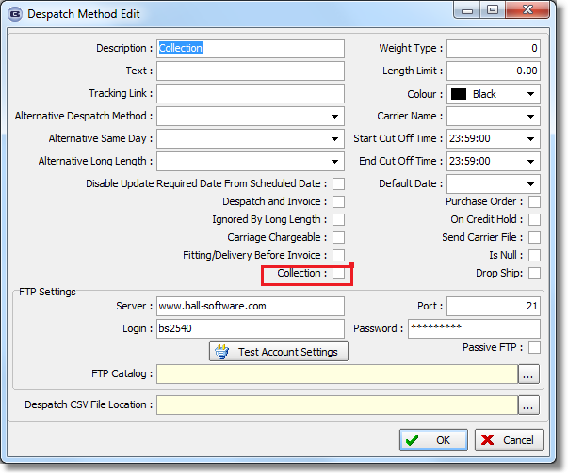

3880. Sub Category / Discounts

For wholesale orders, there is a new system table called ‘Sub Category’. This field can now be held against the stock record. It is also possible to import this field in Import From Excel > Customer Stock Discounts.

This field is also a column choice in Stock Enquiry and it is possible to import it in Import From Excel > Stock Update.

When a component detail line is entered, the discount rules apply as follows: if there is a net price discount, then use that, otherwise if there is a a sub category discount use that, otherwise if there is a category discount use that, otherwise use the normal selling price. (We need to decide where discount class fits in here, but Global will not use it).

