Blindata Release Note 7.1.1 

10 October 2014

Bug Fixes and Enhancements

4913. Bought In Order Amend

This has been optimized as it was causing timeout errors at a couple of sites.

4914. Aeronaut File

The detail lines in an order are now grouped by fabric type in the Aeronaut export file.

4915. Label Print – Bespoke 18

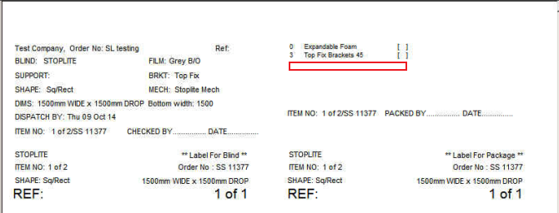

There should be 2 x Side Channel Feet listed with a tick box on there. This can be done as a set up.

The following conditions are required for displaying additional item:
- This option should be in the BOM;
- The “BOM > Stock Item > General > BOM Label” flag should be switched on.

4916. Export Order / Invoice For Customs

The customs HS tariff number has been changed in both the ‘Export Order’ and ‘Invoice for Customs’ report.

New Work and Customer Requests

3749. Efficiency Report 2

There is a new report in Reports > System Reports called ‘Efficiency Report 2’. This relates to a specific customer spec.

3856. Order Processing > Orders On Credit Hold

If an order is taken off credit hold, an internal email can be sent to despatch (to the email address set up in Parameters > Emailing). If it is for a sales order that has a PO generated and it is in ‘Bought In Order Tracking’, if the container number has been filled in, it is now included in the email that is sent ie ‘Container Number: 123456789’.

3866. Process Types

There is now a new flag held against the Blind Type > Man Process Type called ‘Start Scan’. If this process is scanned, it will update the ‘Start’ flag in ‘Order Enquiry’.

3867. Sales Files > Customers > Customer Labels

This now asks for contact name as well as company name, which then print on the first line of the label. This applies to the delivery address label as well. This only applies to ‘Customer Label – 4 ½ x 2 1/2’.

3871. Order Enquiry > Processes

It is now possible to complete processes across multiple orders. In other words, you may use one piece of fabric to cut pieces for blinds that are in different orders. Previously it would only work for blinds that are in the same order.

