Blindata Release Note 7.0.9 

26 September 2014

Bug Fixes and Enhancements

4885. Order Enquiry > Despatch Order Scan

When an order is despatched, ‘Delivery Docket Is Reprinted’ was showing in the history of the order. Fixed.

4896. EDI Import

Sometimes the Import Report not display the correct data. Fixed.

4899. Option Restrictions

The option restrictions were not working properly – items were available to all customers when they should have been restricted. Fixed.

4900. Sales Files > Reports > Aged Debtor Analysis (Summary)

There was a problem with this report. If a customer only had invoices that fell into the ‘Older’ balance, the customer does not appear on this report. Fixed.

4903. Label Print – Bespoke 33A

The weight and chain process has been dded back in.

4905. Quotations > Global

If the Global option was used to change fabrics or blind types for detail lines, when the quotation was converted to an order, the VAT code was missing from the detail lines.Fixed.

4906. Works Order – Bespoke 34A

There is now more space for the fabric descriptions on this report.

4907. Order Processing > Orders > Works Order – Bespoke 17

Selecting multiple works orders to be printed in the ‘Order Amend Enquiry’ form was not working. It is only printing one order. It is ok for the labels. Fixed.

4908. Picking List

There is now more room for the description on this report. We also moved the other columns to the right and made them a bit narrower.

New Work and Customer Requests

3840. Login

When a user logs in, we now record the PC that they have logged in to. One this is done, it is possible to amend the login to allow the user to delete the previous login, but only if it is the same user on the same PC. The following message will appear.

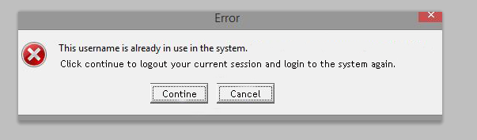

3841. EDI Enquiry

It is now possible to add notes to EDI orders within the EDI Enquiry form. Then when you hover over an order (after it has been imported), it can be seen in the ‘Order Amend Enquiry’ form.

3842. Order Processing > Orders

There is now a new flag in an order called ‘Amendment Hold’. This has an advanced permission in ‘Advanced Permission’ for the user.

It has also been added to the column choice for ‘Order Amend Enquiry’.

If an order is on ‘Amendment Hold’, it is not possible to print the works order or label. It is also not possible to make the order WIP or to manufacture the blinds in the order. At these stages, a message should appear saying that the works order / labels should be returned to the office.

3848. Reports > System Reports > Sales Intake Report

There is a new report called ‘Sales Intake Report’ pdf.

3855. Order Processing > Orders

There are some new fields that have been added to orders.

Contractor Discount – this was greyed out previously – it should be possible to add a figure in this field to 2 decimal places

Retention – this is an amount so should also be to 2 decimal places

Self Bill – this is a flag that defaults to the ‘Raise Application’ flag in the customer record, but can then be edited.

