Blindata Release Note 7.0.8 

12 September 2014

Bug Fixes and Enhancements

4887. Remittance Advice – 8.5 x 11

The invoice number was printing the transaction ID. It is now the invoice no.
The Invoice date is now printing instead of the payment date instead.
The Vendor key (account code) is now printing.
The alignment has been altered for a number of fields.

4891. Order Processing > Orders

If an order was entered and saved, and then someone went back into the order and changed the customer (to one with a different currency), the old currency was left in the order. Fixed.

4892. Mertex Posting

Sales Invoice
Column G Currency Amount: this is now the amount on the invoice in the customer currency.

Credit Note
Column G Currency Amount: this is now the amount on the invoice in the customer currency ie same as the sales invoice.

Purchase Invoice
Column G Currency Amount: this is now the amount on the invoice in the supplier currency. Columns for G/L & VAT amounts: are now in the base currency for the company – therefore columns K, M, O etc are now in the base currency of the database.

4893. Outlook Error

There was an Outlook error message for certain customers when sending emails

4897. Stock Control > Stock Take Import

If a spreadsheet has a record with a ‘Stock In Hand’ = 0, the stock in hand is now updated to 0. Previously it was ignored.

4898. Stock Control > Stock Items

If there is a cost price discount in the stock record, the stock value figure in the stock record was incorrect. Fixed.

It is also now displaying the ‘Stock Value’ amount correctly when it is selected as a column in ‘Stock Enquiry’.

New Work and Customer Requests

3846. Order Processing > Quotations/Orders > Other Contacts Tab

The following fields are now in the ‘Other Contacts’ tab.

- Forecast Date
- Pricings Based On (there is a new system table for this – called ‘Pricings Based On’.
- Discounts Authorised By – with a lookup for operator.

3847. Order Processing > Orders > Variations

It is now possible to record ‘Variations’ for orders. This means that if an order is changed and the price is altered, the user can record the variation against the order. This will be a manual entry by the user.

There is a new button on the ‘Order Amend Enquiry’ form called ‘Variations’. This has a visibility option in Users > Buttons Visibility.

When the ‘Variations’ button is selected, it displays existing variations and has buttons for ‘Add’ and ‘Amend’ and ‘Delete’.

When ‘Add’ is selected, it opens a form to allow the following fields to be added:

Old Amount (if there is an existing variation record, it puts the new amount from the previous record into the old amount, otherwise the user can enter the amount)
New Amount (this is pulled from net total on order).
Reason For Variation – this is a text field that the user can fill in.

It also displays the date/time this was done at and the user who entered the variation.

3849. Reports > System Reports > Sales Forecast Report

There is a new report in Reports > Sytem Reports called ‘sales Forecast Report’.

3850. Rep > Negotiator

There is now an option to change the word ‘Rep’ to ‘Negotiator’ in the system.

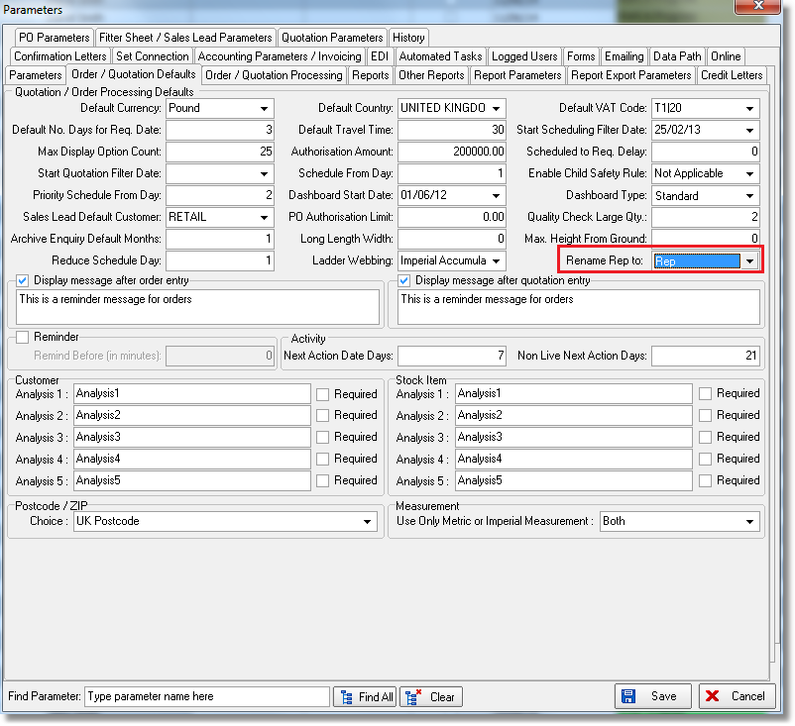

3851. Purchase Order Authorisation By User

It is now possible to restrict the sending of a purchase order if the value is over the authorised value held against a user.

There is a new field in ‘Users’ called ‘PO Authorisation Amount’.

If a user tries to send a purchase order (either regular or bought in) and the value of the purchase order is greater than the ‘PO Authorisation Limit’ held against the user, a message appears saying ‘You do not have authorisation to send this PO’.

3852. Quotations > Projects

Extra fields have been added to the Projects form.

- All fields are text except for ‘Agreed By’ which will look up the operator.
- There is a new system table for ‘Lost Reason’. For ‘Project amendments, revisions, updates etc’ there is now a separate table as there could be multiple amendments.

3854. Purchase Order Enquiry > Regular PO

The ‘Expected Delivery Date’ in the header can now be edited.

3861. Purchase Order Processing > Regular PO

When entering a +Misc detail line in a regular PO, it is now possible to enter a nominal code in the detail line.

