Blindata Release Note 7.0.5 

1 September 2014

Bug Fixes and Enhancements

4865. Company > Bank > Reconcile > Send to Excel

When the reconciliation records are exported to Excel, the date format was interpreted by Excel incorrectly for specific date formats (i.e. 2014-03-01 in Blindata is March 1st 2014 but exported to Excel as 2014-01-03 , January 3rd 2014). Fixed.

The export now also includes the Customer column.

4866. Sales Files > Reports > A4 Statement Running Total

If the statement goes onto a second page, the running total went back to zero. It now continues from the previous page.

4867. Sales Files > Reports > Aged Debtors Analysis (Summary)

The Aged Debtor Analysis (Summary) was missing some customers. This happened after extra criteria were added. Fixed.

4872. Order Processing > Orders

If the chain length is imported in the detail line import, it now ticks the chain length overridden box.

4873. PO Label 2

The lining up has been adjusted slightly. The lines at the top have all be moved down 5mm and the number at the bottom moved up 5mm.

New Work and Customer Requests

3816. Order Processing > Orders > VAT Rate

It is now possible to change the VAT rate (sales tax) in an order detail line. Previously you could have a situation where a customer is set up with the wrong VAT code. When an order is entered, the wrong VAT code was saved. If the operator did not notice this and saved the record, there was no way of changing the VAT rate.

There is an advanced permission for doing this.

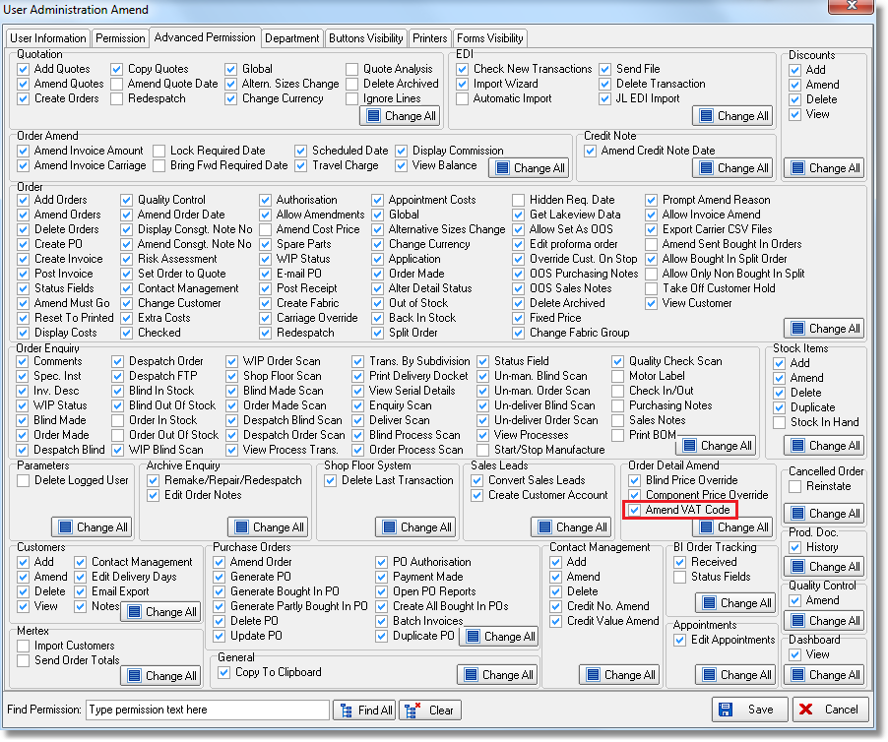

3817. Works Order Bespoke 28

The install height now appears on this works order for all blind types but only if it is not 0.

3818. Dispatch Status

There is a new parameter called ‘Print Del Docket Then Prompt’. This default to false. If it is set to true, then the user is asked if they want to print the delivery docket but not change the status of the order to ‘Delivered’. This will only apply to the ‘Deliver’ function in ‘Order Amend Enquiry’ and does not work in ‘Order Enquiry’.

The new routine will store Employee, Delivery Date and Dispatch Method to the database as it is without changing Order/Detail/SerialDetail statuses. When the delivery is actually done, it will retain these fields.

3819. Administration > Import From Excel > Customer Update

‘Customer Class’ can now be included as a column.

3820. EDI Import

The ‘Create Date’ field that is in the XML file is now imported into the ‘Online Order Date’ field in the Order table.

