Blindata Release Note 7.0.4 

22 August 2014

Bug Fixes and Enhancements

4855. A4 Statement With Running Total

The running total column is now on the furthest right in the detail section.

4856. Aged Debtors Analysis

If the total outstanding was over 1 million, the 2 decimal places did not print properly. Fixed.

4857. Cheque Remittance 8.5 x 11

The lining up for this report was still incorrect. The date and cheque number have been moved slightly in the 2 bottom sections.

4859. Purchase Order Enquiry

For a PO the wrong cost price was being used if the ‘Unit Cost’ price was set up and there was a cost discount. Fixed.

New Work and Customer Requests

3800. Pricing > Price Table Enquiry / Option Price Enquiry

There is now a ‘Save’ button if the price table record is changed in any way. Previously it was too easy to change one of these fields and not realise it has been changed.

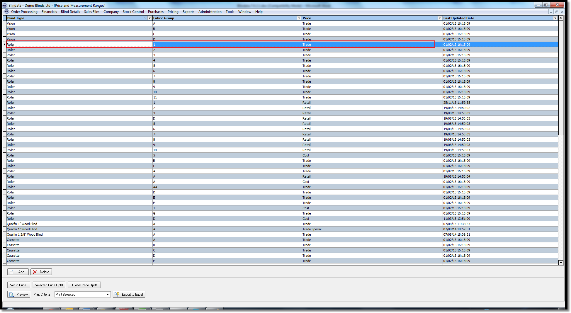

3801. Reports > System Reports > Employee Barcode

Employees now only print out on this report if they are flagged as ‘Production’ in Administration > Employees.

3804. Average Cost Pricing

It is now possible to hold cost prices in stock records using an ‘Average Cost Pricing’ method. Here is a description of how average cost pricing works.

http://accountingexplained.com/financial/inventories/avco-method

There is a new parameter called ‘Cost Method’. This has choices for FIFO Method or AVCO Method. Only one of these can be switched on at a time, and the default is FIFO Method.

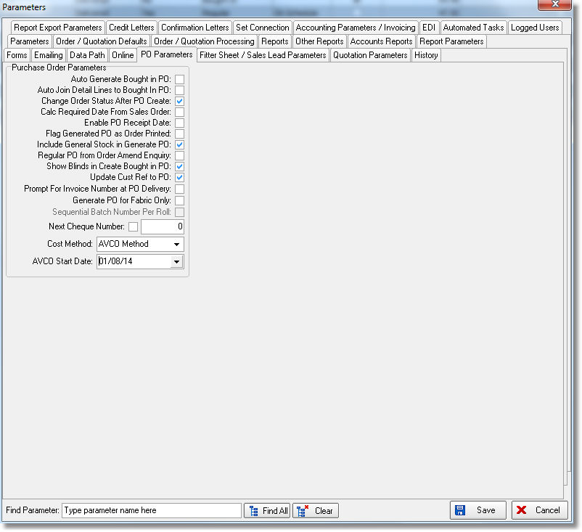

There is now a new field for ‘Unit Cost’ in the ‘Puchase Invoices’ table. When the purchase invoice is created, the purchase invoice record is updated with the unit cost. If ‘FIFO Method’ is switched on, then nothing else is done.

If ‘AVCO Method’ is switched on, then the ‘Unit Cost’ field in the stock record is also updated when the purchase invoice is created in ‘Purchase Order Enquiry’. The unit cost amount is calculated using the ‘AVCO Perpetual’ method described in the link above. It looks at all records that have a date greater or equal to the ‘AVCO Start Date’ held in Parameters.

3805. Sales Analysis by Customer – No Sales

There is a new report called ‘Sales Analysis by Customer – No Sales’ that shows a list of customers, grouped by rep, that have not had any sales orders, invoices or credit between the start and end date entered.

This report shows account code, customer company name, telephone number, postcode.

3806. Order Processing > Orders On Credit Hold

There is now a column choice for ‘Required Date’ and ‘Scheduled Date’.

In the context menu there is now an option to ‘Copy To Clipboard’.

3807. Order Processing > Archive Enquiry

There is a column choice for ‘Balance’.

3810. Purchases > Purchase Order Enquiry > Update

It is now possible to delete purchase invoices listed at the bottom of the screen. This is required because if a mistake has been made with creating an invoice, it should be possible to remove it, and then recreate it.

3811. Order Enquiry > Processes

It is now possible to export the detail lines on the processes form using the ‘Copy To Clipboard’ option that is in the context menu.

3812. Quickbooks

For made to measure blinds, there is now a Quickbooks reference field in the blind type record (if Quickbooks Accounts is switched on).

When ‘Post Invoices’ is done, for a made to measure order, the account field in the Quickbooks sales invoice is filled with the Quickbooks reference field from the blind type record.

When ‘Post Invoices’ is done, for a component order, the account field in the Quickbooks sales invoice is filled with the Quickbooks reference field from the stock item record.

3815. Purchases > Purchase Order Processing

There is a new ‘Contact Record’ field in this form. If a contact management record is added in the ‘Purchase Order Enquiry’ form, then this new field is flagged as true. This is similar to the functionality that exists for updating the contact record flag in ‘Order Amend Enquiry’.

There is a column choice for this field as well.

