Blindata Release Note 7.0.0 

25 July 2014

Bug Fixes and Enhancements

4691. Order Processing > EDI Import

On occasions the defaults were being applyied to EDI orders where there was no mapping set for a tape. If an order was imported and there was no mapping for the tapes then the system automatically applied the default rather than waiting for the tape to be manually mapped. Fixed.

4806. EDI Import – Acknowledgement Print

Excel have reported a problem that needs to be looked at urgently. They are now using Blindata Online and have blind types online that are actually being manufactured by other companies ie Decora and Tropical.

A problem occurred if a customer entered an order online for a blind that was actually being made elsewhere. The order was imported, and then a PO created, which was then sent via EDI to the relevant supplier. However what was then happening was that the order that goes to the supplier got imported into their database and issued an order acknowledgement that is then sent to the end user, when it should be sent to the customer (ie the company that issued the PO).

If you looked at the sales order, it did not have ‘Direct Delivery By Supplier’ set to true in the sales order. Fixed.

4807. Sales Analysis Commission Report Grouped

This report is now prints onto page size 8.5” x 11” (or 11” x 8.5” as it is a landscape report). If the customer is in the USA or Canada.

4808. Aged Debtor Report By Invoice

This report used to not print zero value invoices but they were appearing. Fixed.

4810. Order Processing > Orders > Bill Of Materials Square Cost Price

If ‘Use Fabric Cost Square’ is true, the cost price was not being calculated properly in the bill of materials report for fabrics. Fixed.

4812. FOC Same Day For Certain Blind Types & Customers

If a customer has multiple blind types on their order and not all blind types are within the FOC table then the same day despatch charge is now still be applied to the order.

4814. EDI Import

An error was reported with the EDI Enquiry screen displaying an error stating “Could Not Convert Variant Of Type (Null) Into Type (String). This happened because there was at least one Supplier with Name = Null in database. Fixed.

4816. Sales Files > Customers > Aged Balances

The ‘Older’ balance figure was calculating incorrectly. Fixed.

New Work and Customer Requests

3669. Import From Excel > Link Options

We had a request for an import choice for ‘Link Options’ in Administration > Import From Excel.

In fact we already have functionality to do this. That is a part of the blind type dataset import and we can use it for importing link options only.

There was only one thing that needed to be, though. We have added in extra fields to the link options eg ‘Choice’. We have included these into the export/import.

3675. Sales Files > Customers

There is a new layout for customer labels – Avery J8163. It is also now possible to print labels for all filtered records in the customer enquiry form (Sales Files > Customers). There is a new button called ‘Print Filtered Labels’ on this form.

3702. Order Processing > Cancelled Orders

It is now possible to right click on a cancelled order, and have an option to show the history for cancelled orders in the context menu.

3708. Users > Advanced Permission > Copy To Clipboard

There is now an advanced permission to enable ‘Copy to Clipboard’ in the context menu everywhere in the system. This should default to being true.

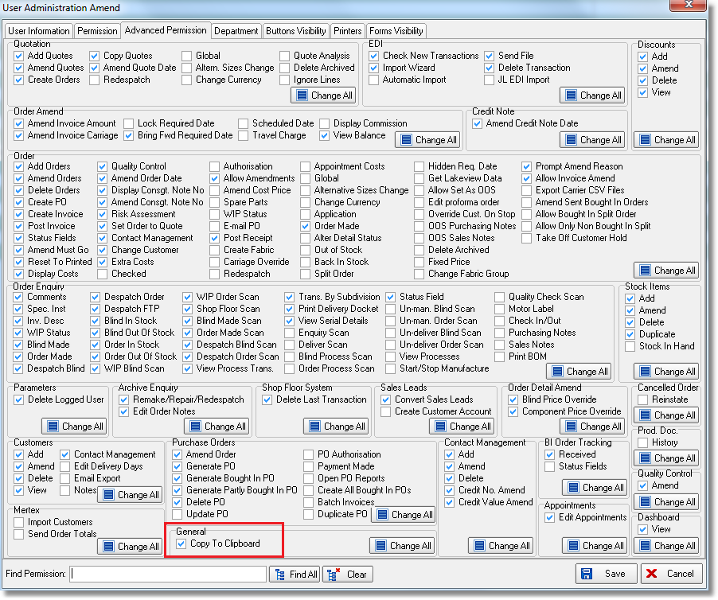

3782. Administration > Company Details > Email Texts > Statement Email Text

There is now field to specify the statement email text. This has been added to Administration > Company Details > Email Text 2.

3783. Company > Bank > Reconcile

Some new fields have been added to the bank reconciliation form.

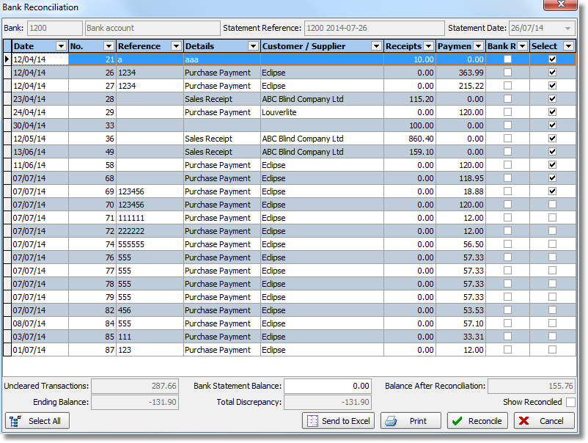

Uncleared Transactions will be the total of all entries to be reconciled.
Ending Balance will be the balance before reconciliation.
Bank Statement Balance is the balance that we should have after reconciliation. It is possible to key this in right before reconciliation so that the amount to be reconciled will be shown.
Total Discrepancy will be Ending Balance less Bank Statement Balance (i.e. the amount to be reconciled in the current session). This will be a useful indicator for the operator to ensure that they have reconciled all necessary amounts before they click the “Reconcile” button.

3784. Administration > System Tables > Currency Types

A new option has been added to the Company menu for ‘Currency Types’. This is the same form as the one in Administration > System Tables.

3785. Reports > Outstanding Orders

If ‘Product’ is selected then there is now a choice to group by blind type or blind identifier. Previously the records were grouped by blind type only.

