Blindata Release Note 8.9.9 

25 May 2018

Bug Fixes and Enhancements

The following bugs were recorded in www.support.blindata.co.uk and have been resolved.

5122. Blindata Compatability With Windows Version 1803
5128. E-mailing purchase orders
5174. Emailing through outlook issue
5178. unable to email invoice from blindata
5186. Cannot email after windows update
5198. Comeback: Attempt to email quotes or orders shuts down BlindData

New Work and Customer Requests
5932. Scheduling > Same Day Despatch

There is a new flag called ‘Schedule SDD Order To Next Day’ which defaults to false. If this flag is set to true, same day despatch orders will be scheduled for the next day, providing they are input before the cut off time, otherwise they will be scheduled for 2 days ahead.

5933. Out Of Stock Email To Customer

We need to be able to send similar information as the following to the customer.
There is a new parameter called ‘OOS Action Email To Customer’ which defaults to false. If true, then the email should go in this format.

Previously you could only specify the specific BOM stock items that are out of stock. If the new parameter is switched on, it is now possible to hold a ‘Next Available Dispatch Date’ and ‘Action’ field against the order detail line. Action is related to the latest despatch date.

The email is sent in the following format.

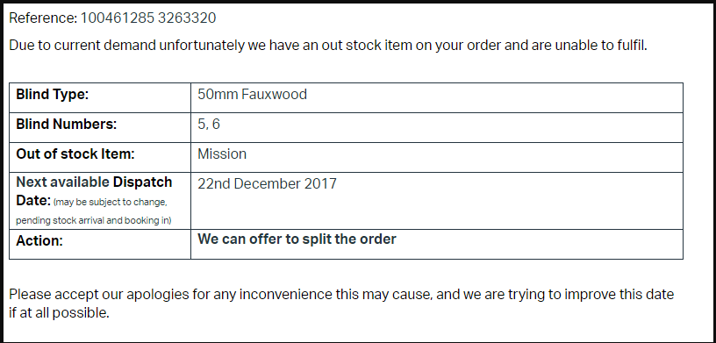

5935. Blindata Online

For proforma customers we have had a request that they are able to submit a quotation to the desktop system instead of using Sage Pay and converting to an order.

At the moment the only way a proforma customer can process an order online is to pay for it first. This means they have to use Sage Pay and a credit card which costs the customer extra (as a % fee on the credit card). It is now possible to submit a quotation online which is then imported via EDI as a proforma quotation and then processed internally as a proforma.

To do this there is a new flag held against the customer record called ‘Allow Proforma Submit’ in Sales Files > Customers > Online, which defaults to false. This flag is only visible if ‘Is Proforma’ = true in the customer record.

If the new flag is set to true, it is possible to submit the online order as a quotation.

5940. Works Order – Bespoke 77

The sizes now appear correctly on this works order.

The total of blinds now appears on the works order, in the header on the right hand side.

For a multi blind, it now shows the overall line with the overall size, and in the other lines show which blind it is eg ‘Blind 1 of 2’. This works when ‘Multi Blind First Line On WO’ is switched on in the blind type record.

5941. Delivery Docket – Bespoke 77

The number of units for components has been removed from the total units figure on this delivery docket. Therefore if there are 3 blinds and then component lines with quantities of 2 and 4, the total units says 3.

5942. Despatch Label – 4 x 2

There is now a parameter to not print out labels for component detail lines. This is called ‘Print Blinds Only in Despatch Label’.

5943. Order Processing > Orders

There are two new flags in the quote/order entry form (in the ‘Totals’ tab), one called ‘Customer Email Approved’ and another called ‘Customer Email Rejected’. If these flags are switched on or off, it should be recorded in the order history.

5944. Order Processing > Archive Enquiry

There is a new button on the Archive Enquiry form called ‘Cust. Email Reject’. If this is selected, then the ‘Customer Email Rejected’ flag is set to true. The order history is also updated.

There is a flag for seeing this button in Administration > Users > Button Visibility > archive Enquiry called ‘Cust. Email Reject’.

5945. Administration > Maintenance

There is a new option in this form called ‘Delete Customer Email Addresses’. If this is run any orders with ‘Customer Email Rejected’ will have the email addresses removed.

5946. Order Processing > Orders

We have removed the ‘Submitted’ choice from the ‘Status Field’ button choice. This has also been done in Archive Enquiry and Bought In Order Tracking.

5949. Order Enquiry > Despatch Blind Scan

The window for this button has been made far bigger and all text be in a far larger font so it can be seen up to 5 metres away.

5950. Order Processing > Order Enquiry

There is a new column choice that indicates the blind is bought in, so we have used the ‘Bought In’ flag from the blind type record.

5951. EDI Import

See Redmine 5167. It is now possible to import the price for a component when doing the EDI Import. At the moment there is a flag called ‘Use EDI Import Prices’ held against the customer record. If this is set to true, then the component price is also imported.

