Blindata Release Note 8.9.6 

4 May 2018

Bug Fixes and Enhancements

The following bugs were recorded in www.support.blindata.co.uk and have been resolved.

4006. Carriage Charge Not Being Added
4361. Pricing Displaying Incorrectly
4876. Made To Measure – Venetian Blind Options

New Work and Customer Requests
5794. Works Order – Bespoke 34A

If an option is a 'Non Print Item' and it does not have a column, it no longer appears in the special instructions.

Also the information from the blind type that prints in the footer has been made about 25% larger.

5911. Label Print After Scanning

In dev 5884 we added functionality so labels could be printed when process scans were done. This works but prints all of the labels blind. For ‘Label Print – Bespoke 70’ it now only prints the labels that are associated with the process type ie the label that is set up in the ‘Print After Label Control’ field in Blind Types > Man Process Types.

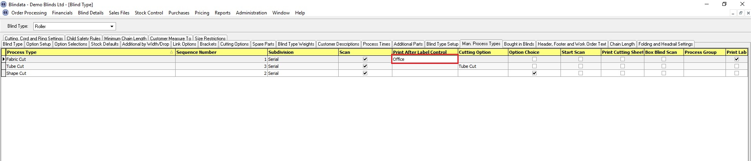

5912. Delivery Docket – Bespoke 34

We should try to print more detail lines on a page. The header now only appears on the first page and the footer is only on the last page. However the page number prints for each page (Page 1 of n).

Both the print and pdf versions have been changed.

5913. Acknowledgement – Bespoke 34

We should try to print more detail lines on a page. The header now only appears on the first page and the footer is only on the last page. However the page number prints for each page (Page 1 of n).

Both the print and pdf versions have been changed.

5915. Out Of Stock Sales Orders

There is new criteria in this report for ‘Stock Code’ and ‘Customer’. A column for ‘On Purchase Order’ has also been added.

