Blindata Release Note 8.9.3 

13 April 2018

Bug Fixes and Enhancements

The following bugs were recorded in www.support.blindata.co.uk and have been resolved.

4881. ftp order acknowledgement
4888. Revised Delivery Date
4890. Global functionality

New Work and Customer Requests
5494. Order Processing > Orders

The ‘Batch No’ (which is assigned to each order detail line) now appears when entering an order detail line.

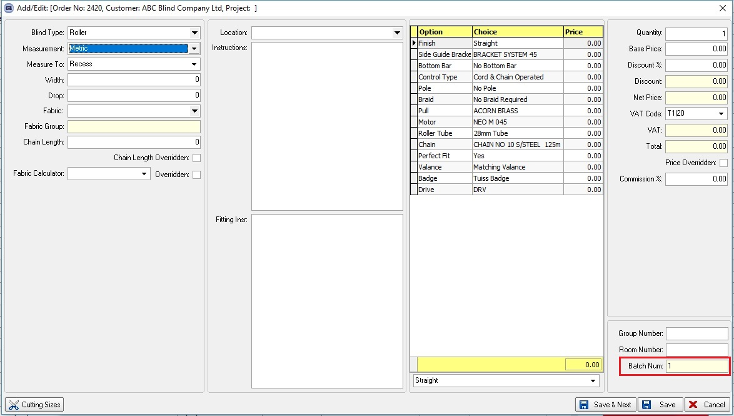

5818. AutomatedTask.exe

The Automated Task report is now sent to the sub account delivery address if ‘Sub Account’ is switched on in the customer record.

5851. Order Processing > Orders > Component Entry

There is a new flag in the stock record called ‘Print WO As Blind’. If this is set to true, then in ‘Works Order – Bespoke 77’ a component detail line with this flag switched on and ‘Box Width’ and ‘Box Drop’ entered, this line will print as a blind.

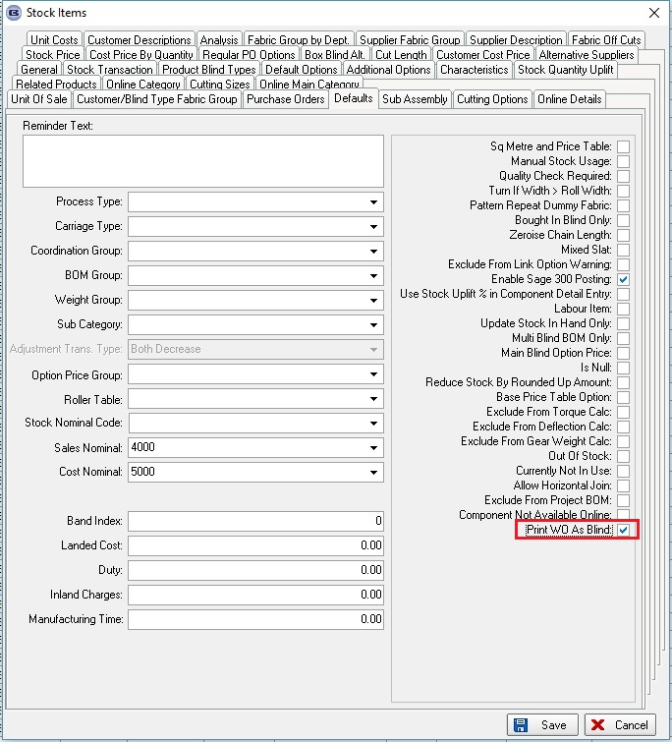

5863. Fabric Optimisation

There is a new flag in the blind type record called ‘Use Pattern Repeat in Optimisation’, which defaults to false. If true, here is an example of how the fabric calculation works.

The fabric amount required is calculated by multiplying the drop by 2 but it also needs to take into account the pattern repeat. If we use the drop calculator we can multiply by two and add on an amount. For example, if the multiplier is 2 and the add on amount is 200, the blind drop of 1000mm would require 2.4m ((1000 + 200) * 2). If the pattern repeat was 500mm, then it would need 2.5m. The calculation would be ((1000 + 200)*2) = 2400mm, then 2400/500 is 4.2, rounded to 5 and then multiplied by 500 gives 2500mm.
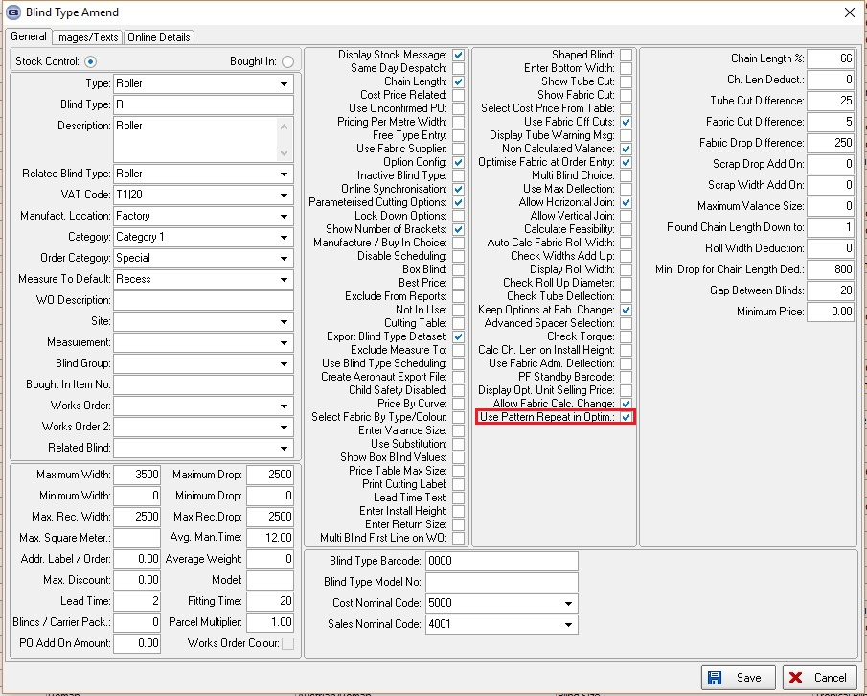

5864. Sales Files > Reports > Aged Debtors Reports

There are now criteria to print these reports by Department. It should be the department that is held against the customer record, and there should be choices for ‘All’ or individual department.

5865. Sales Files > Reports > Audit Trail

There are now criteria to print these reports by Department. It should be the department that is held against the customer record, and there should be choices for ‘All’ or individual department.

5866. Works Order – Bespoke 67

Neither ‘Notes’ nor ‘Notes 2’ now print in the order footer section.

If the detail line is for a component detail line, the ‘Comments’ field now prints where ‘Options’ were.

For a blind detail line, all the entered special instructions print out. Previously they were being cut off. Also all options now print.

5867. Delivery Docket – Bespoke 67

If the detail line is for a component detail line, the ‘comments’ field should print where ‘Options’ are.

5868. Statement – 8.5 x 11 Standard

The logo now prints out a bit smaller and the word ‘Statement’ is in a larger font.

5869. Parameters > Accounting Parameters

There is a new parameter called ‘Do Not Print Zero Value Invoices’ which defaults to false. This is in the ‘Accounting Parameters’ section.

If this is set to true, then zero value invoices are not be printed or emailed from ‘Invoice Batch Print’ but their status is still changed to ‘Invoice Printed’ as they do now.

5870. Label Print – Bespoke 67

The ‘Cust Ord No’ was previously overwriting the ‘Customer Reference’ field. The latter should be moved down a line.

5871. Acknowledgement – Bespoke 67

The Pattern/Colour column has been moved to the left a bit, making more room for the fabric description column.

5872. Quotation – Bespoke 67

‘Unit’ now prints above ‘Retail’ and ‘Net’.
The multiplier now prints, not the discount percentage.
‘Total Net’ now prints for each detail line.
All options that are supposed to print out now do so.
The ‘Quotation Text’ from Company Details also print in the footer of the quotation, on the left hand side (where it previously printed ‘Order Notes’).

5873. Order Processing > Orders > Post Receipt

When a receipt is posted to the sales ledger (using Blindata accounting), the ‘Customer Reference’ in the sales order is now posted to the Reference field and the ‘Customer Order No’ to the Reference 2 field.

5875. Delivery Docket – Bespoke 78

A new delivery docket report has been called ‘Delivery Docket – Bespoke 78’. The page size is 8.5” x 11” and the date format US.

5880. Batch Picking List – Bespoke 72

‘QUALITY REQUIRED’ only prints if the ‘Quality’ flag is selected in the order.
‘REMAKE’ only prints if ‘Remake’ is selected in the order.
If the batch is being reprinted, the word ‘REPRINT’ prints in 14 point.

5881. Works Order – Bespoke 72

This now prints the Width here (exact width).

5882. Order Amend Enquiry > Quickbooks Export

The ‘Notes’ field has been excluded from the export file. Also numbers are now exported in format 9999.99, not 9,999.99, because this causeed errors in the csv file (which is comma delimited).

