Blindata Release Note 8.9.1 

3 April 2018

Bug Fixes and Enhancements

The following bugs were recorded in www.support.blindata.co.uk and have been resolved.

4346. system reports new
4797. Louvres Only Pricing
4804. PP-OOS-Order

New Work and Customer Requests
5816. Reports > System Reports > Quotations By Rep

There is a new report to show the status of a quote for each rep filtered by dates. The report is called ‘Quotations By Rep’ and has been added to Reports > System Reports. The criteria for the report are ‘Rep’, ‘Start Quote Date’ and ‘End Quote Date’.

5821. Parameters > Online > Online Site Tags

There is now a field for inserting Javascript code into the online website for trade ordering (www.*.blindata.co.uk).

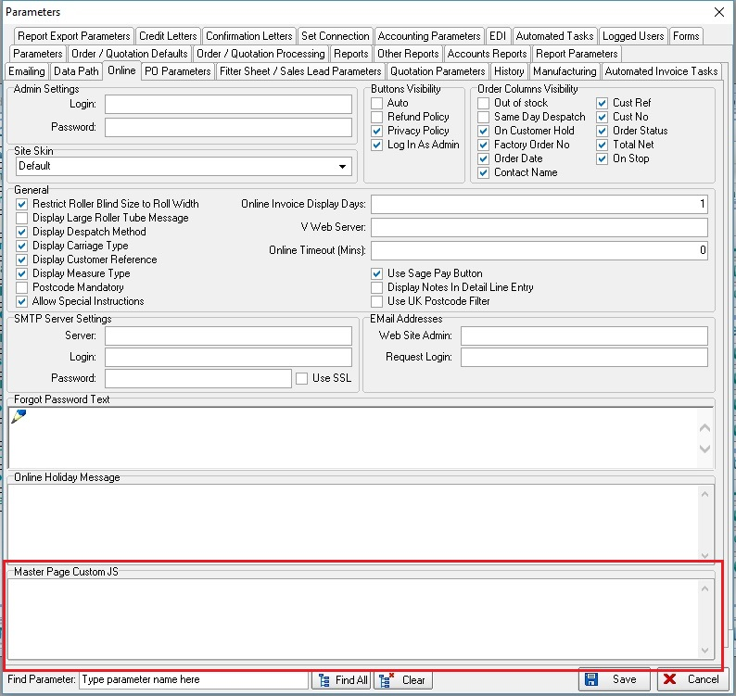

The online sites have been modified to take this new field into account. The text will be added to the first page of the website.

5824. End Of Day Despatch CSV File

It is now possible to send an end of day report in a csv format to a customer for the orders that have been despatched that day.

There is a new flag in Sales Files > Customers > FTP Settings tab called ‘Send End Of Day Despatch CSV File’ which defaults to false.

There is a new ‘End Of Day Despatch CSV File Location’ field where a FTP folder can be selected.

There is a new parameter called ‘End Of Day Despatch CSV File’ in Parameters -> Automated Tasks with ability to enter a time at which the CSV file will be imported.

There is a new routine which will send CSV file to all customers having ‘Send End Of Day Despatch CSV File’ = TRUE and FTP settings filled. Order Details where DeliveryDate = TODAY will be included into spreadsheet.

5827. Stock Control > Reports > Stock Transaction Audit

There is a new report in Stock Control > Reports that prints an audit of all stock transactions between two dates. This is grouped by stock item then stock transactions. There are criteria to print by supplier and stock item range.

5830. Total Of Orders Outstanding

It is now possible to display ‘Production’ in a form from ‘Total Of Orders Outstanding’. Previously this data was only sent out to a spreadsheet.

The order of processes can now be determined by holding a ‘Sequence Number’ against the ‘Process Type’ in the System Tables > Process Type form. The export to Excel routine has been amended to handle this.

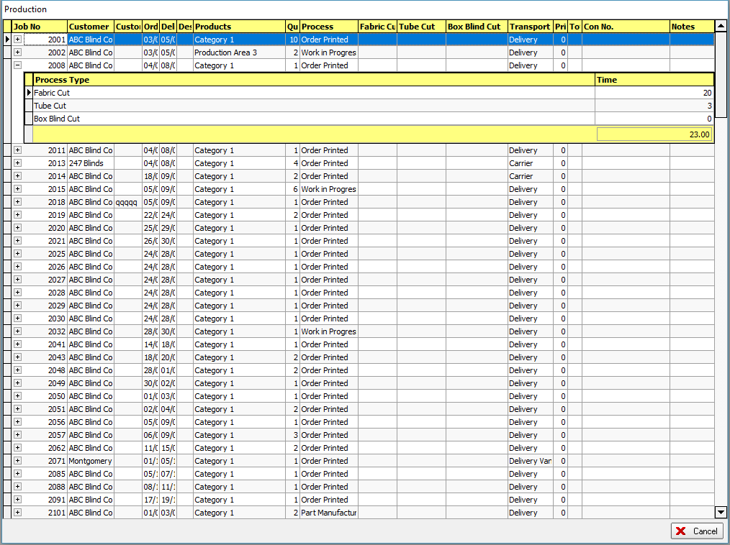

5836. Works Order – Bespoke 73

There is a new report based on ‘Works Order – Bespoke 70’ called ‘Works Order Bespoke 73’.

If the blind identifier = Curtain or Cushion, it shows number of widths, also if pair or single, pair is described as total no of widths / 2. This prints to the right of the fabric description.

Pattern repeat also prints to the right of the fabric description.

5837. Order Processing > Orders > Option Lock

We now have a lot of customers who have got very complicated link options set up against blind types. This is good but sometimes they have situations where it is not possible to get the link options to work properly, because other options get changed (even after negative numbers are set up against choices).

There is a new field in the Option section of ‘Window Blind Amend’ called ‘Lock’, which will be a flag. It defaults to false but if the user sets it to true, then this option cannot get changed in the order detail line, regardless of what is set up in link options.

This new field is a column choice.

If an order detail line is copied, then this field is also copied.

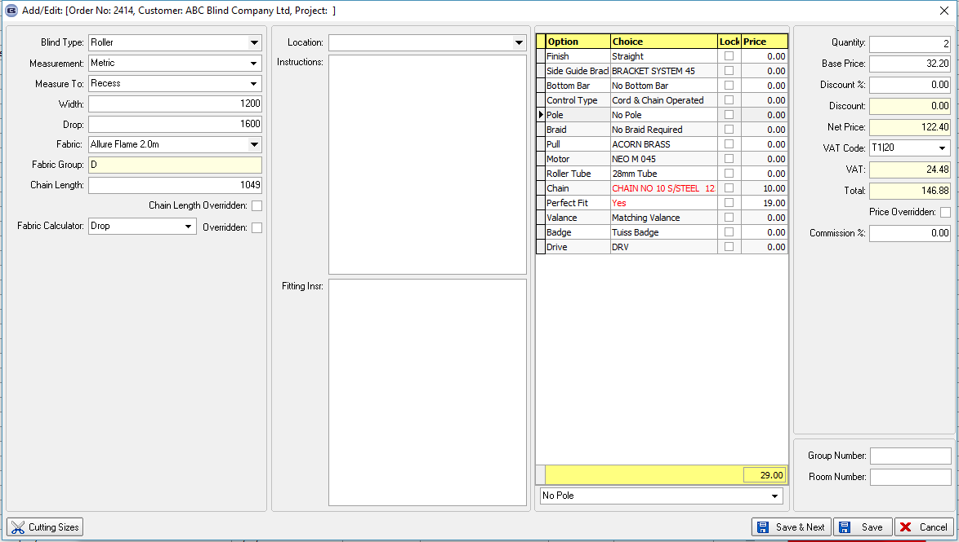

5838. Order Processing > Orders

When the name gets remembered for a free type, it also holds the fabric selling price and the pattern repeat and roll width. When a second and subsequent detail lines are entered and the same fabric description and free type chosen, the fabric selling price, pattern repeat and roll width are filled from that choice.

5839. Delivery Docket – Bespoke 73

A new report has been created called ‘Delivery Docket – Bespoke 73’, based on ‘Delivery Docket – Bespoke 77’. It is A4 size, UK date format.

5840. Invoice – Bespoke 73

A new report has been created called ‘Invoice – Bespoke 73’, based on ‘Invoice – Bespoke 77’. It is A4 size, UK date format.

The ‘Number Of Widths’ prints to the right of the fabric description.

5841. Reports > System Report > Customer Special Instructions

There is a new report in Reports > System Reports called ‘Customer Special Instructions’. This shows customer, then special instruction records from Customers > Spec Ins tab. The report is in A4 Portrait size.

5842. Order Made / Despatch

If ‘Combine Order Made/ Despatch’ is switched on, it is now printing the delivery docket if the delivery docket is set to print.

5844. Order Made / Despatch > Component Orders

It is now possible to allocate batch numbers against stock items at order made / despatch. It will be possible to hold multiple batch numbers against each line.

A form will appear at this stage so the user can enter a batch number against each order detail line (that is a component detail line and is for a stock item that has ‘Batch Numbering’ = true).

A window appears before the stock is updated with the order detail line stock code, stock description, quantity and a field to enter the batch number. When this is saved and order made / despatch is done, the stock records are updated and stock transactions added and batch stock transactions updated.

There is a new parameter for this called ‘Specify Batch No At Order Made / Despatch’, which defaults to false.

5845. Stock Take Entry / Import

If average costing is used, when a stock take entry is done, we now create a stock transaction for each difference in a batch.

In the past we have discussed what the correct thing to do is when a ‘Stock Take Entry/Import’ is done. At the moment it creates a ‘Stock Take’ stock transaction record, which holds the new ‘Stock In Hand’ value.

5846. Regular Purchase Orders

If ‘Batch Number Is PO Number’ is set to true, when the PO is saved, it saves the PO number with the prefix U to a new field, PO Batch Number. The user will then be able to edit this field in the purchase order.

Also, if this parameter is switched on, when the PO is delivered into stock, it uses the PO Batch Number as the batch number and not the PO number.

5847. Order Processing > Quotations

There are now flags in the Totals tab for ‘Price Total By Group’ and ‘Price Total By Room’ – these are both already available in order entry.

5848. Quotation – Bespoke 52

This report now looks at the flags ‘Price Total By Group’ and ‘Price Total By Room’ and prints accordingly.

