Blindata Release Note 8.9.0 

23 March 2018

Bug Fixes and Enhancements

The following bugs were recorded in www.support.blindata.co.uk and have been resolved.

4714. HELP - labels cutting off characters
4779. Out of Stock Message
4780. Message flash up after Picklist validation
4785. Purchase Order Enquiry > Amend

New Work and Customer Requests
5773. Bill Of Materials Summary

1. In the order > Bill of Material Summary, the landed cost and total landed cost columns should print.
2. For users where cost is not shown on BOM, landed cost is also not shown.
3. Printed BOM now shows Total landed cost
4. In the total tab it takes into account the Cost Square of fabric but not the landed cost of fabric. There is a new parameter called if ‘Use Landed Cost in Quotation’. If it is set to true then fabric cost is calculated by using landed not cost square.

If the ‘Use Fabric Cost Square’ is switched on, the system only calculates the square foot/metre cost for the fabric. The other items in the BOM should have their cost calculated as it is. This applies to Cost and Landed Cost. The BOM totals are the fabric square foot/metre cost + normal costs for other items.

5814. HD Web Import

- When a quote is imported, it should Set Proforma to No, regardless.

- Required date: this is no longer mapped into the quotation, and can be edited by the user when converted to an order.

- The Delivery Address Email is now set to the Customer email in their profile

- It is now possible to set a default Dispatch Method when a quotation is imported. This can be set up in System Tables > Despatch Method.

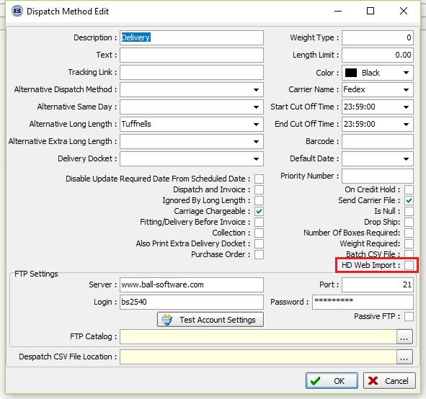

- We now map Alta’s Quote # to Blindata’s Quote Notes… “Alta Quote #: xxxxxx”.

- Added Notes to the column choice in Quotation Inquiry.

5817. Order Processing > Orders

When an order is added and a sub account customer is selected, the lookup now shows the sub account name as well as the sub account code.

5819. Bloc Blinds PO Export File

When a sales order is entered for a bought in blind from Bloc Blinds, it is now possible to send Bloc Blinds a file in this format.

The file format is in Redmine 4284.

There is a new flag in the supplier record called ‘Ftp CSV Semi Colon Separated File’ which defaults to false.

The file is sent to a ftp location so if this flag is set to true, the ftp location is made available.

This works the same way as a PO XML file except it should be sent as a csv file.

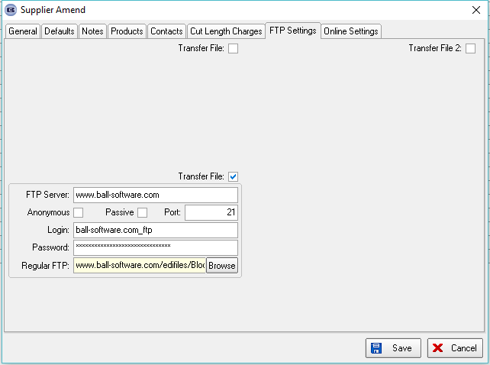

5822. Order Processing > Orders > Velux

If an order detail line is entered for a blind type with blind identifier = Velux, the secondary price table in the customer record is now taken into account.

5823. Parameters > Online

There is a new parameter to 'Administration > Parameters > Online > Order Columns Visibility' for ‘On Stop’. This will determine whether or not the ‘On Stop’ column appears in the online system.

5825. Works Order – Bespoke 34A

There is now a detail line printed for each serial detail line on this report.

5826. Stock Control > Stock Transaction Entry

When a stock transaction entry is done, the operator is recorded against the stock transaction.

5829. Out Of Stock By Stock Item

A new report has been created called ‘Out Of Stock By Stock Item’. This is in Stock Control > Reports.

The criteria are ‘Stock code’ (enter from lookup by either stock code or description – same as stock transaction entry), order detail line flagged as OOS, BOM record where free stock is < 0.

The report shows Stock Code, Stock Description

There are columns for Sales Order No, Customer Name, Order Date, Required Date, Quantity.

5831. Stock Items > Stock Transactions

We have a customer who does not want to see quote stock transactions or factory stock transactions in Stock Items > Stock Transactions.

There are two new parameters called ‘Display Quote Stock Transactions’ and ‘Display Factory Stock Transactions’ in Parameters. These both default to false, and neither quote nor factory stock transactions will appear in the Stock transactions tab. If they are switched on, they will appear.

The ‘Display Factory Stock Transactions’ flag only displays if ‘Use Factory Stock’ = true.

5832. Stock Items > Stock Transactions > History

This functionality occurs when ‘Use Factory Stock’ is switched on.

A stock transaction entry was made to transfer stock from the warehouse to the factory. This creates two stock transactions, which is correct. However it is not reflected correctly in the ‘History’. It has updated ‘Issues’ correctly but no longer updates ‘Receipts’. A receipt will only occur if the warehouse stock is being added to.

Also, when the order is manufactured, the factory stock in hand was reduced. Previously it added this amount to ‘Issues’ which it no longer does, because it is being reduced from factory stock.

To summarise, the ‘History’ is not updated if there is a factory stock transaction. The reason for this is if we update ‘History’, it is counting things twice. When the stock is transferred from the warehouse to the factory, it is a stock transaction issue. When the order is manufactured, it does not issue the same item again. The same principle applies to receipts.

5834. Quotation – Bespoke 73

There is a new report based on ‘Quotation – Bespoke 70’ called ‘Quotation – Bespoke 73’. Department is not used – ie the company name and address are taken from ‘Company Details’. The page size is A4, with date in UK date format.

The number of widths and curtain fabric amount were added to right of fabric description.

5835. Order Processing > Quotations

In the Totals tab there is a flag to determine whether individual option prices show or just the option total. This has been implemented in ‘Quotation – Bespoke 73’.

