Blindata Release Note 8.8.8 

9 March 2018

Bug Fixes and Enhancements

The following bugs were recorded in www.support.blindata.co.uk and have been resolved.

3285. Form Change - Acknowledgement Bespoke 52A
4650. Incorrect order number / order date on credit note 146
4658. Form Change - Acknowledgement Bespoke 52
4659. Form Change - Quote Bespoke 52
4667. Order Processing > Orders > Ctrl/E
4684. import from xls/xlsx
4688. Out of Stock Email

New Work and Customer Requests
5763. Order Processing > Orders > Out Of Stock Notification

If there are a number of purchase orders for a stock item, the date in the pop-up box only shows that date from the most recent purchase order placed ie from the ‘Exp Delivery Date’ in the stock record.

There is a new ‘Parameter’ flag called ‘Take Exp. Del. Date From PO’, which defaults to false. If true, in a sales order, when the form below is displayed, it takes the ‘Expected Delivery Date’ from the oldest undelivered PO for that stock item.

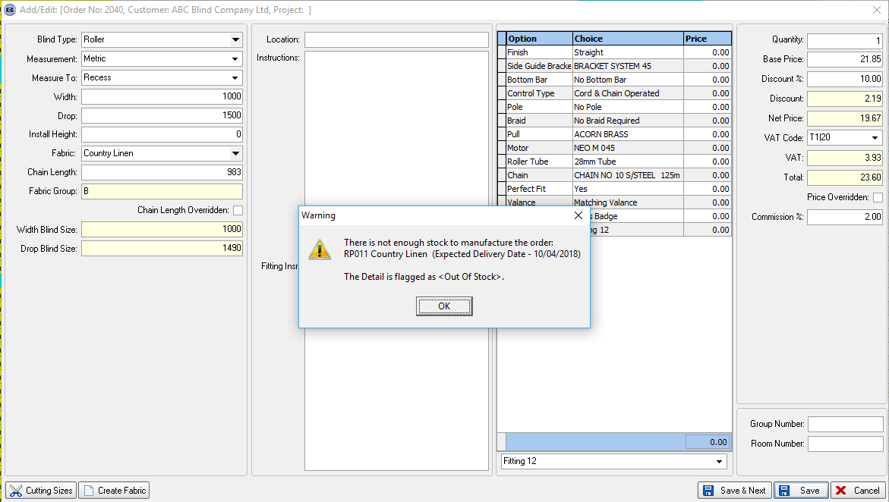

5764. Purchase Order Enquiry / Shortfall

At the moment there is a ‘Generate’ button in the regular PO for creating PO detail lines.

We have a user that uses the ‘Shortfall’ button on the Stock Enquiry form and would like to apply the same rule when ‘generating’ PO detail lines.

Currently on the Shortfall Report in ‘Stock Enquiry’ there are two ways of displaying information:

1. If ‘Override Shortfall Rules’ if ticked in Parameters then Shortfall Conditions and Shortfall Formula are used.
2. Otherwise records where ‘(Stock In Hand + On Purchase Order) < Reorder Level’ are displayed.

For regular PO generation we use two ways as well:

1. If ‘Ignore Sales Orders In Generate PO’ is ticked in Parameters then we add stock items where ‘(Stock In Hand + On Purchase Order) < Reorder Level’ – this is the same as condition 2 above.
2. Otherwise we add stock items where ‘(Stock In Hand + On Purchase Order – On Sales Order – Allocated Stock) < Reorder Level’.

We have made the following changes:

1. Changed the Shortfall routine to take ‘Ignore Sales Orders In Generate PO’ into account as well.
2. Changed PO Generate routine to take ‘Override Shortfall Rules’ and Shortfall Conditions and Shortfall Formula into account.

5771. Bank Reconciliation

There is now functionality to unreconciled bank transactions.

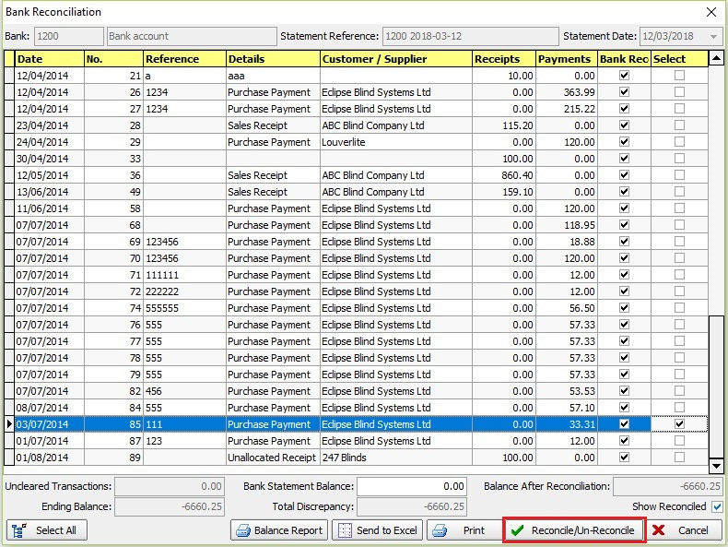

5772. Reports > Receipts By Type

There is now criteria for "Receipt Type" in the form for this report.

5773. Bill Of Materials Summary

- In the order > Bill of Material Summary, the landed cost and total landed cost columns now print.
- For users where cost is not shown on BOM, landed cost is also not shown.
- The printed BOM now shows Total Landed Cost
- In the total tab it now takes into account the Cost Square of fabric and the landed cost of fabric.

5798. Order Processing > Orders

It is now possible to show either the square metreage or the square footage of a blind in a column on the ‘Window Blind Amend’ form. If ‘Imperial Setup’ in Parameters = false, then square metreage is held, if true then square footage is held. The calculation is just the exact width x exact drop. This is a column choice. If the column is selected, it then shows the ‘Total Sq. Mts’ or ‘Total Sq. Ft’ at the bottom of the form and also the ‘Price Per Sq Mts’ or ‘Price Per Sq Ft’.

5800. Order Processing > Orders > Fabric Calculator

There is a new parameter called 'Allow Fabric Calculator Change' which default to false. This is held against the blind type (if blind identifier = Roller).
If this parameter is set to true, it is possible to amend the calculator for a fabric in an order detail line ie if a fabric has a calculator of ‘Drop’ they may want to change it to ‘Width’ or ‘Width or Drop’.

Currently only one routine in Blindata is affected by different calculators (they could be taken from Stock Items, Product Blind Type tab, Velux Code table or Coordination Code table). This is the BOM calculation. Other routines (Optimisation etc. will continue to use the Calculator which is held against Stock Item).

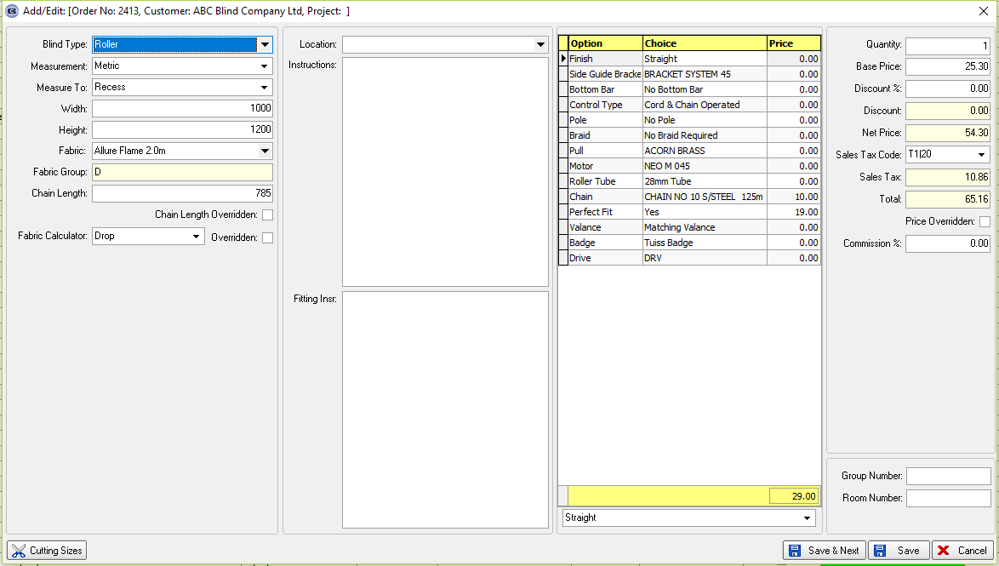

5802. Order Processing > Orders

We added two fields into the blind type record, but we only needed one of them. We have removed ‘Hide Fab Group in Ord Entry’ and changed ‘Display Fab Selling Price’ to say ‘Replace Fab Group With Price’.

If ‘Replace Fab Group With Price’ = true, then the fabric group is not displayed in the order entry (or amend) and the ‘Fab Selling Price’ is moved from the right hand side and put in its place.

5803. Pricing > Option Price Enquiry > Formula

The ‘Roll Width’ fields were currently greyed out – they have been made active.

