Blindata Release Note 8.8.7 

2 March 2018

Bug Fixes and Enhancements

The following bugs were recorded in www.support.blindata.co.uk and have been resolved.

New Work and Customer Requests
5770. Administration > System Tables > Vat Rates

There is a new field in the System Tables > VAT Rates table called ‘Receipt Default’. If this is set to true against one of the records, then when a receipt is entered against an order, the VAT rate defaults to the one set to true in the VAT Rates table.

5797. Stock Items > Landed Cost

This field now holds up to 4 decimal places.

5799. Order Processing > Orders

We previously added a ‘Quickbooks Export’ button to the ‘Post Invoice’ form. This has been moved to the ‘Order Amend Enquiry’ form.

5801. System Tables > Price Tables

There is now a new field in System Tables > Price Tables that holds a colour against the price table record.

When an order is entered, and a customer selected, the colour for the price table for that customer appears in the background of these two fields.

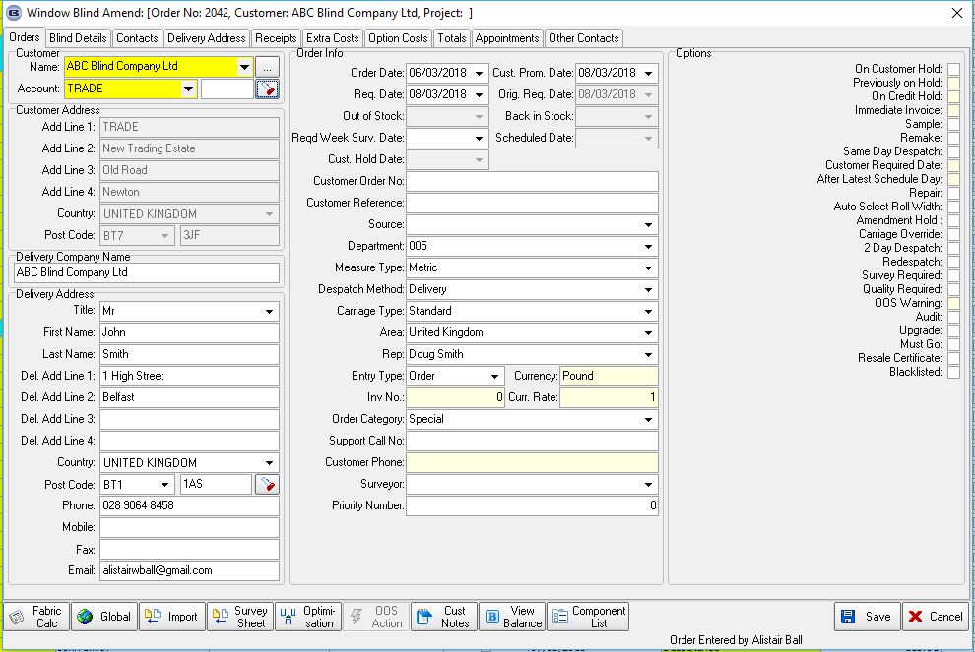

The columns for these two fields are also displayed in the relevant colour on the ‘Order Amend Enquiry’ form.

