Blindata Release Note 8.8.6 

16 February 2018

Bug Fixes and Enhancements

The following bugs were recorded in www.support.blindata.co.uk and have been resolved.

4524. Why is this printing

New Work and Customer Requests
5518. Production Scheduling

It is now possible to hold a priority number against an order. This appears below the ‘Surveyor’ field in order entry and is an integer field.

There is a new ‘Priority Number’ field in System Tables > Despatch Method. This is used as a default against the priority number in order entry.

5667. Order Processing > Orders > Global

If detail lines are changed using ‘Global’, the out of stock functionality that takes place in order detail line entry is also applied ie if there is an out of stock BOM, then the order detail line is flagged as OOS. If the detail line was OOS and is now not OOS, the flag is updated.

5715. Emailing To Delivery Addresses

We now hold email addresses against the delivery addresses for ‘Order Ack Email’, ‘Out Of Stock Email’ and ‘Delivery Note Email’. If these are filled, they are used instead of the email address held against the customer.

5729. OOS Emails

At the moment there is only one flag to cover this in Sales Files > Customers, called ‘Send OOS Message To Customer’. This is now only used for sending the OOS email. There is a new flag in the customer record called ‘Send BIS Message To Customer’ which defaults to false. If true, it is examined before a BIS email is sent ie the BIS message is only be sent for this customer if this flag is true.

5730. OOS Emails

There is now functionality to preview the email and amend the text in the Out of Stock emails before they are sent to customers. Previously this could be done if ‘Email Straight Away’ is switched on in Parameters > Set Connection, but this applies to all emails. There is a new parameter called ‘Email OOS Message Straight Away’ which defaults to false and is applicable prior to the OOS email being sent.

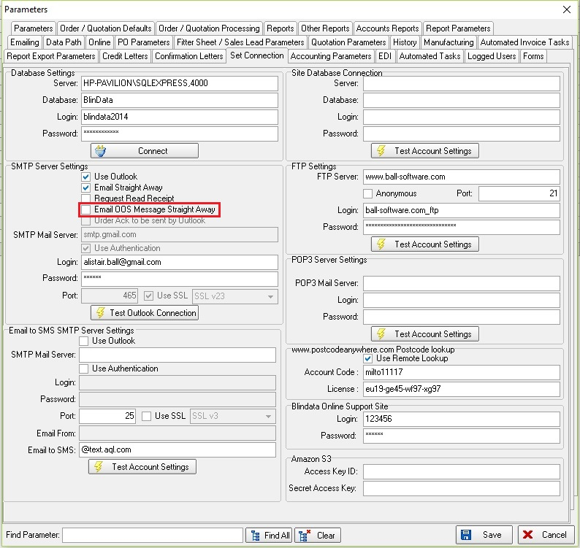

5756. Order Processing > Archive Enquiry

The total at the bottom of the screen is the sum of all the filtered invoice records minus the credit notes.

5758. Pricing > Discounts

There is a new column choice in ‘Discount Management’ called ‘Fabric Supplier’. If this is selected, then in the Discount form there is a new lookup called ‘Fabric Supplier’ which will look up suppliers.

When discount is being calculated in blind detail line entry, it now takes into account the new discount by fabric supplier. The supplier is found by looking at the supplier held against the fabric choice for the order detail line.

5759. Dashboard > Bar Graph Rep

The wholesale amount was adding to the total sales ie meaning the 'This Week’s Total Sales' was reading higher than it actually should be. The ‘This Week’s Total Sales’ no longer includes the wholesale amount.

5765. Order Processing > Orders

There is a new parameter in Administration > Parameters called ‘Disable Blind Type Notes Display’, which defaults to false. If this is set to true and there are ‘Notes’ set up in the blind type record, these will appear in a pop up window in the order detail line entry.

5774. OOS Email To Customer

We made a change in dev 5684 so the OOS message is only sent if ‘Checked’ is ticked in the order (‘Display Checked’ = true in Parameters). However if you enter an order but don’t check it and save it, then go back into the order and set ‘Checked’ to true, the email isn’t sent. It now is.

The logic was changed so when we save the order, if ‘Display Checked’ is true in Parameters and there is an OOS stock detail line, it sends an OOS email to the customer. It only do this once.

We could have a situation where an order is checked, and an email sent. Then another detail line is added later which is also OOS. It also sends an email for this.

5789. Order Processing > Orders

When the order is saved, the program checks to see if any of the order detail lines are flagged as out of stock. If yes, then the order is flagged as out of stock. If no, then the order out of stock flag is set to false.

5790. Quotations > Create Order

If a quote is entered and it is flagged as ‘Out Of Stock’, when it is converted to an order, it now removes all the ‘Out Of Stock’ flags and then recalculate the BOM and flag as ‘Out Of stock’ where necessary. This is because the stock in hand may have altered between the quote being entered and the order being created.

This is dependent on whether ‘Display Checked’ is switched on in Parameters. If it is and the quotation is flagged as ‘Checked’, when it is converted to an order, it has the same rules as an order ie if ‘Checked’, it then sends the order ack email (if this is switched on).

If the order that is created from the converted quotation is flagged as ‘Out Of stock’, and ‘Checked’ is true and the OOS email is switched on, the email is sent.

5791. Out Of Stock Email

This relates to the OOS email that is sent if ‘Send OOS Message To Customer’ is true and ‘Send OOS Summary’ is true, both in the Customers > Email Fields tab. The functionality for this has been changed so that more fields can be set up in an order header section and an order detail section, as follows.

Order Header information is held in the ‘<OrderHeaderData></OrderHeaderData>’ tags.
Order Details info is held in ‘<OrderDetailData></OrderDetailData>’ tags.
If there are no tags added then system will behave as it currently does.

Here is an example of what the email text will be entered as in Company Details > Email Text > OOS Email Text.

<OrderHeaderData>
Dear Customer
Order Ref: [Order Number]
Your Order Ref: [Cust Ref]
We'd like to make you aware for your order ref [Cust Ref] the following blind(s) will be sent outside the standard lead times.
The order will stay on back order and go into production automatically when stock arrives. You do have the option to part deliver or cancel your order, or we would very much like to offer you an alternative slat size or colour. If you would like to make any amendments please advise in writing within 48 hours of receipt of this email.
Whilst we always endeavour to match each order, there may be colour variations between batches of stock when part delivering orders.
Any orders that are dispatched and are no longer required after the stock is delivered will be charged for in full.
Your satisfaction is important to us, if you have any questions don't hesitate to respond to this email or call us on 01274 568 822.
</OrderHeaderData>
<OrderDetailData>
[Blind Type] [Entered Drop] [Entered Width] [Fabric Description] [Location]
Now due to you week commencing: [Approx. Due Receipt Date]
</OrderDetailData>

5795. Label Print – Bespoke 75

This report now has the same functionality as ‘Label Print – Bespoke 68’, which uses ‘Label Control’ and has the change we did in dev 5434 (v8.5.2).

