Blindata Release Note 8.8.5 

16 February 2018

Bug Fixes and Enhancements

The following bugs were recorded in www.support.blindata.co.uk and have been resolved.

4417. PO - Richard Alton feedback on Inland Charges and Frieght % as per email to Alistair Ball
4439. Order History - showing POs that are incorrect
4452. Verticals - Total FL on works order doubled
4456. 'Operator_id' in History look-up
4530. Missing button in release 8.8.4 add. Sorry, I forgot to attach the pictures

New Work and Customer Requests
5685. Stock Issues By Product By Month

There is new criteria to group by ‘Blind type’ or ‘Category’ and filters to select by ‘Blind Type’ or ‘Category’, with the default of ‘all’ for each.

There is also a flag called ‘Sales By Drop’ which defaults to false. If it is false, then the rows should display as they currently do and the ‘Sales By Drop’ column should not print.

If it is set to true, then the ‘Sales By Drop’ column will appear. This will group records by field Analysis 1 in the stock record.

There are also now extra columns for:

Sales By Drop
Maximum Monthly
Average Sales per Month
No of Months – this figure is calculated as ‘Free Stock’ / Average sales per Month
Physical – stock in hand
Demands – on sales order
Free stock – stock in hand less ‘On Sales order’
On P/O – On Purchase Order

5753. Order Enquiry > Blind Process Scan

If a process scan is done on a blind process for an order that is 'On Customer Hold', a message appears saying 'This order is on customer hold so this process cannot be scanned'.

5754. Order Processing > Quotations

There is a new parameter called 'Email Quote After Save' which defaults to false. If set to true, when the quote is saved, a message appears saying 'Do you want to email this quotation to the customer now?'. There are then choices for 'Yes' and 'No'.

5755. Works Order – Label 7

The ‘Install Height’ now prints on this label.

5775. Stock Control > Stock Transaction Entry

If the user permission called ‘Stock Take Entry Batch No Lookup’ is set to true, then when the batch number is selected here, it look up only existing batch numbers for this item. When a batch number is selected, it pulsl the cost price from that batch stock transaction and fills ‘Enter Cost Price’ with it.

Also if you click ‘Cancel’ for this transaction, it does not update the stock in hand.

5776. Stock Control > Stock Take Entry

If the stock item being entered has ‘Batch Numbering’ switched on, then the cost price is pulled from the existing batch stock transaction that is selected, in the same way it is done for a stock transaction entry.

This cost price is written into the stock transaction record and also the stock batch transaction record created.

5777. Regular PO > Deliver

For purchase orders where the supplier is set up with a non base currency, the currency rate applied is now the one saved when the purchase order is entered.

5778. Import From Excel > Stock Update

When a ‘Stock Update’ is done, the first column must be the stock code. There is now an option so the first column is the ‘Supplier Part No’. There is a flag called ‘First Column Is Supplier Part No’ which defaults to false. If true, the records are updated by matching the first column with the Supplier Part No in the stock record.

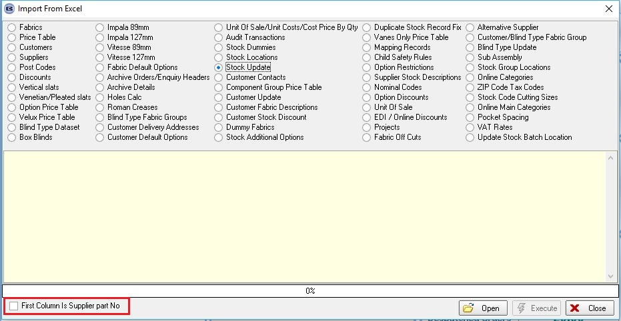

5779. System Tables > Despatch Method

The carrier file can now be sent to either the ftp location or the csv locations, depending on which field is filled in.

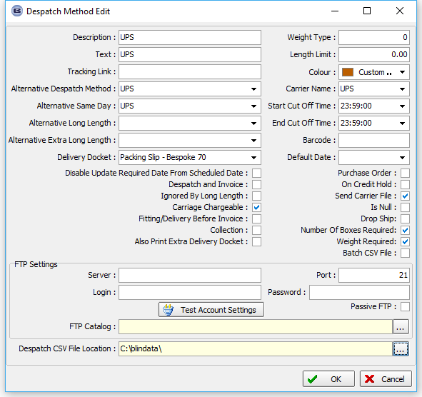

5780. Lead Time By Option

It is now possible to calculate lead time by an option chosen in an order detail line.

There is already a ‘Lead Time’ field held against a stock record. If this is not 0 or null, and it is a bigger number than the lead time held against the blind type, then it can be used for calculating the required date.

NB. Originally this functionality worked for Regular POs only in Expected Delivery Date calculation (and only if Add Option Time to Scheduling was ticked in Parameters). Now the ‘Required Date’ calculation for Sales Orders also takes Stock Item > Lead Time into account.

5781. Works Order – Bespoke 72

A number of layout changes have been made to this report, as per request.

5782. Picking List – Bespoke 72

There is a new batch picking list for called ‘Batch Picking List – Bespoke 72’. This is based on ‘Batch Picking List 1’ with changes as per request.

5783. Order Processing > Orders

If ‘Bypass Order Manufacture Status’ is switched on in Administration > Parameters, the ‘Order Made’ button does not appear on the ‘Order Amend Enquiry’ form.

5784. Delivery Docket – Bespoke 72

A number of layout changes have been made to this report, as per request.

5785. Quotation – Bespoke 72

A number of layout changes have been made to this report, as per request.

5787. Order Amend Enquiry > Order History

If a contact management record has been added and then amended, the order history now shows which contact record fields were changed and the old and new value.

5788. All Contact Records (Ctrl/T)

There is now a column choice for ‘Account Code’ here.

5792. Purchase Order – Bespoke 72

A number of layout changes have been made to this report, as per request.

