Blindata Release Note 8.7.9 

5 January 2018

Bug Fixes and Enhancements

The following bugs were recorded in www.support.blindata.co.uk and have been resolved.

4187. Blind reference out of sync on worksheet
4207. DG2500 pop-up message

New Work and Customer Requests
5675. Order Processing > Orders

At the moment if there is a special instruction set up in Customers > Spec Ins tab, it is pulled into the special instruction on the order detail line. There is a new parameter called 'Fill Spec Ins From Customer' in Administration > Parameters, which defaults to true. If this is set to false, these special instructions will not be saved in the order detail line.

5676. Order Processing > Orders

When an order is being split, the split order form now has a column for 'Out Of Stock' so the user can see which is the correct detail line(s) to select.

5677. Sales Files > Customers

There are now column choices for ‘Quality Control’ and ‘Notes’.

5678. Order Processing > Quotations > Create Order

There is a new Parameters > Email flag called ‘Email Order Ack After Check Complete’. If this new flag is set to true, then the order acknowledgement is emailed after the order is flagged as checked and saved. Only one of these flags can be set to true at any one time.

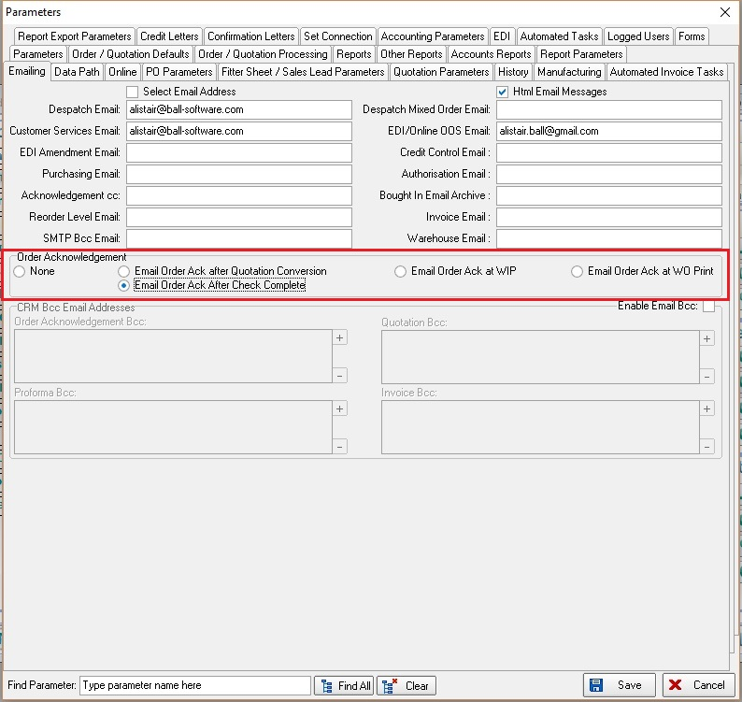

5679. Order Processing > Order Enquiry

There are now column choices for ‘Customer Reference’ and ‘Order Out Of Stock’.

5680. Order Processing > Paid Proforma

There is now a column choice in the context menu. The columns include existing fields plus 'Customer Reference', 'Is Out Of Stock', 'Must Go', 'Same Day Despatch'. There is also an option to print preview a Proforma, which has an advance permission flag. The context menu also has a choice to view the order history.

5681. Order Processing > Credit Notes

There is now a button for 'Contact Management' on this form. This will open the same form as is opened on the 'Order Amend Enquiry'.

5682. Order Processing > Orders

If an order detail line is flagged as out of stock and an email is then triggered for the customer, this is now recorded in the order history.

5683. Administration > Company Details

Fields have been added in Company Details > Email Texts for blind type, fabric description, entered width, entered drop, location, so they can then be selected for the OOS and BIS email text.

5684. Order Processing > Orders

If 'Display Checked' is switched on, it is no longer possible to send an OOS email to a customer until the order has been flagged as checked.

5686. Purchase Order Enquiry > Regular PO

There is now an import routine for detail lines for a regular PO. There is a button on the ‘Generate Regular Purchase Order’ form called ‘Import’. This imports records from a spreadsheet which has fields for stock code, unit of sale, quantity.

5687. Stock Control > Stock Items

There is a new field in the stock record called ‘Cubic Capacity’ in the Characteristics tab.

It is also possible to import this in ‘Stock Update’.

5688. Financials > Financial Year > Period Ends

This is required if Blindata accounting is used and ‘Enable Monthly Period Ends’ is switched on.

There are flags against each of the sales ledger, nominal ledger and purchase ledger months called ‘Closed’. These flags default to false. If a ‘Closed’ flag against a ledger for a specific month is set to true, then it will not be possible to post to that ledger.

For example, if a sales invoice is dated 31/12/17 and the current date is 02/01/18 and the month 01/12/17 – 31/12/17 is locked, then it will not be possible to post the sales invoice. A message appears saying ‘You are trying to post this sales invoice to a sales period that has been completed’. Similar messages appear for the other ledgers.

There is a rule that if the nominal ledger is closed for a period, then both the sales ledger and purchase ledger are also closed for that period.

5689. Order Processing > Paid Proformas

It is now possible to extract a report that shows all proforma records and their detail lines. This is required so out of stock records can be identified when stock arrives.

There is a new button on this form called ‘Print All Filtered Proformas’. This prints a report that shows ‘Proforma Date’, Customer, Status (paid or not), net total, then beneath that the detail lines for the quote, including blind type, fabric description, quantity, width, drop , net price.

5690. Order Processing > Orders

If the Out of Stock Pop Up box text does not have an ‘Expected Delivery Date’, then '(Expected delivery date unknown)' is removed from the form.

5691. Order Processing > Orders

In order entry, when ‘Same Day Despatch’ is ticked, so is ‘Must Go’. When ‘Same Day Despatch’ is unticked, ‘Must Go’ remains ticked. This has been changed so when ‘Same Day Despatch’ is unticked, ‘Must Go’ is unticked (i.e. if both are added, both are removed).

5692. Order Processing > Order Enquiry > Batch Picking List

There is now a new page for each report in this order.

5693. Order Processing > Orders

At order entry stage, when the Remake or Repair option is selected, the Quality Required tick box is automatically selected. If Remake or Repair is unticked, the Quality Required tick remains. Now if Remake and Repair are deselected, the Quality Required box is automatically unticked.

5707. HD Web Import

There is a new system table called ‘Import File Blind Type Mapping’, which has two fields: Import Blind Type Code, Blind Type Code.

This table will have to be filled with the KMAT code in the ‘Import Blind Type Code’ and the Blindata blind type code in ‘Blind Type Code’.

When the HD Web Import is being done, the ‘Blind Type Mapping’ table is searched for ‘Import Blind Type Code’ (the KMAT product code in the import file) and is then substituted with the ‘Blind Type Code’.

5708. HD Web Import

Further changes have been made to this import.

‘Order Category’ is taken from the blind type record
‘Order Entered By’ is now filled.
‘Direct Delivery’ is now always set to TRUE.
City was being moved to Delivery Address2 – it now goes in delivery address 3.
State / Zip was in wrong field – the first part (the state code) now goes in the State field.
Customer Email is now getting picked up – it goes in the ‘Email’ field.

5709. Quotation – Bespoke 60

The ‘Special Instructions’ field has been made shrinkable so it will print out all the special instructions that are imported from an Alta order.

