Blindata Release Note 8.7.7 

22 December 2017

Bug Fixes and Enhancements

The following bugs were recorded in www.support.blindata.co.uk and have been resolved.

3957. Quotation - Bespoke 72
4037. 5543. Blind Types > Bought In Blinds tab
4140. Stock Receipt Price
4177. Order Processing>Orders>Orders

New Work and Customer Requests
5629. Order Processing > Orders > Curtains

When entering an order detail line for a curtain, the description of two fields have changed – Left Border now says ‘Leading Edge’ and Right Border says ‘Trailing Edge’. See 5630 as well.

5630. Order Processing > Orders > Curtains

If a curtain has a border, this means that a second fabric has to be used. This is held as an option choice ‘Fabric’. For a border fabric, the fabric in the option needs to have pattern repeat and roll width. Therefore we need to be able to enter a ‘Border Fabric Pattern Repeat’ and ‘Border Fabric Roll Width’ and use these fields when calculating how much stock to use. It is also needed for pricing so we now have these new fields in the ‘formula’ form for ‘Dimension Calculations’, ‘Option Price Tables’ and ‘Square Metre / Linear Width Pricing’.

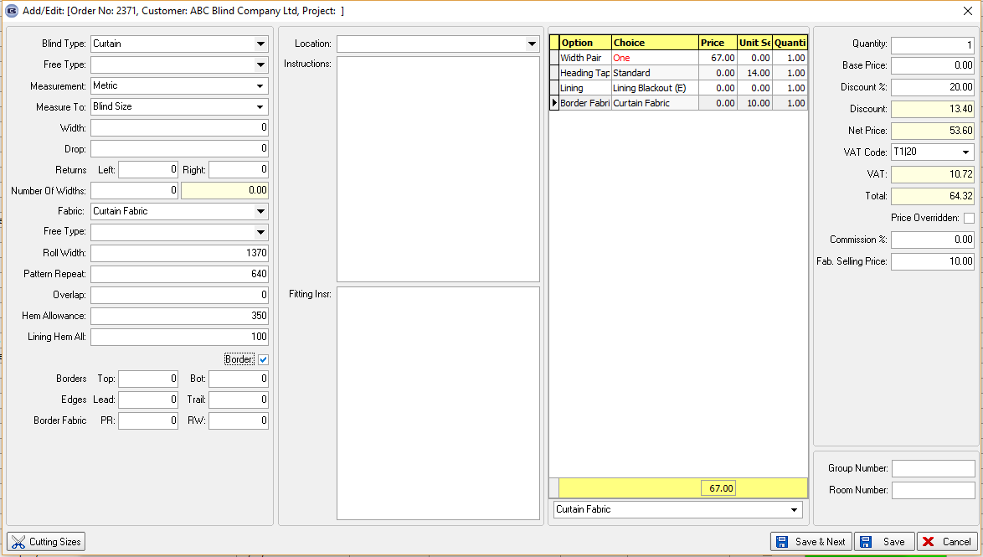

For a Fabric option choice, it is now possible to call it something else eg ‘Border Fabric’. This is done by filling a new field in System Tables > Option Names > alternative Option Description.

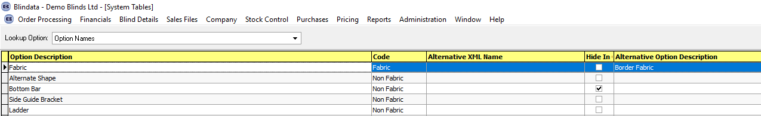

5631. Order Processing > Orders > Curtains

It is now possible to enter the cost price for a BOM record and hold it against the BOM. There is an advanced permission flag per user, called ‘Edit BOM Cost Price’.

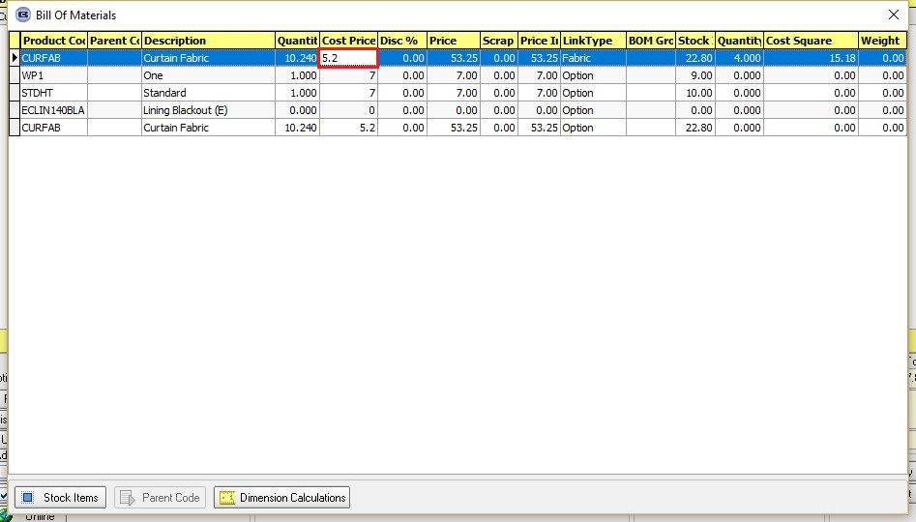

5632. BOM Summary

If the free type has been entered for the blind type or the fabric description, the free type for blind type and fabric now print on the BOM report and also the BOM Summary. In the summary the fabrics are grouped by description and free type.

5633. Order Processing > Orders > Number Of Widths

There is a new flag in the blind type record called ‘Incl. Returns in No. Of Widths’, which defaults to false. This flag appears for all blind types where ‘Enter Return Size’ is available. If set to true, the number of widths calculation should be ((Width + Left Return + Right Return) * Fullness Ratio)/Roll Width.

5635. Blind Details > Blind Types

There is now a flag for ‘Display Fullness Ratio’ in the blind type form (if blind identifier = Curtain or Cushion or Roman).

5644. Works Order – Bespoke 75

There is a new works order report called ‘Works Order – Bespoke 75’. This is based on ‘Works Order – Bespoke 45’ as it is similar.

5668. Quotation – Bespoke 72

There is a new quotation print called ‘Quotation – Bespoke 72’.

5674. Alta Web Services Connection

We now hold connection details for the Alta web services integration. See documentation. This functionality will be suitable for all customers that place orders online using the Hunter Douglas PIC Business portals.

The vendor needs to be set up in the Vendor table and the correct information entered when ‘HD Web Import’ is ticked. This information can be provided by the vendor.

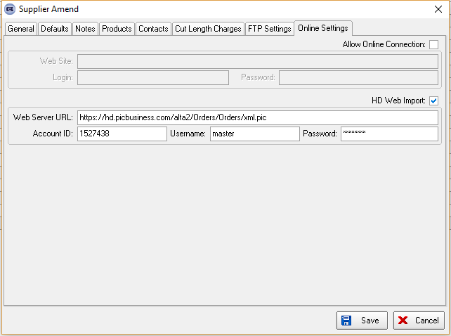

There is a new advanced permission in Administration > Users > Advanced Permission that should be switched on.

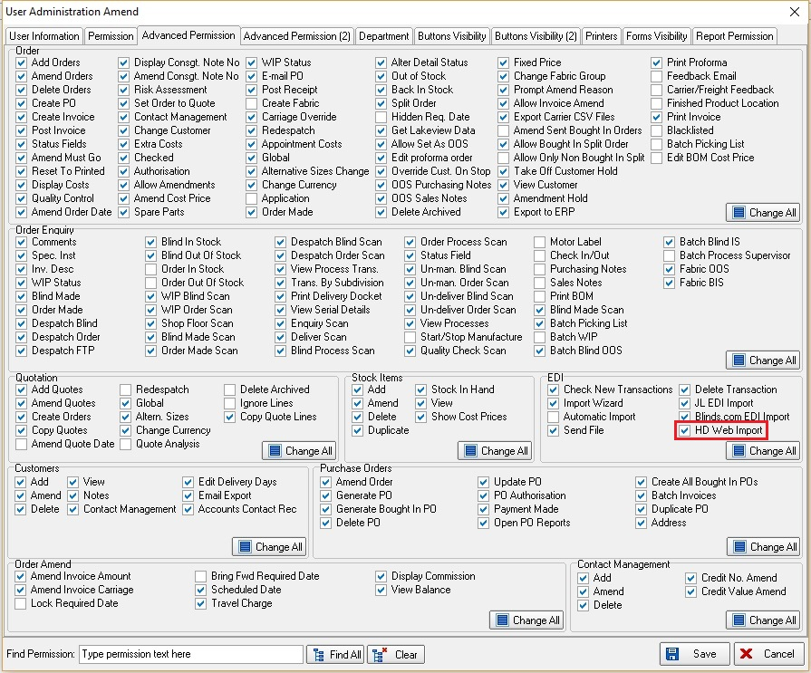

When this flag is switched on, the following button will become available in Order Processing > EDI Enquiry > Receiving Data.

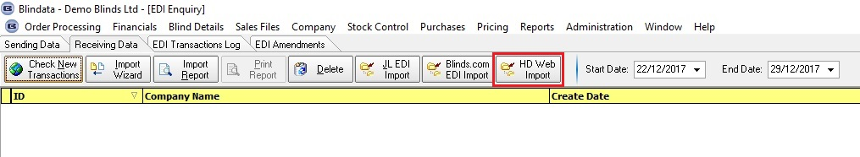

When this button is selected, all quotes that are held on the vendor portal that have not previously been imported will be imported in to Blindata as quotations. This will import quotes that have a status UN-SUBMITTED QUOTE’ as well as other quotes.

The quotes will only import correctly if the correct account code exists in Blindata – this has to match what is entered in the ‘Client Reference’ field in the header section of the quote in the portal.

The blind type code is also validated and will have to exist in Blindata.

If either of these fields do not match, a warning message will appear in the import screen and the record will not import.

