Blindata Release Note 8.6.8 

19 October 2017

Bug Fixes and Enhancements

The following bugs were recorded in www.support.blindata.co.uk and have been resolved.

3583. Work Order - Bespoke 67
3710. Nominal Category/Code
3736. Quantities for Components
3746. Packing Slip Bespoke 70

New Work and Customer Requests
5576. Stock Control > Stock Items

There is a new flag in the stock record called ‘Exclude From Project BOM’ which defaults to false.

The purpose of this field is to distinguish between records where the BOM cost will not change eg brackets, roller tube, and items which could change eg fabric. These records will then be excluded in the ‘Project Profitability By BOM Group’ project cost but still included in the estimate amount line.

5577. Purchase Order Enquiry

There is now functionality to allow a user to manually assign a sales order number to a purchase order detail line. At the moment there is a context menu option to relate a sales order detail line to a purchase order detail line.

There is a new option that will allow a user to assign a sales order to a specific purchase order detail line.

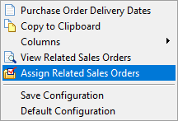

The purpose of this is so purchase order detail lines can then be identified by sales order number for the ‘Project Profitability By BOM Group’ report.

5578. Order Processing > Orders > Extra Costs

There is a new field in the System Tables > Cost Price Description table called ‘BOM Group’. This looks up the BOM Group system table.

Order Processing > Orders > Extra Costs

There is a new field for ‘BOM Group’ in this form, which looks up the table System Tables > Categories. The BOM Group displayed defaults to the one held against the ‘Cost price Description’ selected, but it is possible to change it.

5579. Project Profitability By BOM Group

There is a new report in Reports > Financial Reports called ‘Project Profitability By BOM Group’.

It is possible to print out this report by either ‘Project Name’ or ‘Order No’. There are criteria for choosing one of these.

The purpose of this report is to compare original estimates for costs against actual costs, either by project or by order.

When an order is entered, the costs are calculated by the BOM (for blinds made in house) or by bought in cost (if blinds are bought in).

However when the blinds are made, a different amount of material may be used. The cost of this can be calculated by associating the PO cost for the fabric with an actual sales order (see dev 5577). There may also be a difference in installation cost and this can be added by using the ‘Extra Costs’ form.

The report prints up to 7 BOM Group columns. The figures in the rows with the order number in them will show the actual costs – these are the totals by BOM Group excluding records where ‘Exclude From BOM Group’ = true.

The actual costs for the BOM Groups are taken from the following data

Sales order BOM records where ‘Exclude From BOM Group’ = false
PO records which are associated with sales orders
Sales order bought in order detail line records (cost of blinds)
Extra costs records held against sales orders

The original estimate costs are taken from

Sales order BOM records
Sales order bought in order detail line records (cost of blinds)

The report has the following columns

Order No/Invoice No – the first row will print the order no, the second row will be the invoice number. If ‘Project Name’ has been selected, there could be several orders/invoices.

OrderDate/Invoice Date – first row order date, second row invoice date.

Gross sale – the actual invoice total (including sales tax).

Net Of Sales Tax – total excluding tax.

‘BOM Group’ headings. The figures in here are the grouped totals for BOM Groups, taken from the BOM, Extra Costs and bought in blind type ‘BOM Group’. These records will exclude BOM stock codes where ‘Exlude From Project BOM’ = true.

Total Costs – total of the BOM groups.

Net Profit – this is equal to ‘Net Of Sales Tax’ – ‘Total Costs’.

% - Net Profit / Net Of Sales Tax.

The report has the following rows at the bottom.

Project Totals – this is a total for the columns

Original Estimates – this is the ‘BOM Group’ taken from the bill of materials held against the orders. It does include records where ‘Exclude From Project BOM’ = true. It excludes ‘Extra Costs’ records and PO records associated with sales orders.

Difference – this will show the differences by ‘BOM Group’, ‘Total Cost’ and ‘Net Profit’.

5581. Order Processing > Orders > Option Price

There is a new flag in the blind type record called ‘Display Option Unit Selling Price’.

This means the option unit selling price can be altered in the order detail line entry. If a formula is set up in Pricing > Option Price Enquiry, then the option price can then be altered on the fly.

In Option Price Enquiry > Formula, there is a field for ‘Unit Selling Price’ so a price for an option can be calculated by a formula involving the unit selling price of the option.

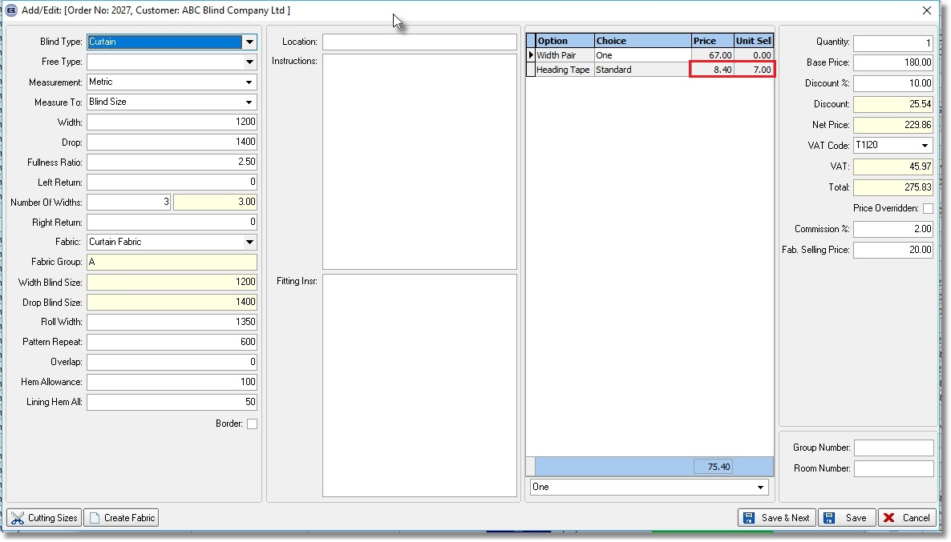

5582. Order Processing > Order Enquiry

There is now a column choice for ‘Must Go’ on the Order Enquiry form.

5587. Blind Details > Blind Types

If ‘Bought In’ is set to true in the blind type record, there is a new field called ‘BOM Group’. This will be a lookup that selects a record from System Tables > BOM Group.

