Blindata Release Note 8.6.6 

29 September 2017

Bug Fixes and Enhancements

The following bugs were recorded in www.support.blindata.co.uk and have been resolved.

3453. Credit being created at different amount to invoice
3679. Valance width
3678. Work order bespoke 70 not printing correctly
3667. Fitters Sheet experiencing issues
3665. Browser Not Supported

New Work and Customer Requests
5541. Order Processing > Orders

When a ‘free type’ is entered for a fabric in an order detail line, there is a lookup for existing free types. We have a customer that wants to restrict the free type lookup to only free types that have been entered for that quote/order.

To deal with this, there is a new parameter called ‘Order Only Fabric Free Type Lookup’ which defaults to false. If set to true, then the following lookup will only show free types entered in the current order/quote.

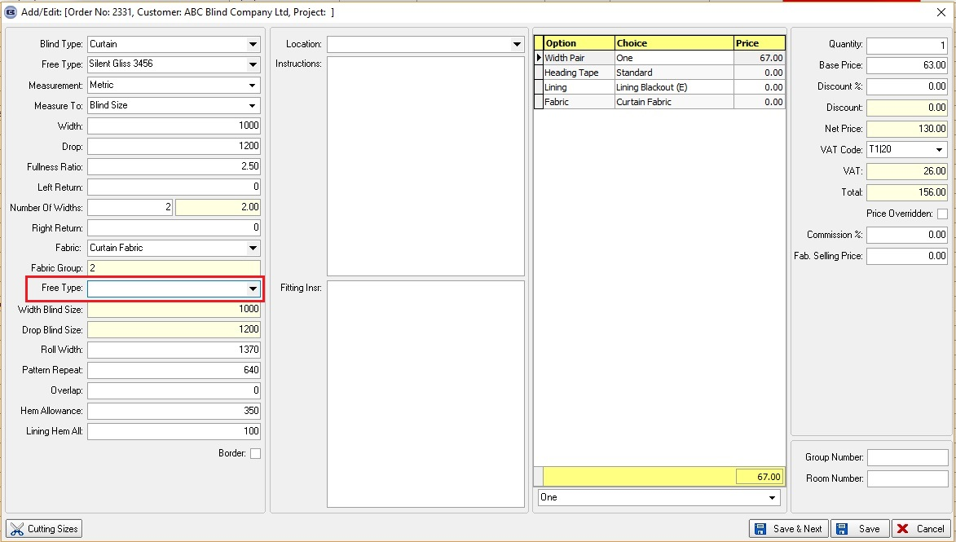
5570. Order Processing > Orders > Components

Quite a few customers are saying that the component order detail line entry is still too slow. It has been improved recently but still takes a long time to open.

We have made a further change to this form. In Administration > Users > Forms Visibility, it is possible to switch visibility on/off for fields. The system may be a bit quicker if ‘Filter’ and ‘Location’ are switched off.

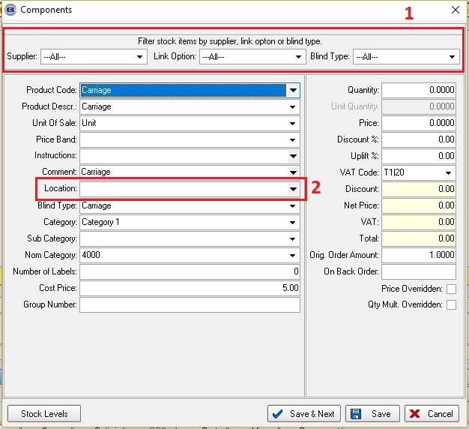
5584. Label Print – Bespoke 75

The number of vanes now appear on the label if blind identifier = Vertical or Vanes Only.

If the blind identifier = Pleated, the number of pleats prints in the same place.

If the blind identifier = Venetian or Wood, the number of slats prints.

