Blindata Release Note 8.6.7 

6 October 2017

Bug Fixes and Enhancements

The following bugs were recorded in www.support.blindata.co.uk and have been resolved.

3514 - PACKING SLIP CORRECTION - Feature #3144
3565 - eCommerce | Made to Measure product pages
3591 - eCommerce | Unable to order curtain tracks

New Work and Customer Requests
5580. Blind Details > Blind Types

A while ago we introduced new functionality for curtains, where the following extra fields could be entered.

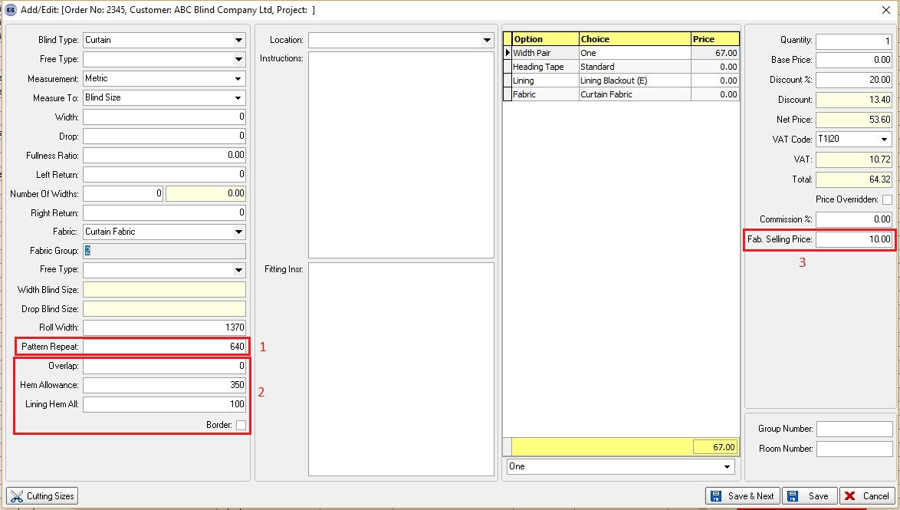

This is now available for blind identifier = ‘Austrian/Roman’. There are three new flags in the blind type record called:

- Display Pattern Repeat
- Display Allowances
- Display Fab. Selling Price.

These all default to false. These flags appear in the blind type record if the blind identifier = Curtain, Austrian/Roman, Screen or Cushion.

If the flags are set to true, then the relevant fields appear in the order detail line entry.

5583. Purchase Order Bought In – Bespoke 52

There is a new field in the customer record called ‘Priority PO Message’, which defaults to false. If set to true, then the following message appears on this report. It says ‘** [CUSTOMER COMPANY NAME] PRIORITY ORDER **’. If false, the report remains the same.

5585. Purchase Order Bought In – Bespoke 52

The fabric description has been moved so it is below the ‘Location’ and prints across the line.

5586. Label Print – Bespoke 75

The following modifications have been made:

Increased the number of characters available for Customer Name
Sidemark had too many characters available.
Switched the locations of the Customer name and Sidemark.
The label name is no longer cut off, at least 12 characters are now visible.
The blind size was in decimal format, now in imperial with fractions.

