Blindata Release Note 8.6.2 

1 September 2017

Bug Fixes and Enhancements

The following bugs were recorded in www.support.blindata.co.uk and have been resolved.

3070. Response Time
3478. Order Processing >Orders>Orders
3503. Contact name in shipping address

New Work and Customer Requests
5512. System Tables > Process Times

There is now a new button to set up process times against processes. There is also an option to update the times for all the blind types in one process to the same time.

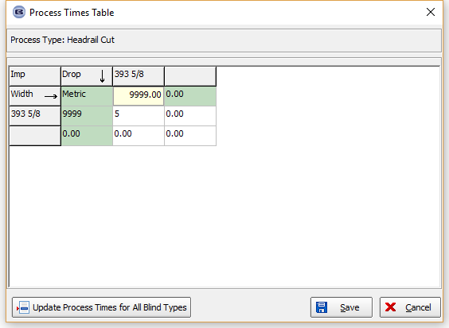

5526. Stock Control > Stock Items

There are two new fields in the stock record, called ‘Duty’ and ‘Inland Charges’. Both are currency fields. They are displayed beneath ‘Landed Cost’ in the ‘Default’ tab.

5534. System Tables > Carriage Charge By Blind Type

It is now possible hold a carriage charge by blind type by size (width and drop). This amount defaults to zero.

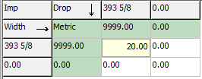

The carriage charge functionality has been changed to take into account carriage charge by blind type. The carriage amount will be calculated by the quantity of blinds per order detail line multiplied by the carriage by blind type by size.

There is a new parameter in the customer record for this, called ‘Carriage By Blind Type’ which defaults to false. If true, the carriage is calculated by looking at the blind type instead of at ‘Carriage By Area By Total’ etc.

There is also functionality to update the ‘Carriage By Blind Type’ in Sales Files > Customers > Customer Update.

5536. Blind Types

There is a new flag in the blind type record to hide the ‘Fabric Group’ field in the order detail line entry. It is called ‘Hide Fabric Group In Order Entry’ and defaults to false.

5537. Order Processing > Orders > Window Blind Amend

When a detail line is copied to another, the room number is also copied onto the next detail line. Also the room number is remembered for the next line.

5538. Works Order – Bespoke 73

All sizes are now in centimetres.

5539. Label Print – Bespoke 75

There is a new label layout called ‘Label Print – Bespoke 75’. The label size is 5” x 1 7/16” and it was based on the same rules as ‘Label Size – Bespoke 68”.

5540. Label Print – Bespoke 74

There is a new label layout called ‘Label Print – Bespoke 74’. The label size is 4” x 1 ½” and it is based on ‘Label Print – Bespoke 68’.

